SOP-S006

Analyzing Amgen Data Sets using Plate Analyzer

Objective: The goal of this SOP is to create protocols to visualize and analyze dose response curves and Kolmogorov-Smirnoff (KS) distance response curves

Procedures:

To create dose response curves and export response data:
- Open the most recent version of Plate Analyzer.
  - To get the most recent version, go to scratch\Valery\platan. DO NOT open Plate Analyzer from this folder.
  - Copy the file “PlatAn.exe” into a new directory and open from here.
  - If the number in the upper left is higher than the number of the version already copied to the computer, than the version you just copied is more recent and should be used. You can also check the date modified.

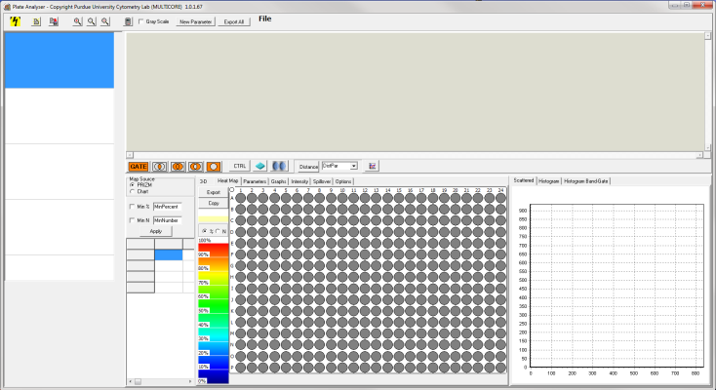
- Click on the “lightning bolt” icon in the upper left corner.
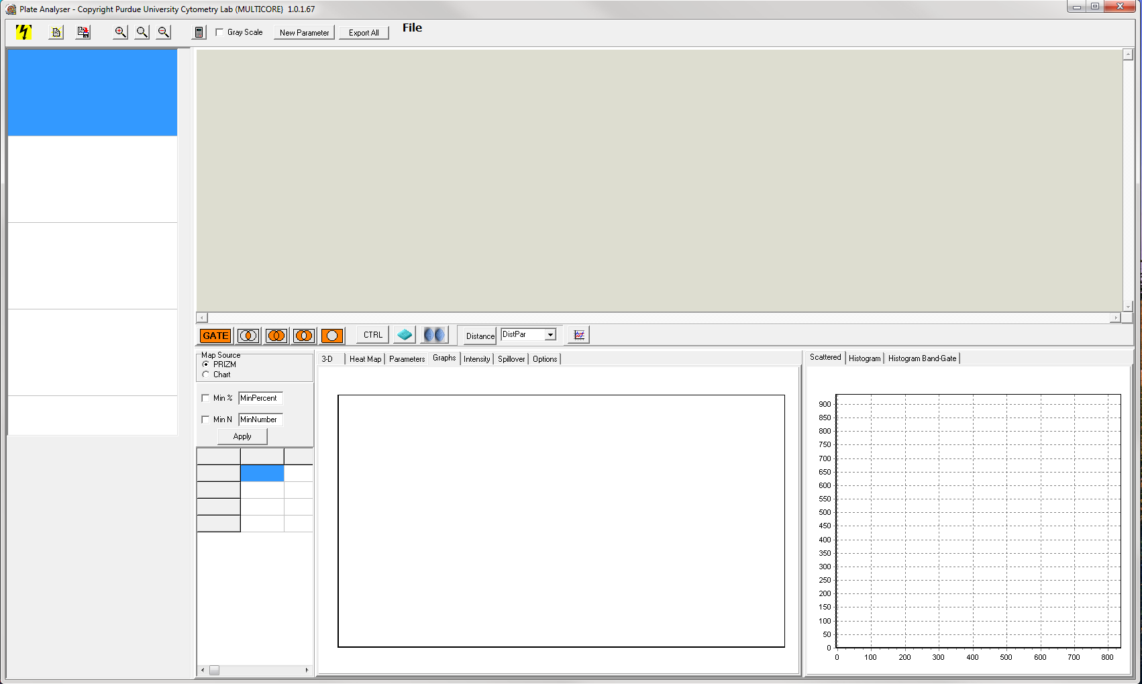

- Choose a data set and select OK.
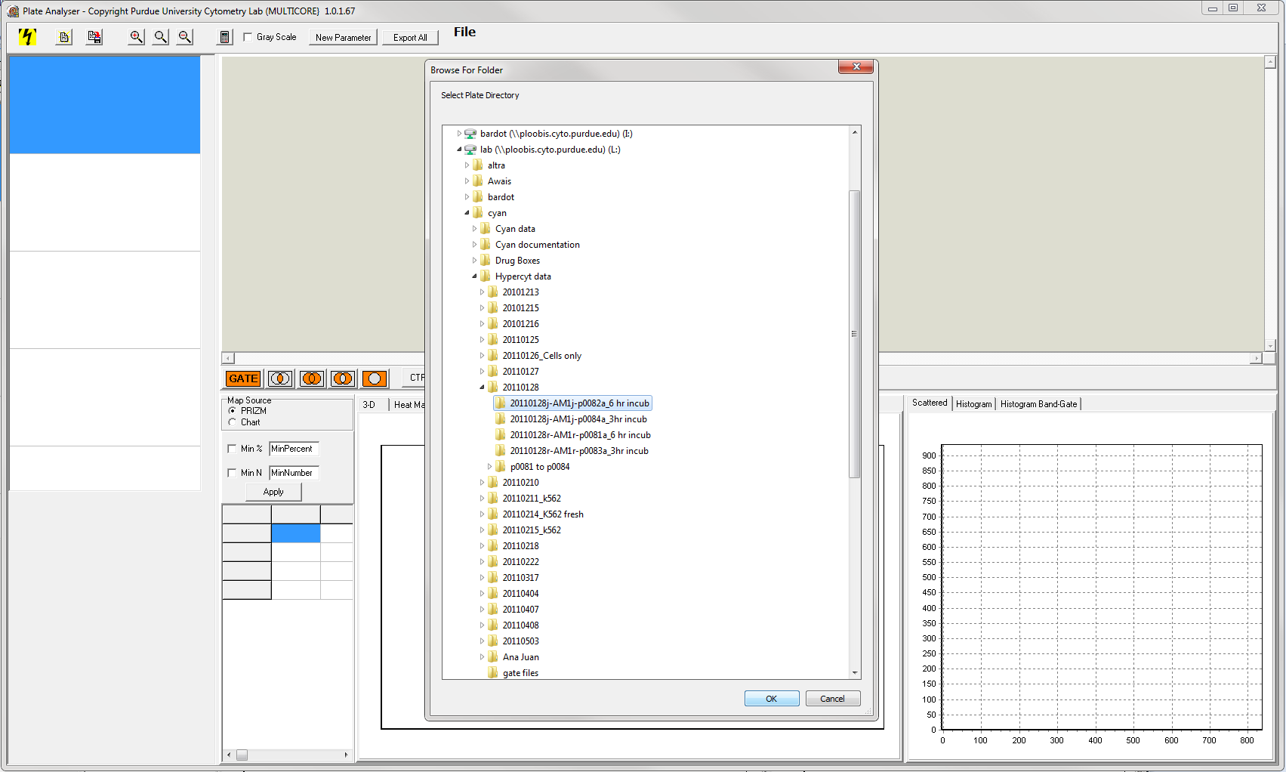
- On the view of the 384-well plate, click the dot above the “A” and before the “1”. This exchanges data between the well plate and the scatter plot/histogram in the lower right corner. It should turn green.

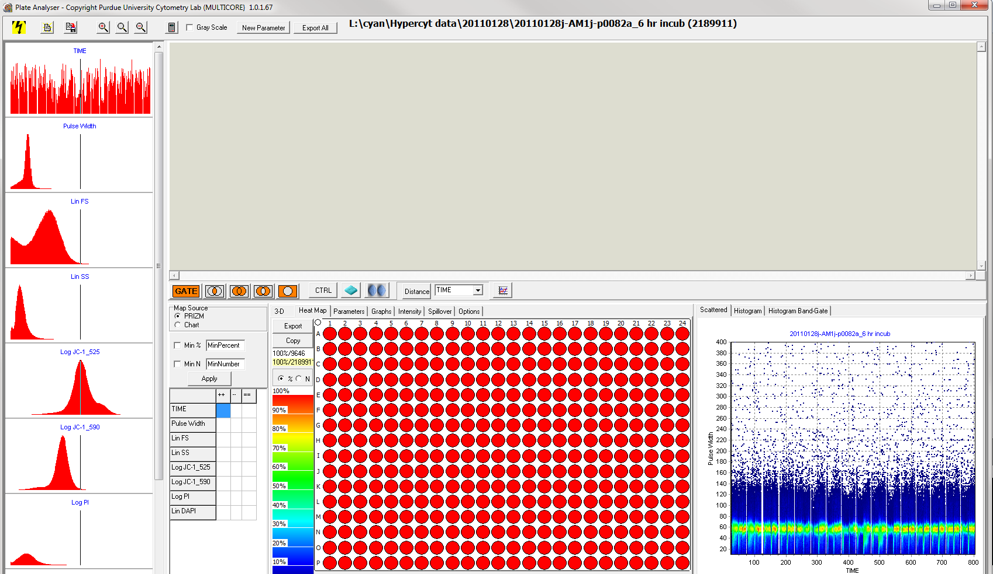

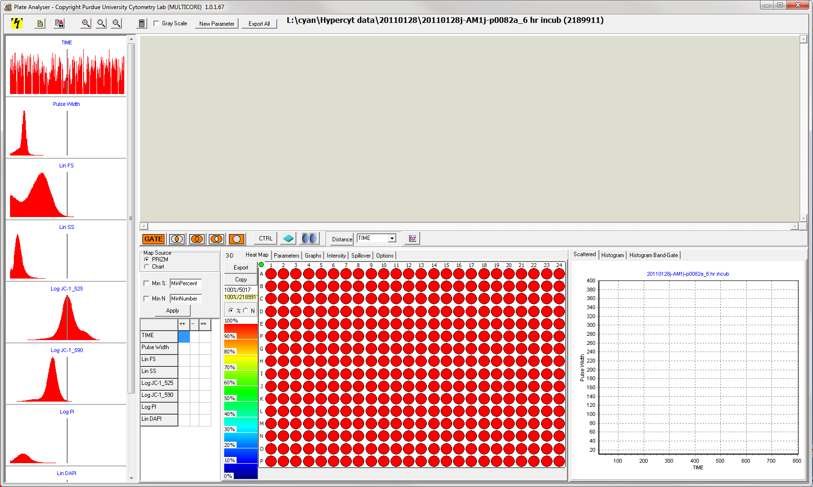

- Entering compound concentrations:
  - Select the parameters tab.
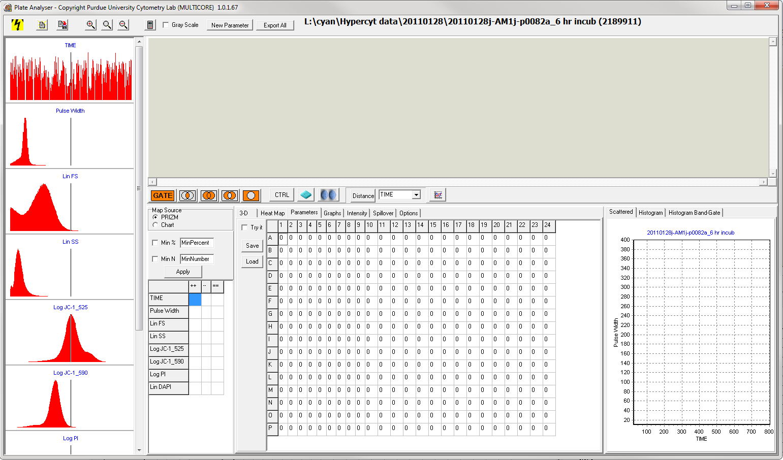
- If concentrations have already been saved, they can be opened by selecting “Load” and opening a premade parameters chart.
  - Amgen screening list is found at lab L:\cyan\Parameters\drug-concentrations 10
- Otherwise. enter the compound concentrations for each well.
  - Concentrations can be added by column by selecting “try it.”
- Select “Save” and save the concentrations to a desired directory.

- Creating Gates:
  - Select the “Heat Map” tab.
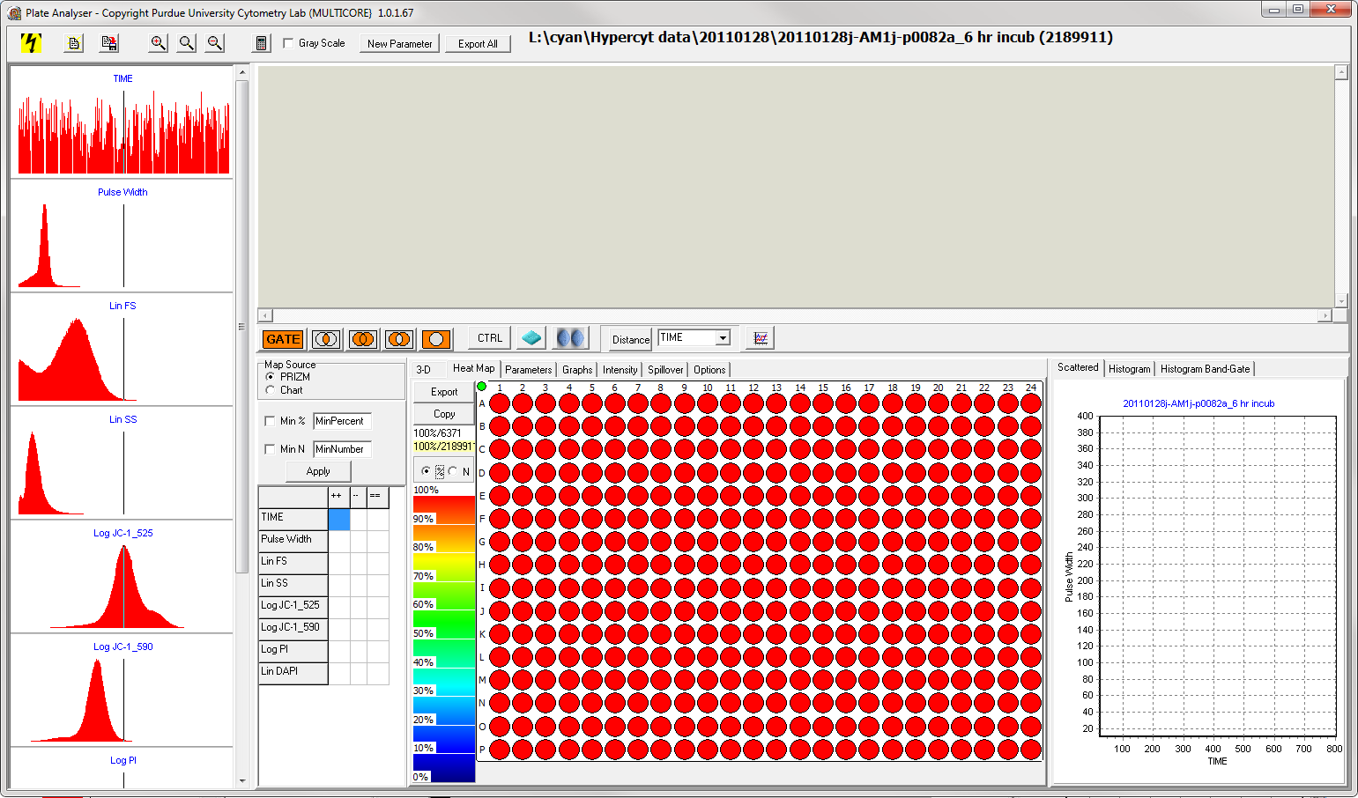

  - Highlight every well on the 384-well plate.
  - Select the scattered plot tab in the lower right corner.

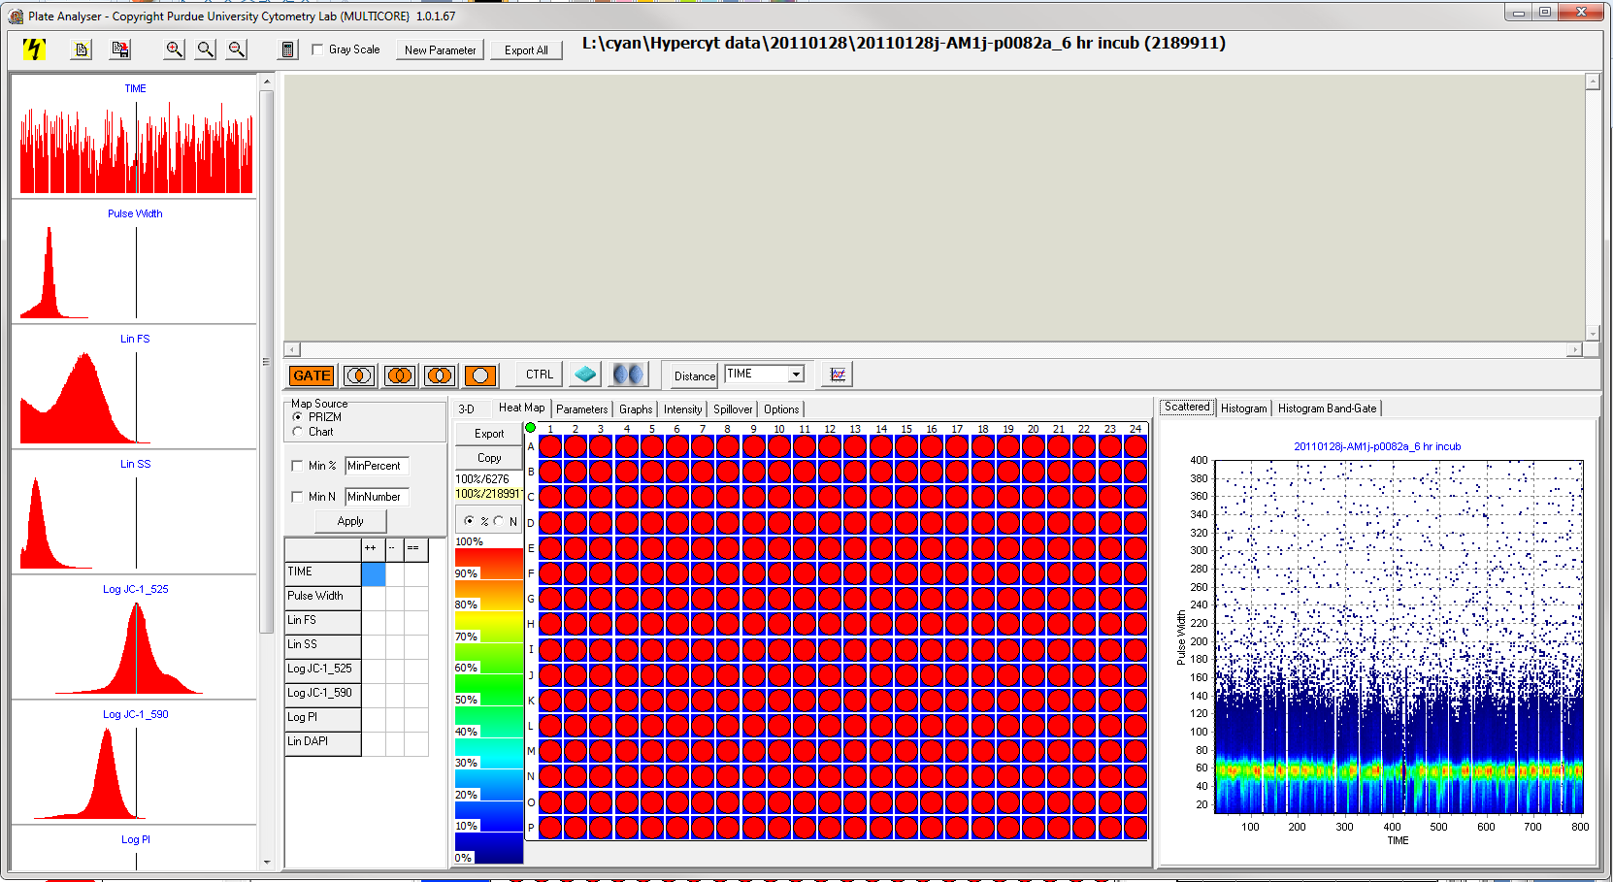

  - In order to gate, parameters should be chosen that distinguish between normal and abnormal cells. Select parameters for the x-axis and y-axis by right-clicking on the axis title.
    - For JC1 assays, Lin FS (y-axis) versus Log JC1-525 (x-axis)
    - For redox assays, FS (y-axis) versus SS (x-axis)

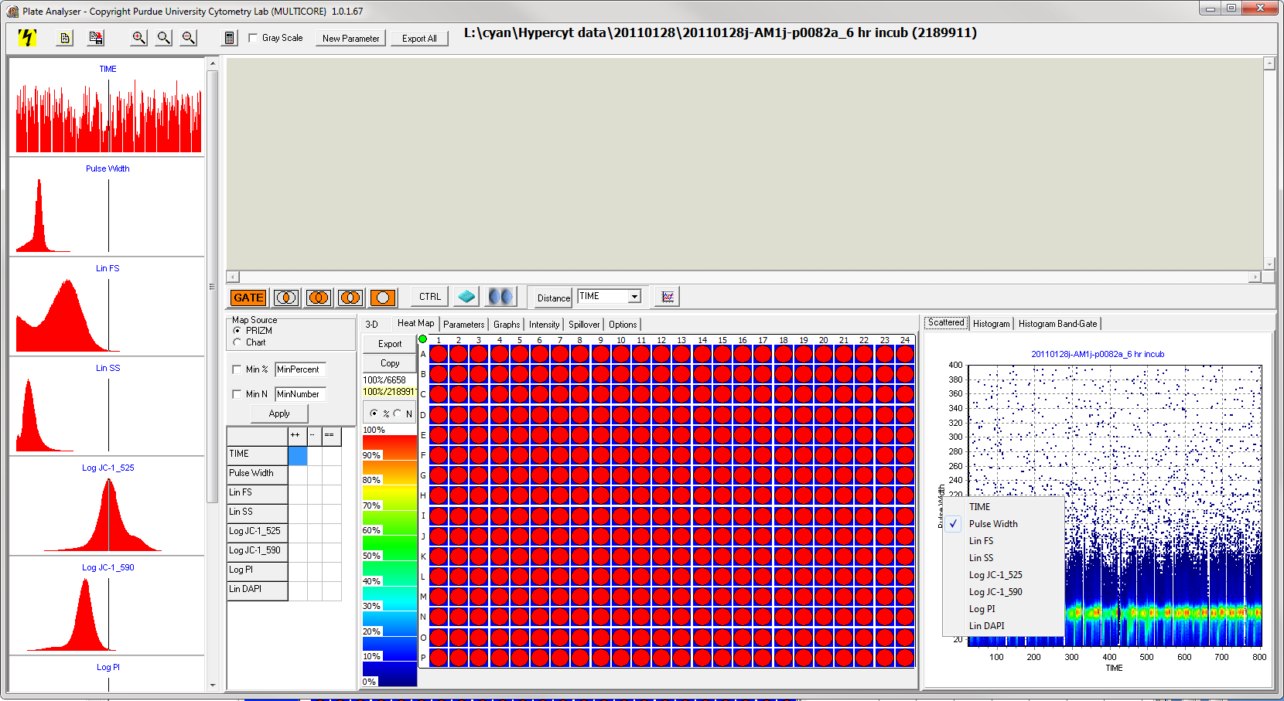

  - Select the “GATE” button.

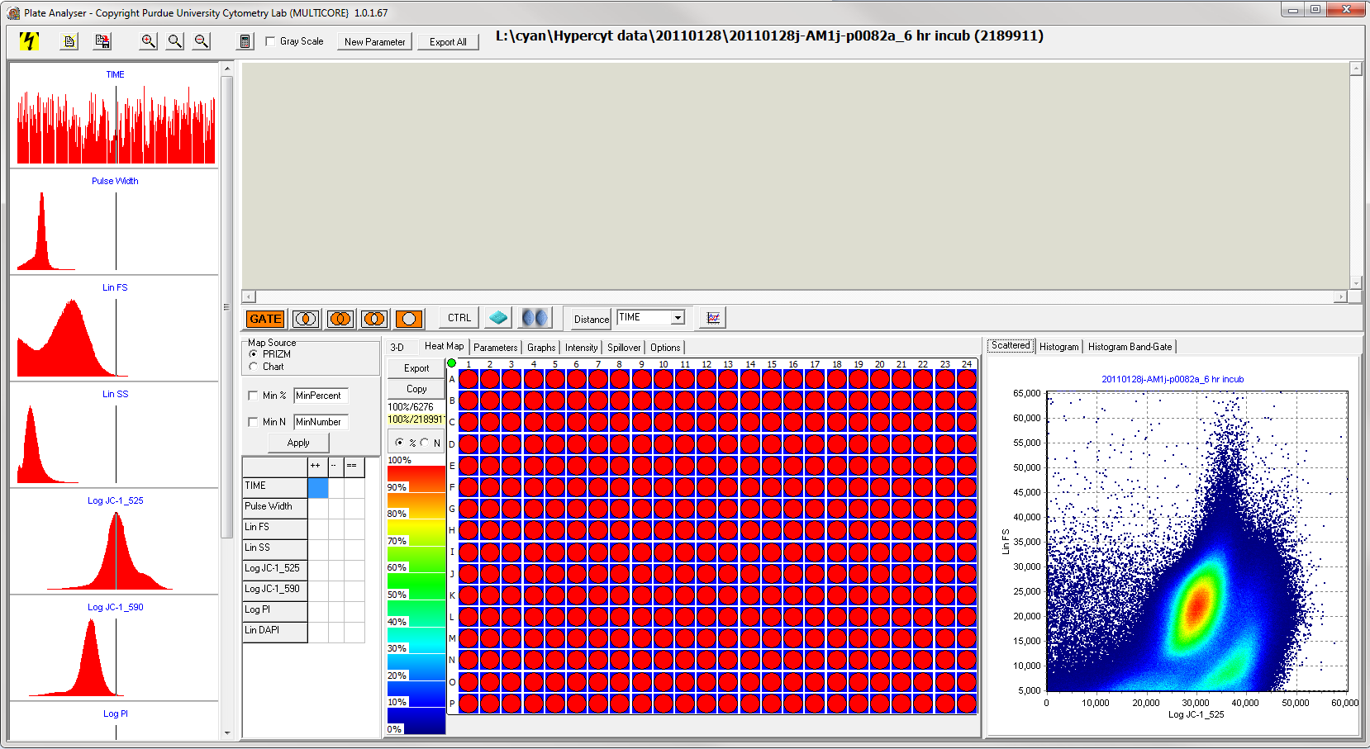

  - Left click multiple times on the scatter plot to draw a loop around normal cells. Right click to end the loop.
  - A mini scatter plot with the gate should appear.

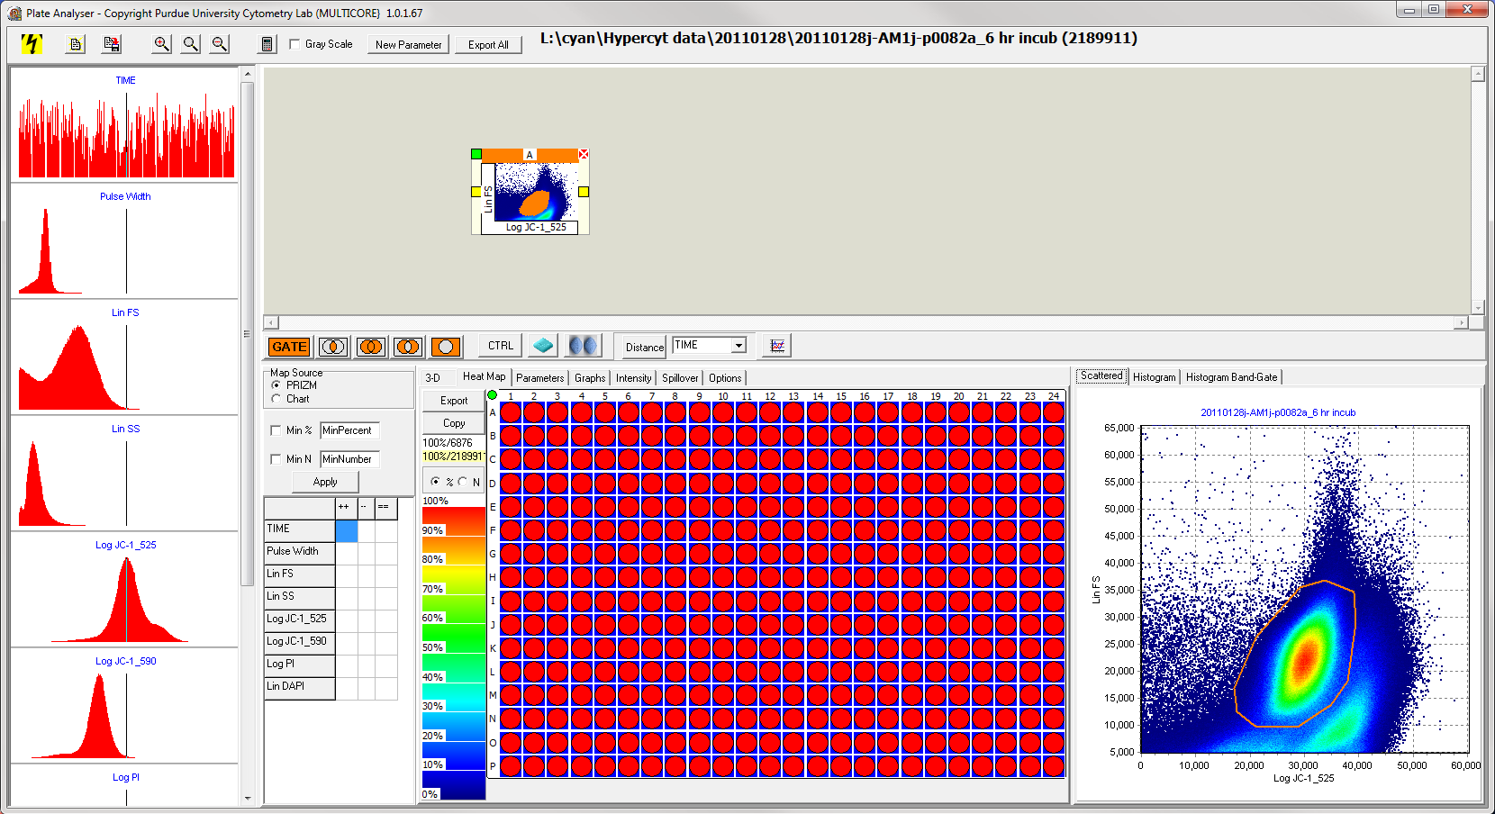

- Drug containers represent the locations of drugs on the plate. If a premade drug container has not been built, proceed to Step 8. To load a premade drug container:
  - Select the icon depicting two pills located to the left of the “Distance” button. A box will appear.

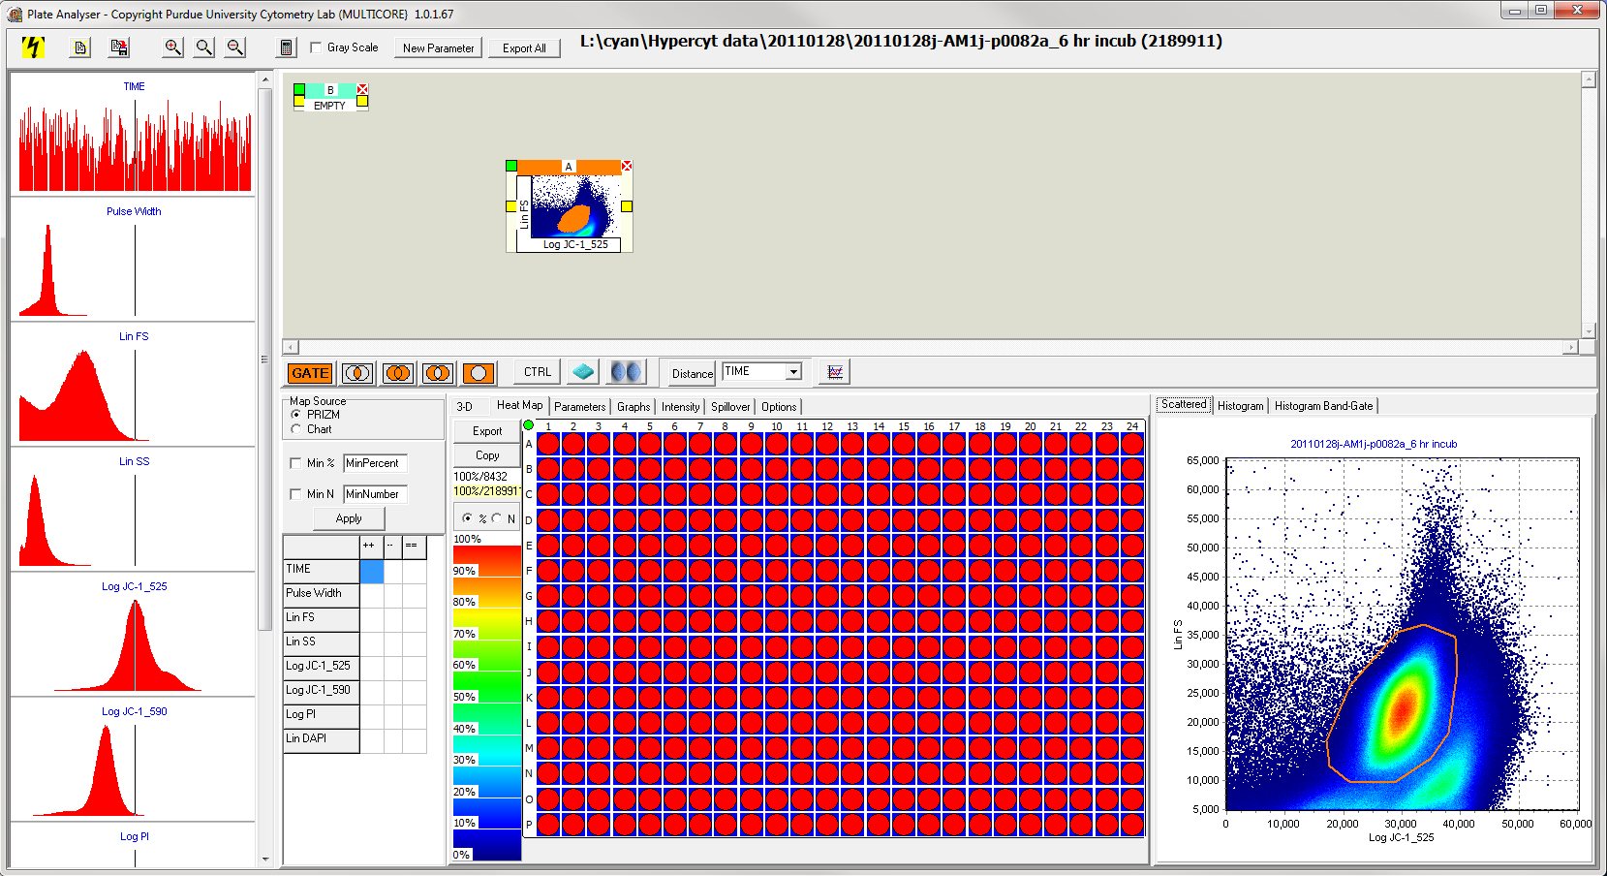

  - Right click on the green square on the upper left of this box, and select “Load.”
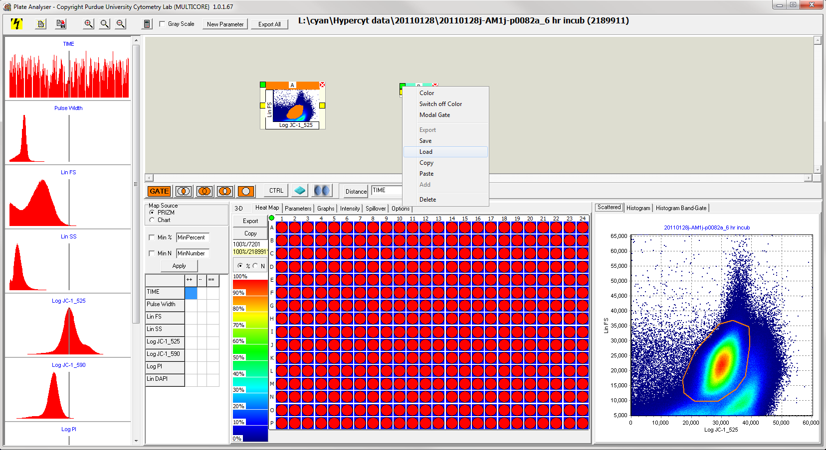
  - Choose the .gat file corresponding to the desired drug container. Premade containers are saved: L:\cyan\Amgen documents
    - For Amgen, load 4 boxes:
controls 1-16
controls 17-32
normal- drugset 1-16
normal – drugset17-32
  - The drug container should appear (it might be necessary to use the scroll bars to find the container).
  - Connect all the drug containers to the mini scatter plot (JC1) or the histogram (redox).
  - Select the plot button.
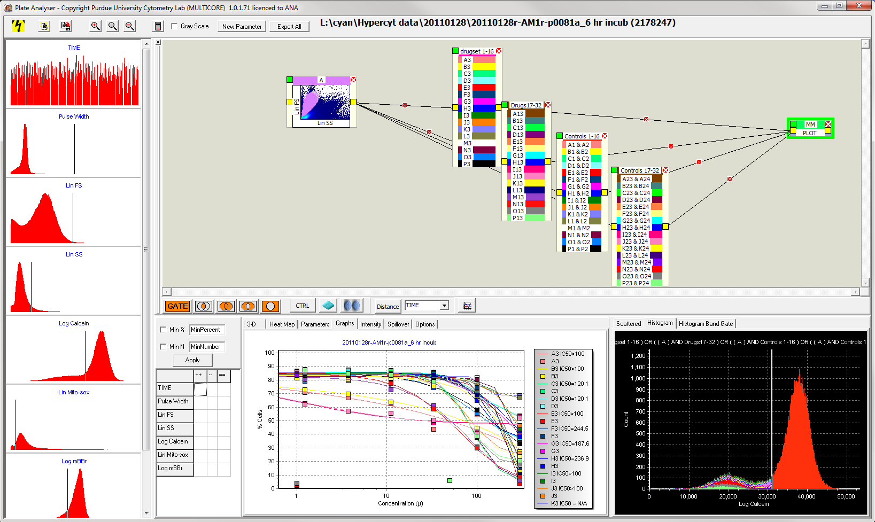
  - Connect the four drug boxes to the “plot” box.
- If a premade drug container has not been built:
  - Select the “Heat Map” tab to the left of the “Parameters” tab.
  - Click on the icon of two pills to the left of the “Distance” button.
  - Click on the box that appears, where it says “Empty.” The box should be highlighted in green.
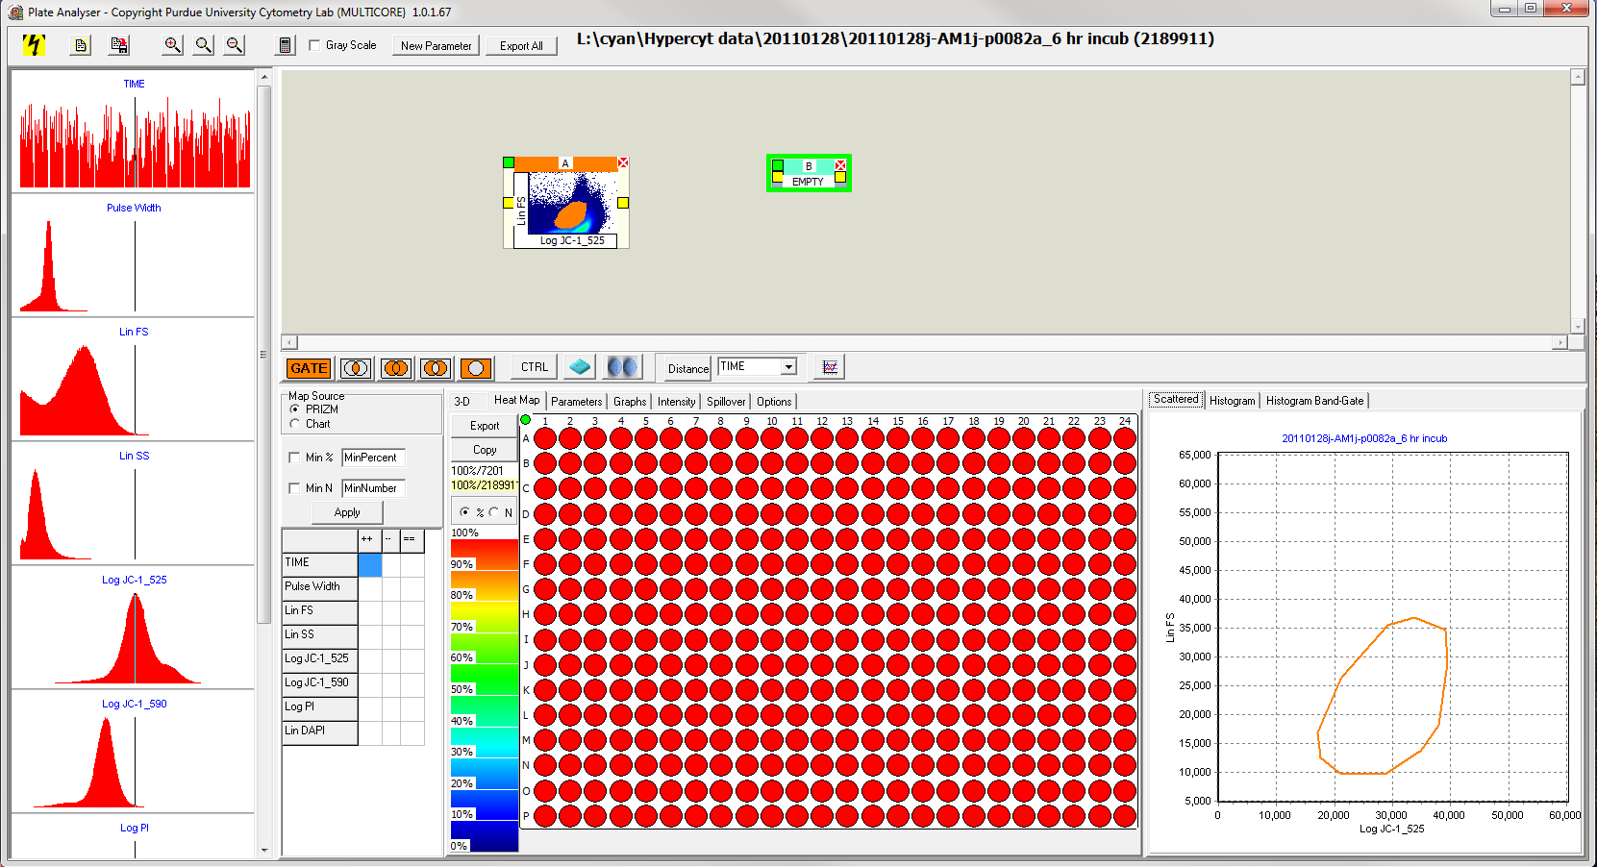

  - Drag the mouse to select the wells on the 384-well plate which correspond to one drug. Alternatively, select one well, press and hold “ctrl” and click on additional wells to be included as one compound.
  - After selecting one compound, click the drug box icon to the left of the icon of two pills. This will add the selected compound to the container.
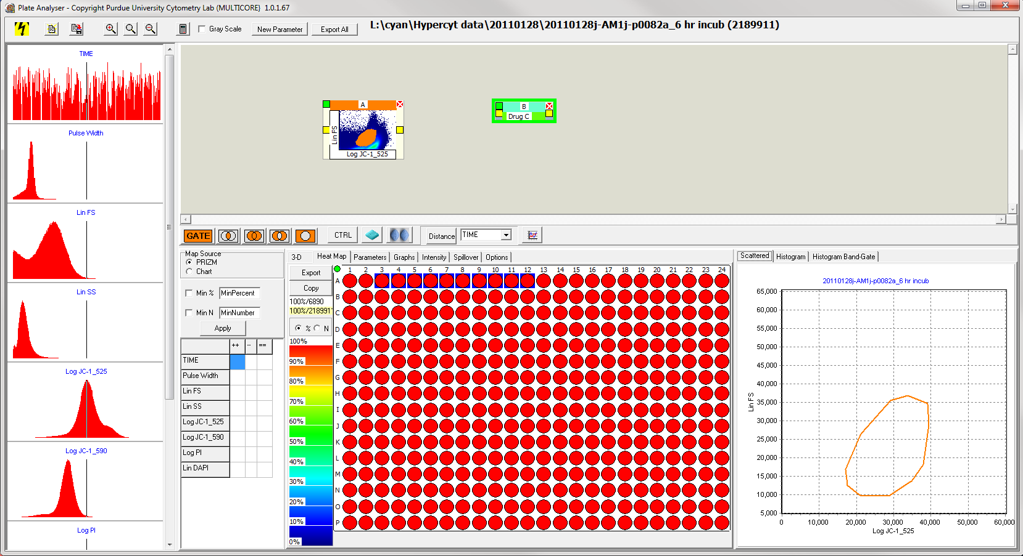
  - To change the name and color corresponding to a specific compound, double click on the drug box to get the “Drugs” window. Double click on the drug in the “Drugs” window to rename it or change the color. When finished, click OK or pres Enter.
  - Repeat steps 7d – 7f until all compounds have been added.

NOTE: It is recommended to not place more than 16 compounds in the same drug container so that it is easier to look at the plots.

- For plates with multiple assays (redox), proceed to step 10.
  - For plates with one assay (JC1), draw a connecting line between the mini scatter plot and the drug container. (Left click on the yellow square on the right side of the mini scatter plot, hold the mouse, drag to the yellow square on the left side of the drug container, and release the mouse.)
  - Skip to step 11.

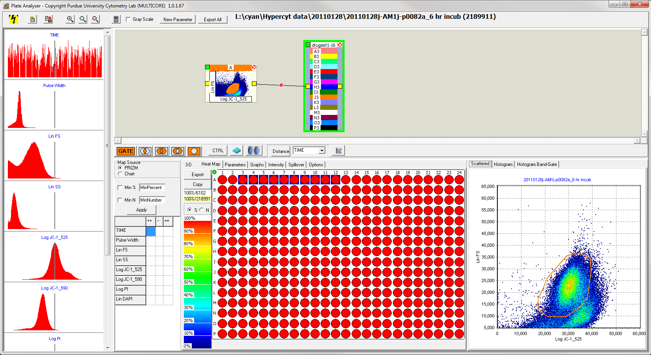

- Only for plates with multiple assays (redox), additional gates are required to analyze effects of the individual assays. To create a one dimensional gate from a histogram, use the panel of histograms on the left of the Plate Analyzer window.
  - Set the vertical threshold bar to separate the normal and abnormal cells for the desired histogram.
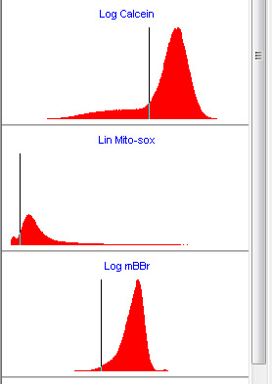
  - Select the “GATE” button and left click on the side of the histogram associated with the normal cells. A mini histogram should appear.

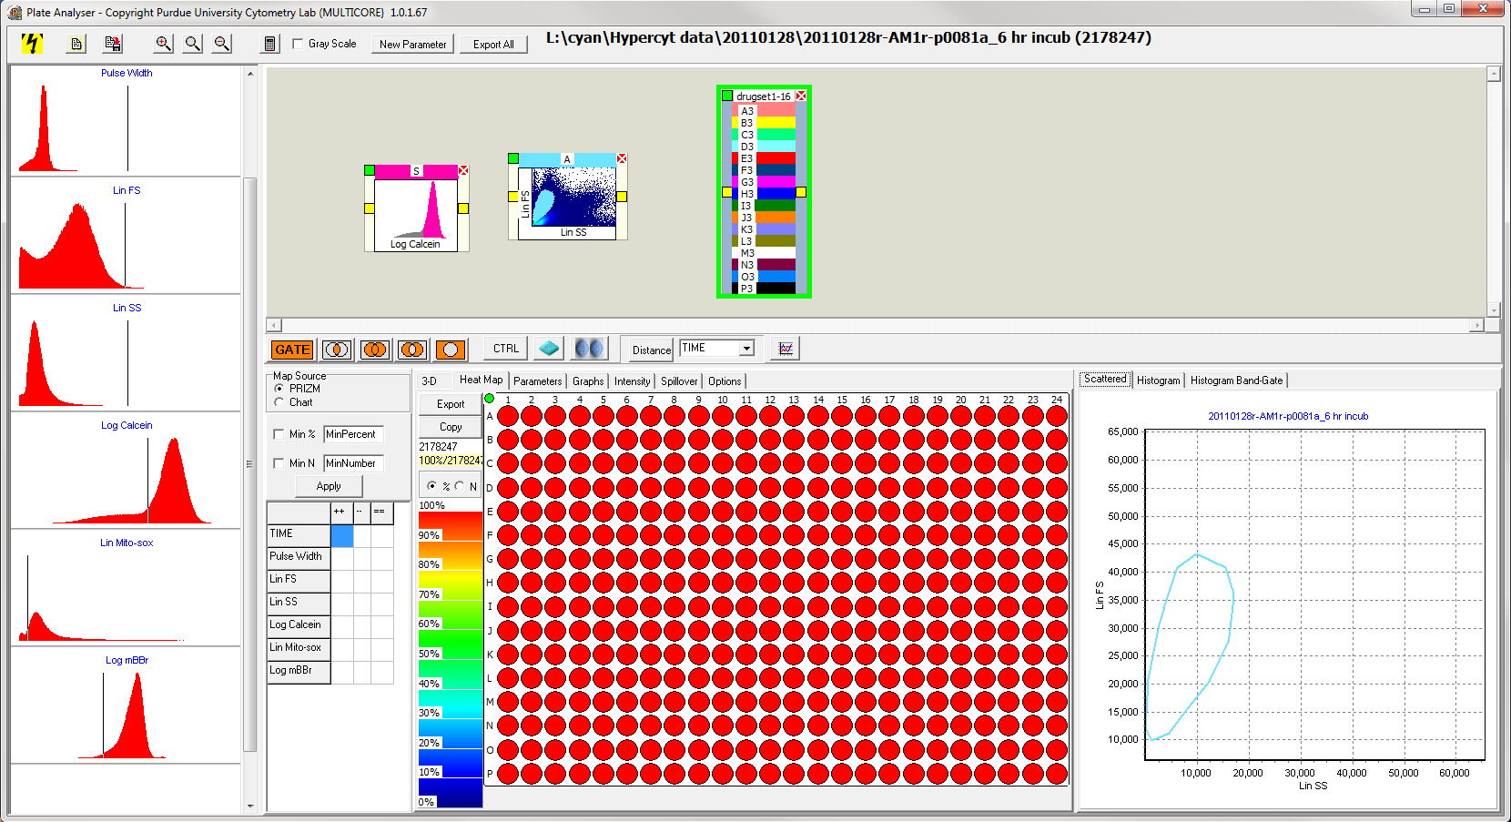
For calcein, click somewhere on the right side of the vertical bar.

  - Draw a connecting line from the first mini scatter plot to the mini histogram.
  - Draw a connecting line from the mini histogram to the drug container one at a time for calcein, mitosox, and mBBr. Make sure to disconnect the old one if switching to a new histogram.

NOTE: The placement of the vertical bar in the histogram in the lower right does not affect the placement of the vertical bar on the left panel.
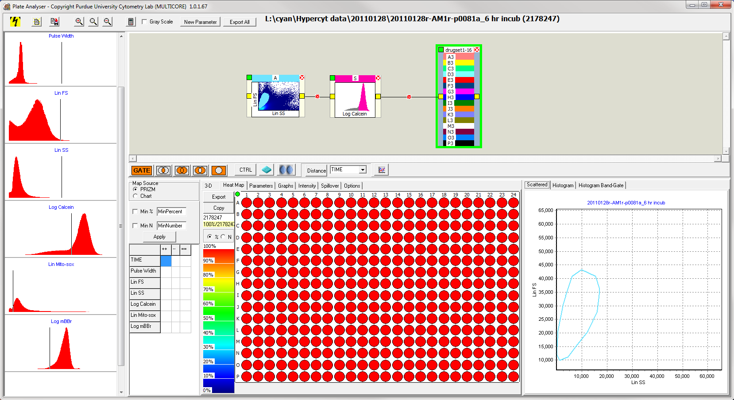

- To plot the dose response, select the drug container (in the center where the drug names are). Then, select the “Graphs” tab.
Note: If a graph of curves does not appear, click on the mini scatter plot, then click on the drug container again.
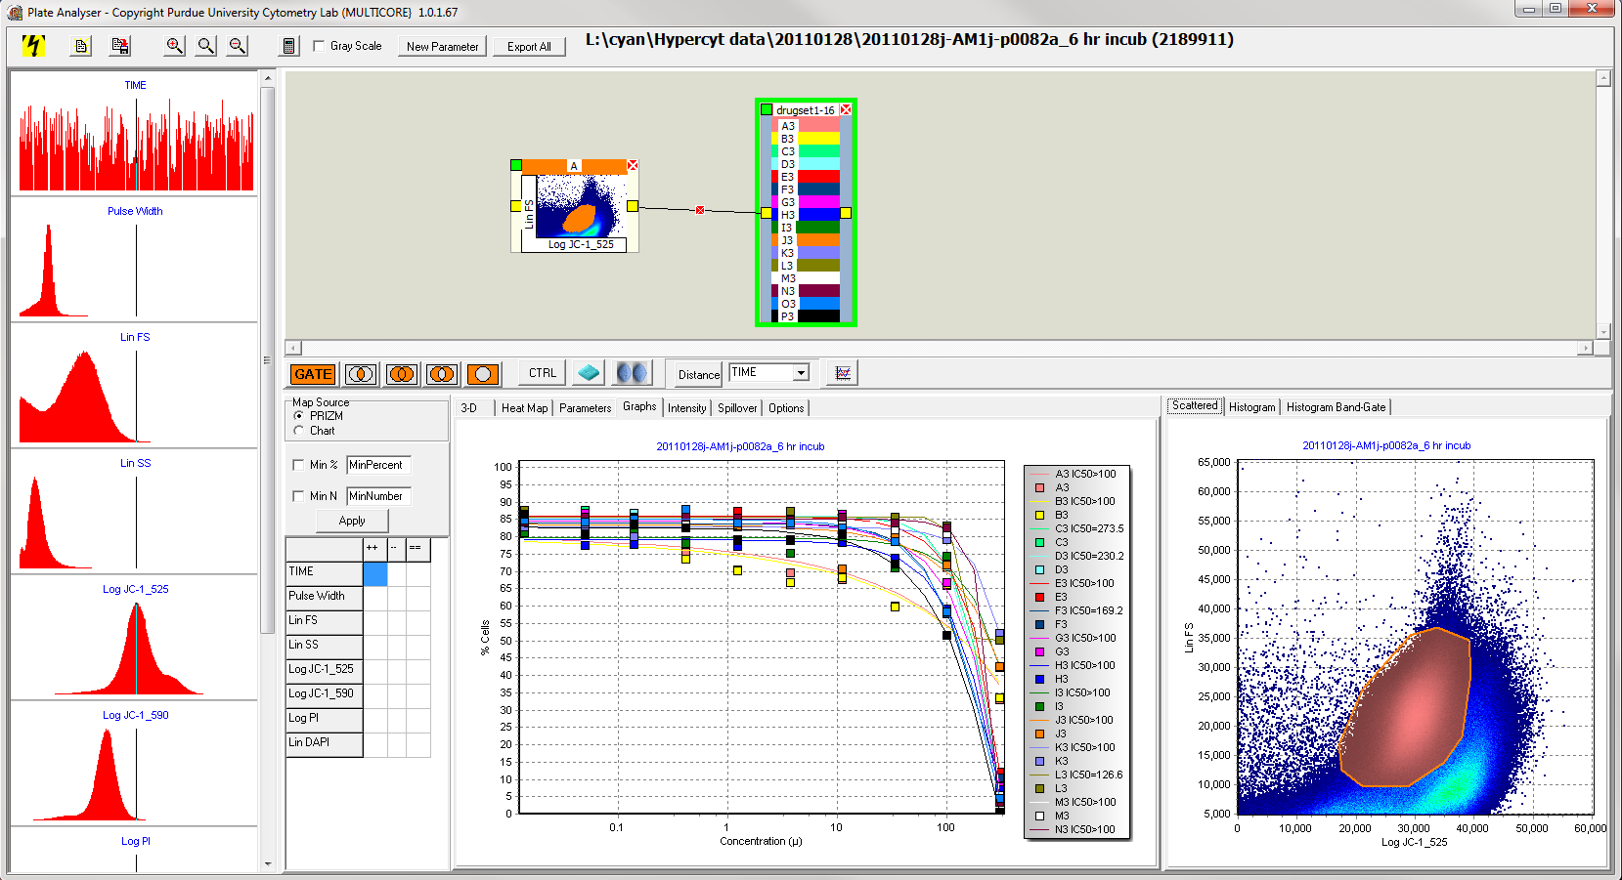

- To export data, right click anywhere on the graph. Select the “Export” icon. Save to the desired directory. Amgen data is saved to the same directory as the fcs plate files.
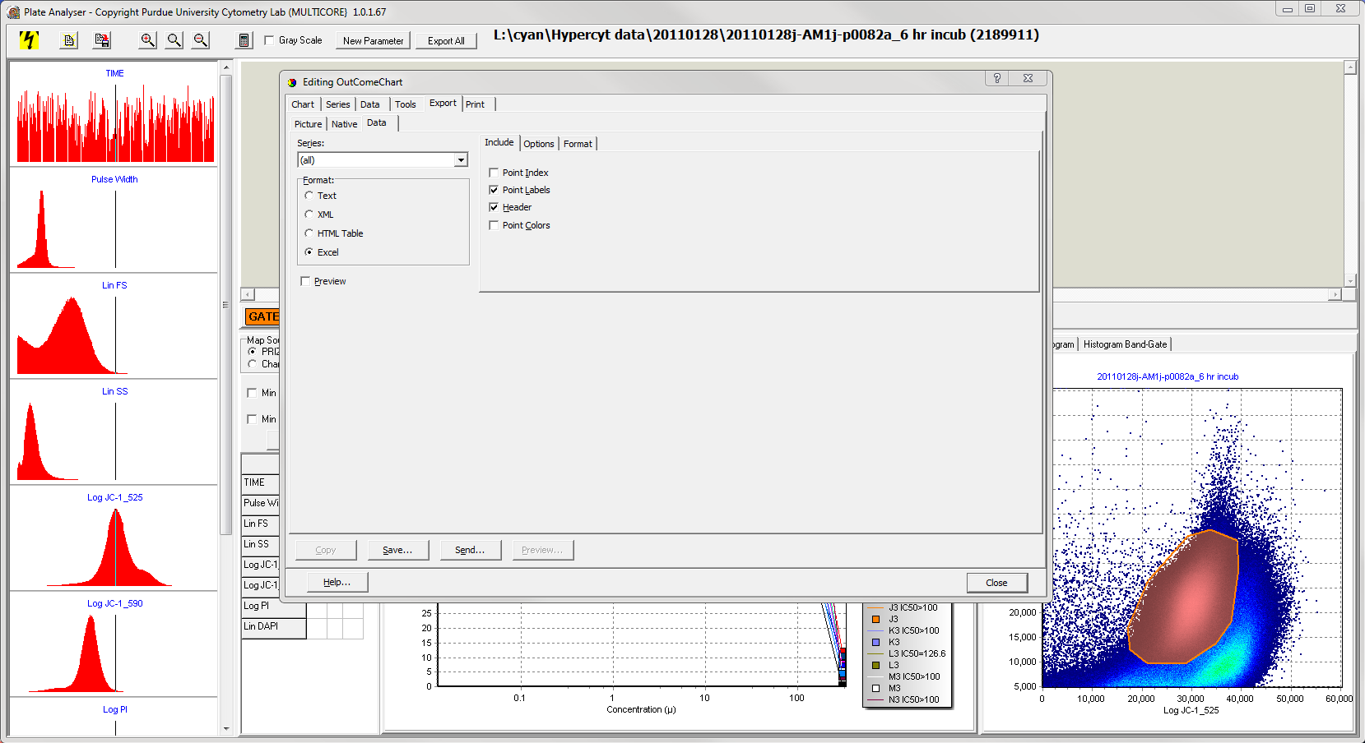

After exporting, click “close.”

To organize data into the format that Amgen wants
*Note: this step must be done from the computer where Nicole usually sat (that is where the macro is saved)
- Open the excel data sheet created in step 12.
- In the first column of numbers, select the “x”.
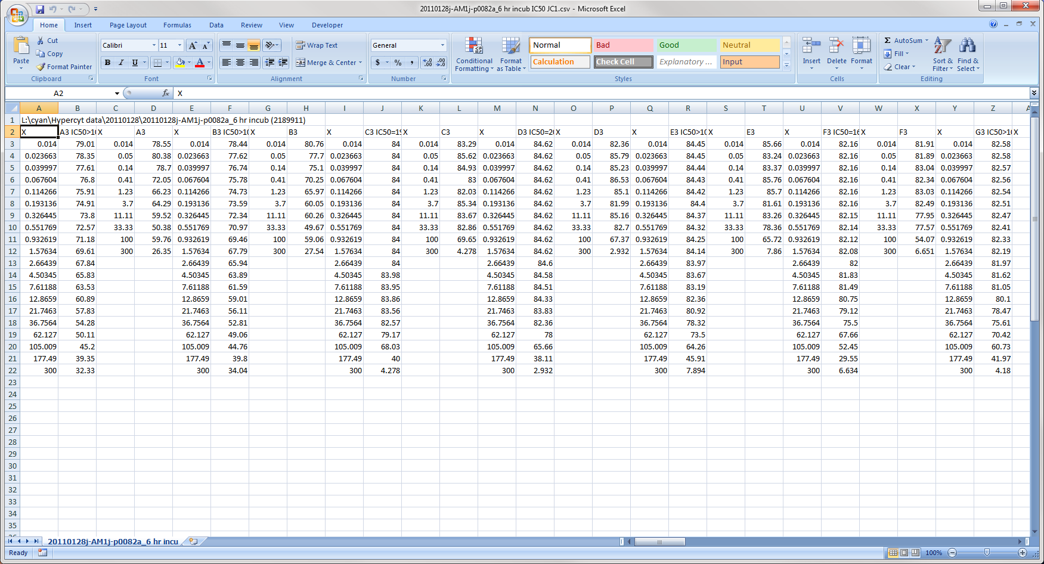

- In the excel menu, select the developer tab.
- Under the developer tab, choose “macros.”
- In the macro window that appears, double click Sorting4.
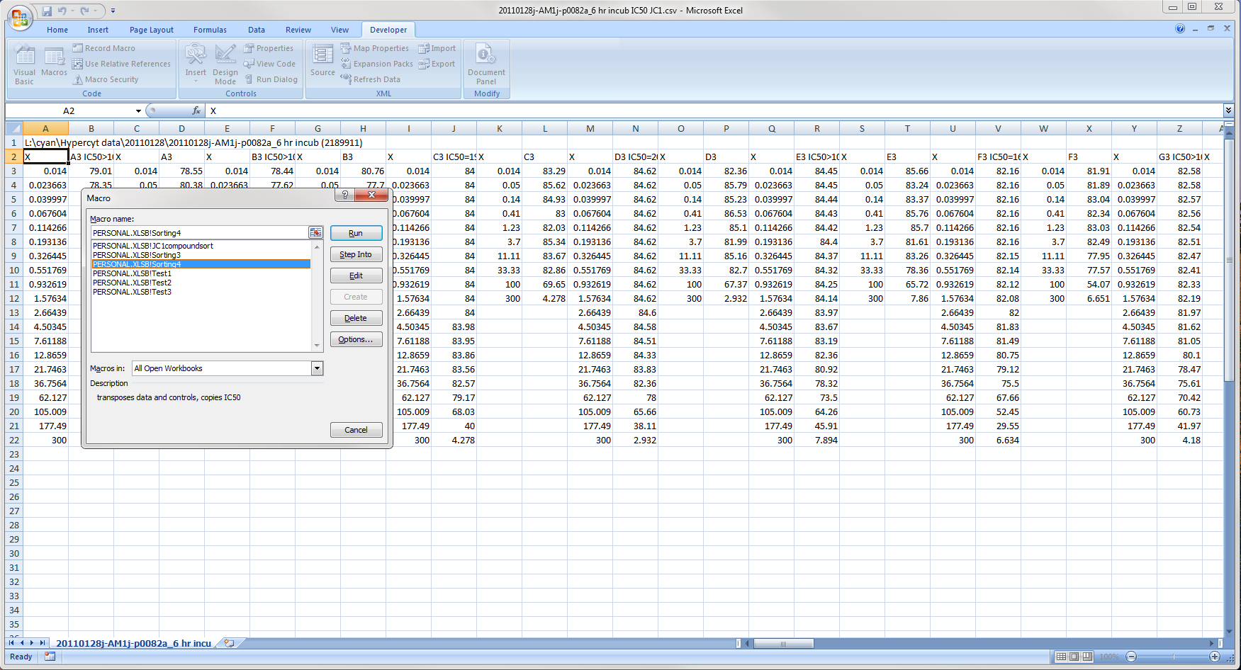

- In the Microsoft visual basic window, select end.
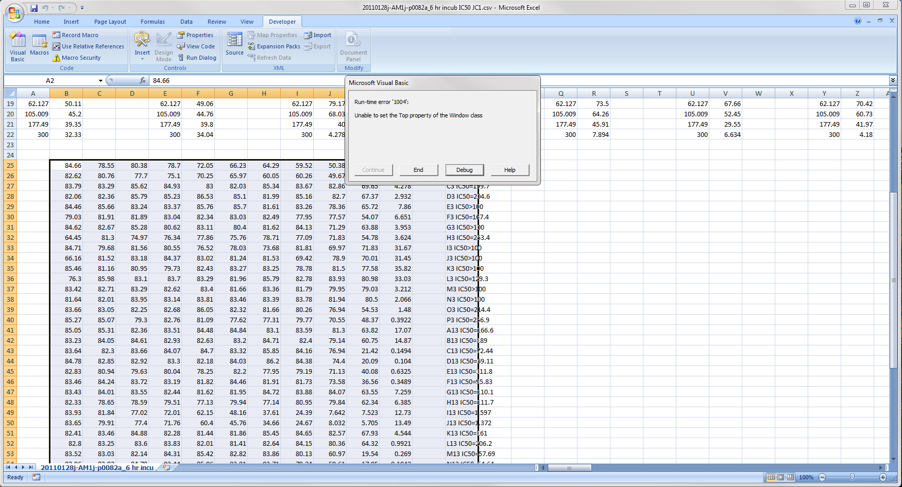

- The data is now copied in the desired format.
- Paste the data (ctrl + v) into the compound list to be sent to Amgen. An example compound list is provided: lab (L: ) \ cyan \ JC1 example Amgen Report Sheet. It is important that the same exact format is used (paste into column H, and leave 3 lines between each plate).
- Save the Amgen report sheet as “JC1,” “Calcein,” “mitosox,” or “mBBr.”

To create KS Distance response curves and export response data:
- Follow steps 1-5 in the dose response protocol above.
- In step 6 of the dose response protocol, the gate will be drawn around the outside of the scatter plot to include all cells.
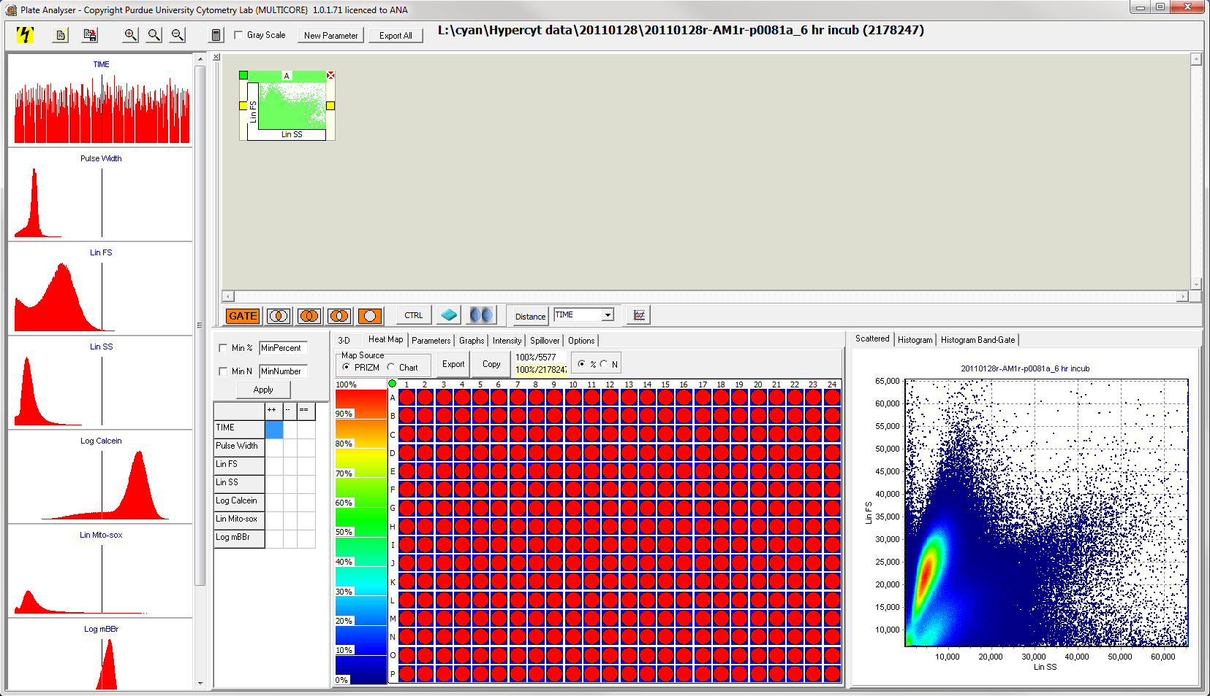

- Create the drug boxes but not controls as in steps 7-9 of the dose response protocol above. Do not make the plot connector yet.
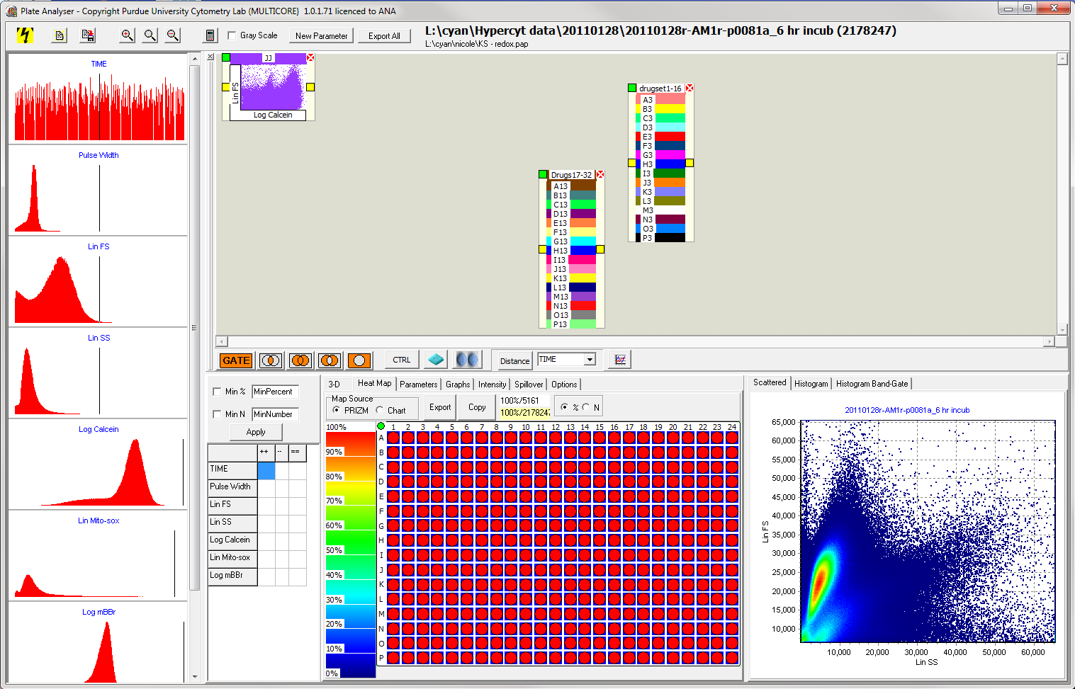

- For a redox plate, create a gate similarly as in step 9 of the dose response protocol. Instead of setting the threshold between normal and abnormal cells, set the threshold all the way to the right. Then, draw connecting lines between the mini scatter plot, the mini histogram, and the drug container.
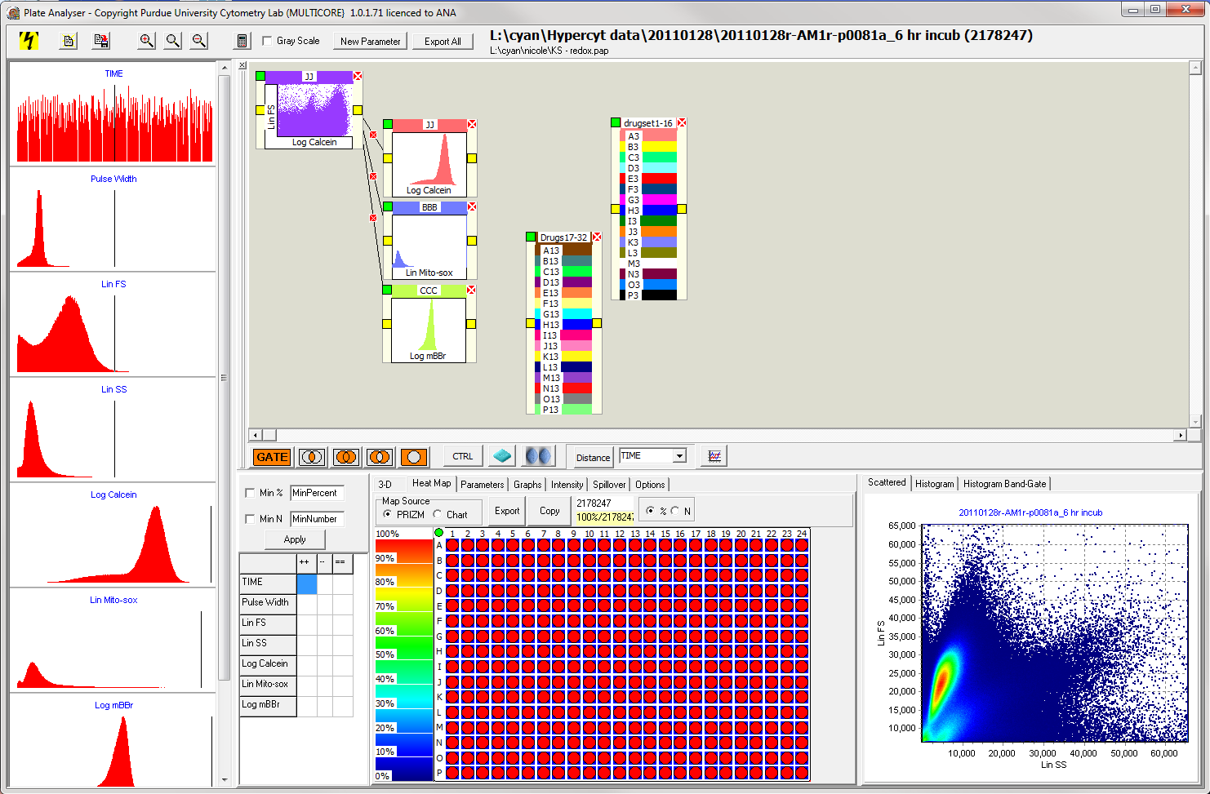
- Create a logic gate (the one with the two circles filled in).
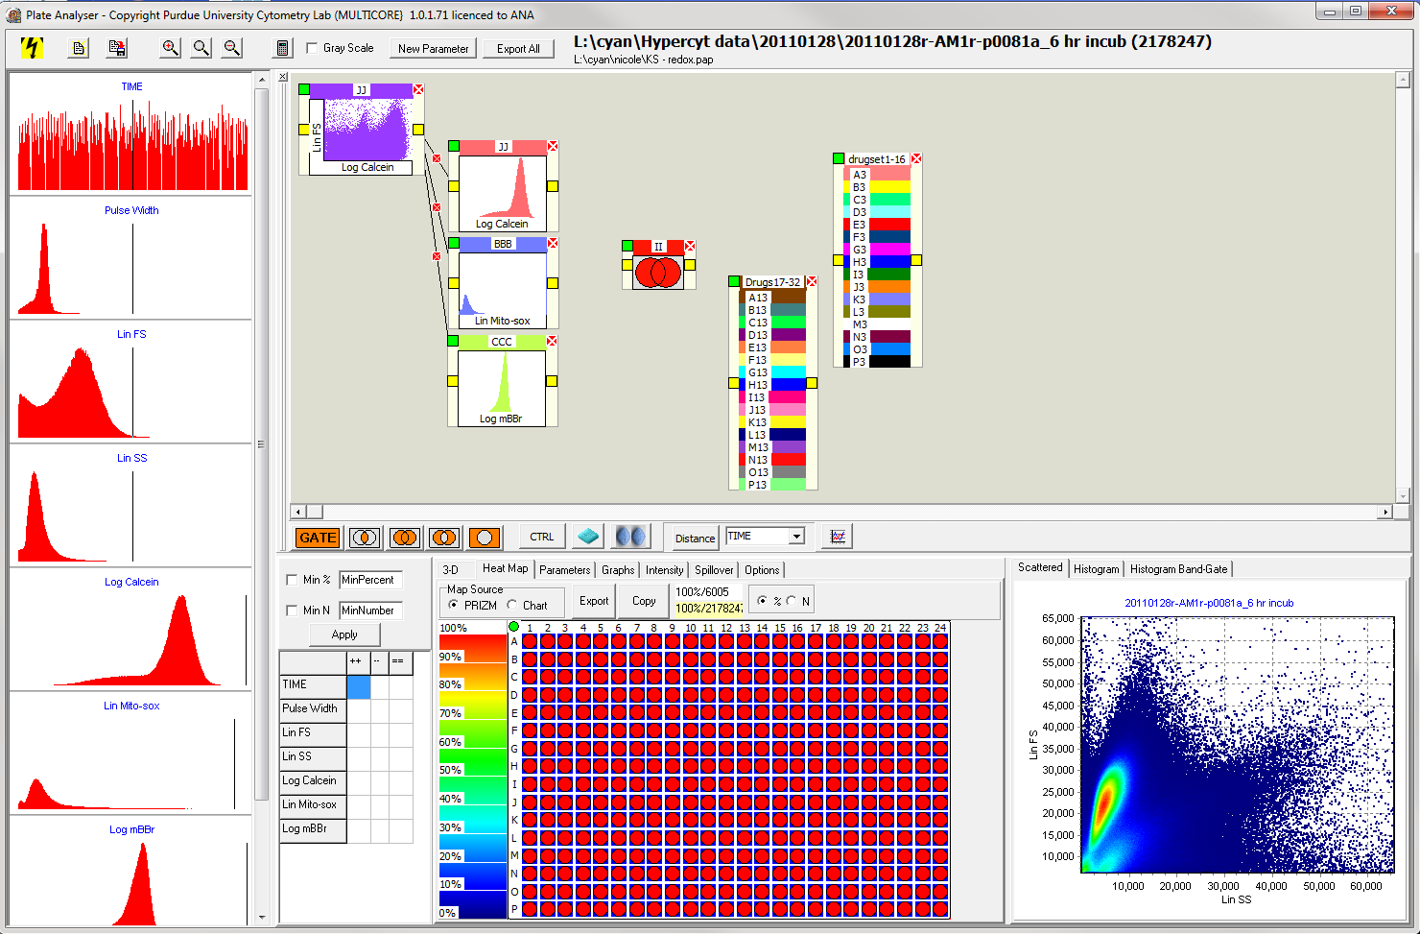

- Connect the logic gate to the two drug boxes.
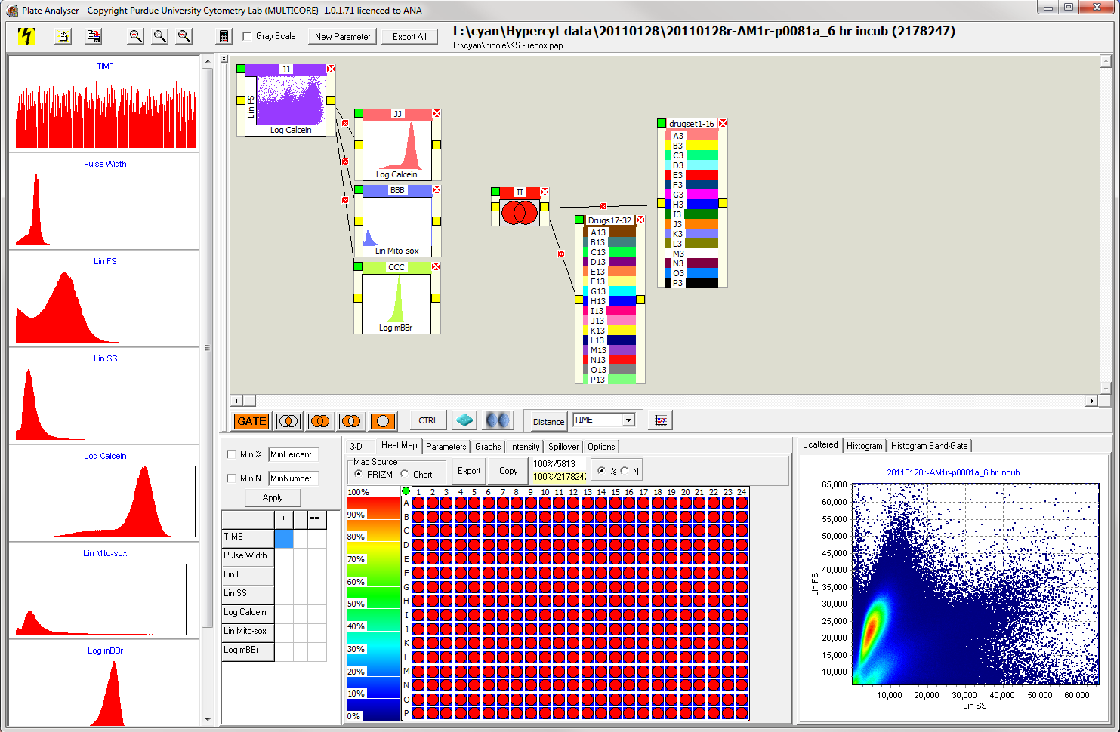

- Create a control by highlighting the wells (e.g. A1, A2 or B1, B2, etc.) of normal untreated cells on the 384-well plate under the “Heat Map” tab. Then, select the “CTRL” button. A new box should appear and can be given a descriptive name by right-clicking where it says “control.”
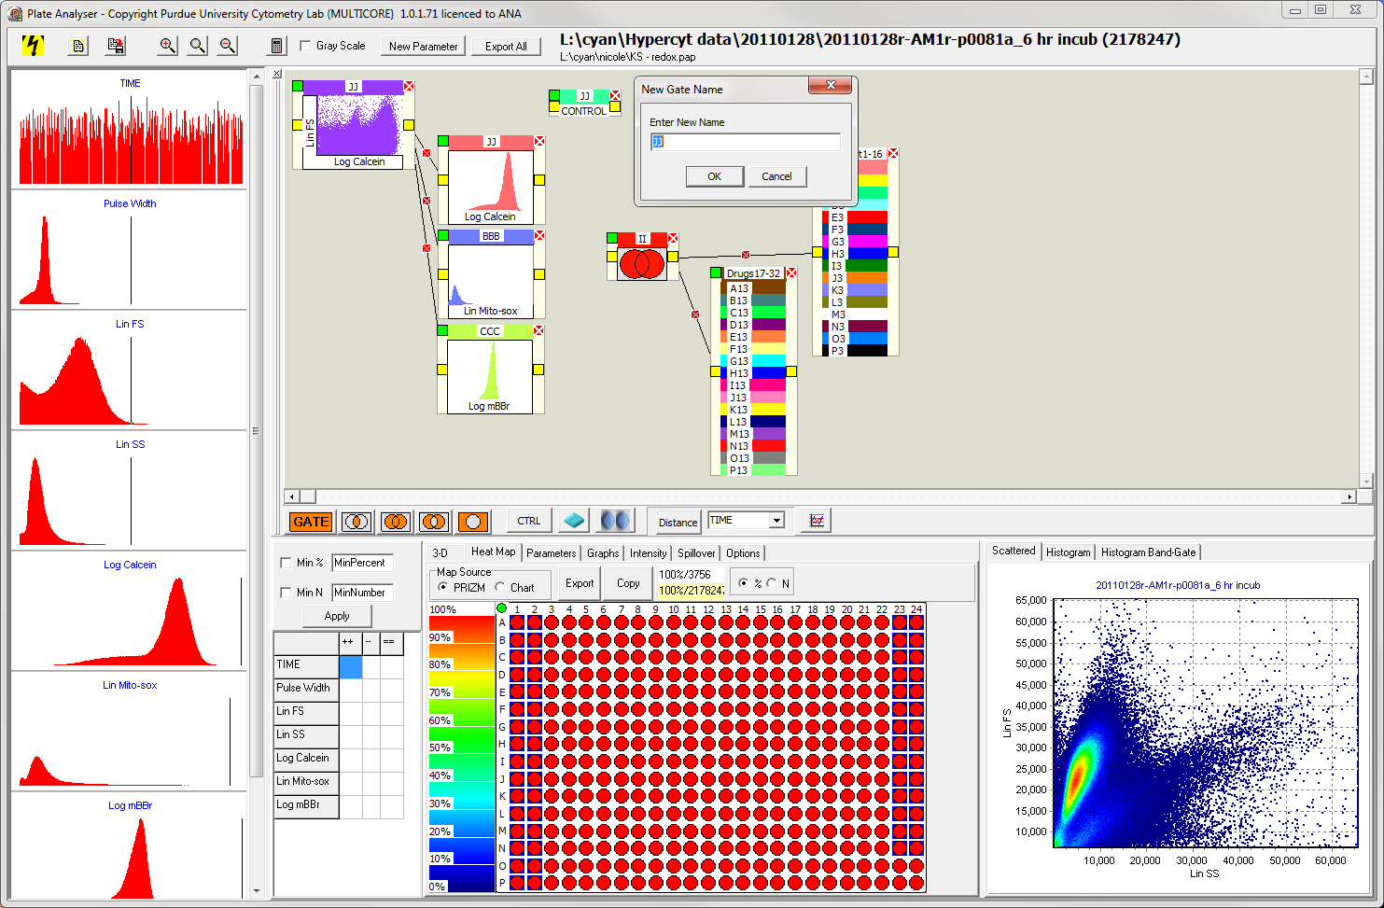

- Draw a connecting line from the mini scatter plot to the controls box.
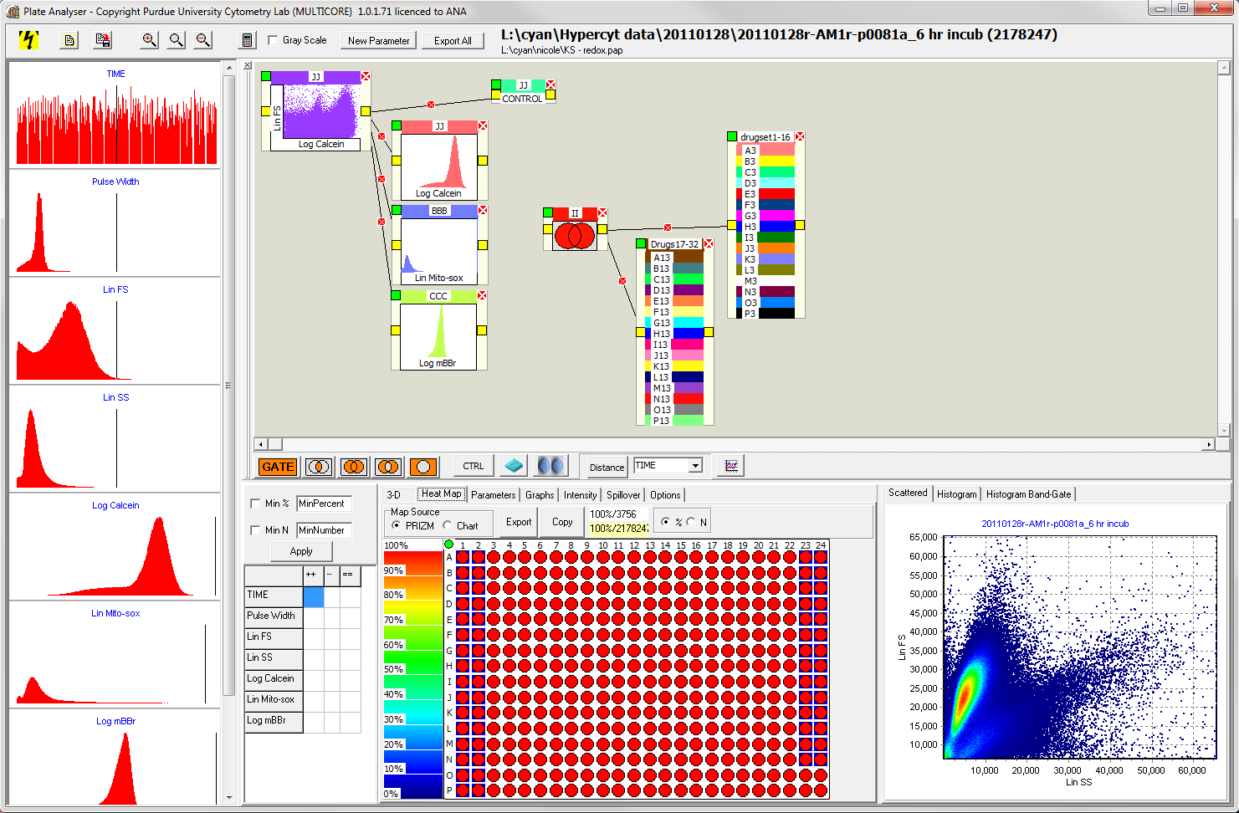

- Select the distance measure of interest from the “Options” tab. Select the desired parameter and press “Distance.” A box should appear and can be given a descriptive name.
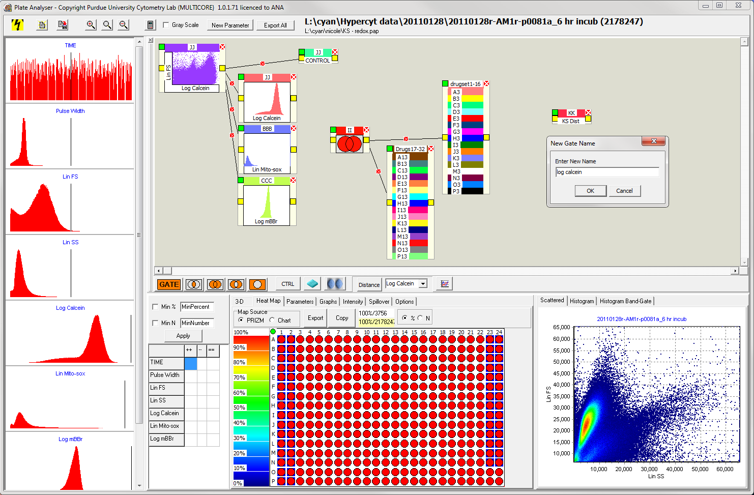
- Draw connecting lines from the control to the distance box and from the drug container to the distance box.
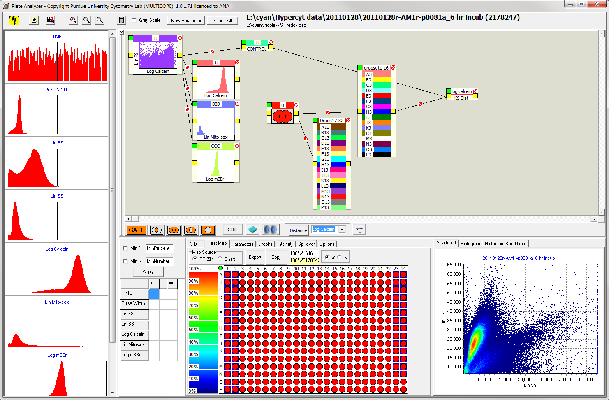
- To see KS distance response curves, click on the distance box so that it is highlighted in green and select the “Graphs” tab.
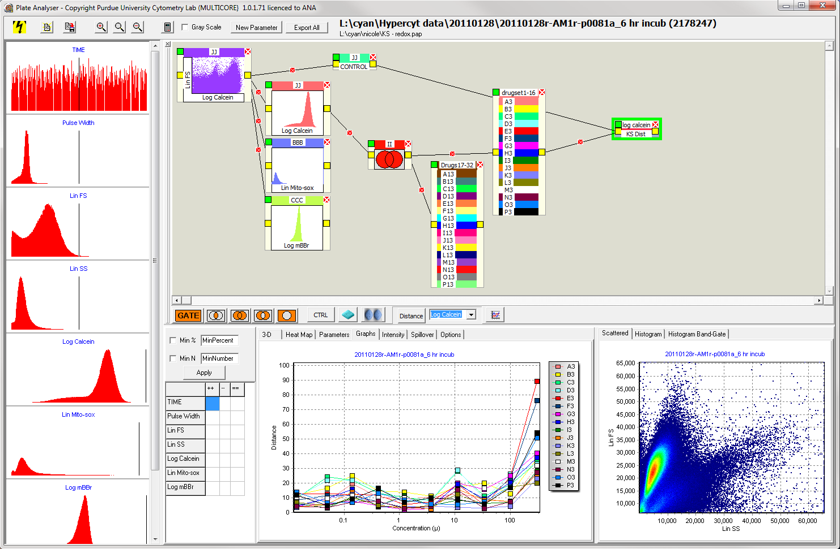

  - Only one drug box can be connected to a single distance box.
  - Distance boxes should be made for each parameter that is wanted for analysis (could be a combination of FS, SS, calcein, mBBr, mitosox, etc) for each drug box.
  - The plot connector can be used to plot all KS distances on the same graph.
  - A final protocol might look like this:
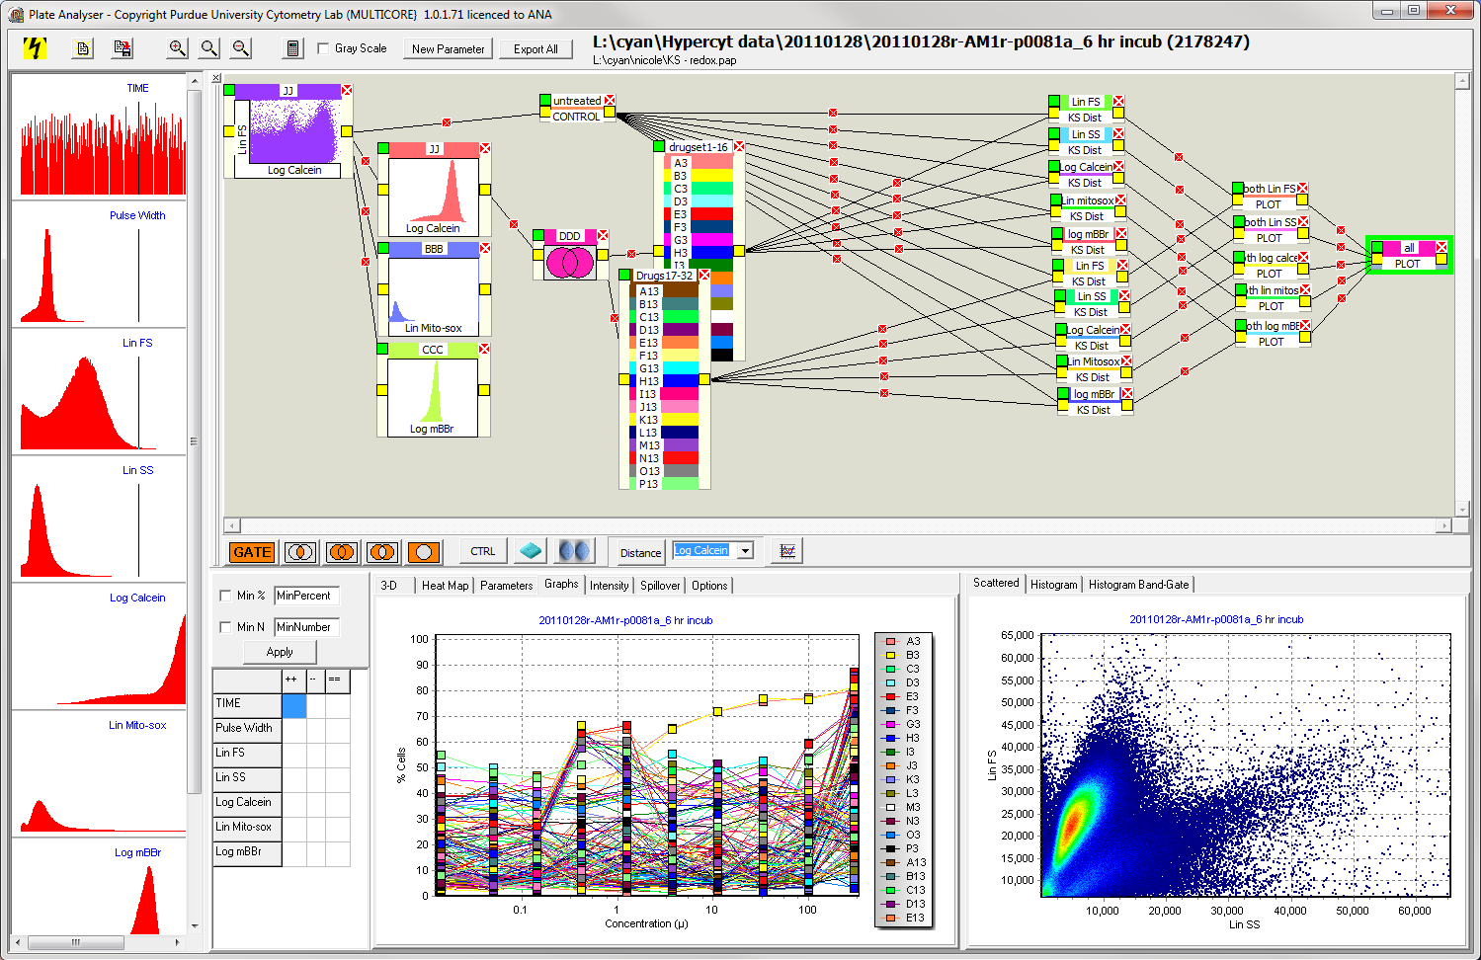

- To export data, right click anywhere on the graph. Select the “Export”. Save to the directory containing the fcs files for the plate.
- All Amgen files are in L:\cyan\Amgen documents

------------------------------------------------------------------------------------------------------------

Created by: Nicole Lewis Date: October 18, 2010
Updated Date: 07/06/2011

Verified by: Date:
Sign Name
Print Name

