BEAM
SOP-S008

BEAM User Manual version 2.0

File Location: Macintosh HD:Users:wombat:OneDrive - purdue.edu:Doclu Software folder:User manuals:BEAM manual:BEAM User manual_Mar_2016-v5-EBae.docx

Prepared by
E.Bae & JP Robinson
June 2016
NOTE:
Baclan software is the analysis software provided with the BEAM
Bugbuster software is the data collection hardware for the BEAM
Contact Information

Purdue University

School of Mechanical Engineering Dr. Euiwon Bae ebae@purdue.edu
585 Purdue Mall West Lafayette, IN 47907
765-494-5688

College of Veterinary Medicine Dr. J. Paul Robinson jpr@flowcyt.cyto.purdue.edu
625 Harrison Street, West Lafayette, IN 47907
765-494-0757

File location:Macintosh HD:Users:wombat:OneDrive - purdue.edu:Doclu Software folder:User manuals:BEAM manual:BEAM User manual_Mar_2016-v5-EBae.docx

Table of contents

Contents
1. Overview 5
1.1 Development history of the elastic light scatter system 5
2. Operating the BEAM Instrument 7
2.1 Plan your experiment and barcode print 7
2.2 Basic layout of the Graphic User Interface 10
2.2 Using database options 24
3. Classification by Baclan Software 29
3.1 Training and building the library 32
3.2 Classification 36
4.1 Operation of the remote monitors 39

List of figures

Figure 1. Two prototypes of the first generation system. 5
Figure 2. Prototype of BEAM system showing two detection stations (right and left) and a central light illumination. 6
Figure 3. Flow chart to print the barcode labels for the sample plates. 7
Figure 4. Screenshot of the barcode printing program and its functionalities. 8
Figure 5. Screenshot of the database input. Detailed information will ensure users can easily locate their experimental data when they have large numbers of datasets to search. Entry into this database should be detailed and deliberate as these become the metadata for all experimental datasets and all these fields can be used to search for or select datasets. 9
Figure 6. Overview of the main graphic user interface for Bugbuster program. 10
Figure 7. Multi-window options for Bugbuster. This option allows users to access more detailed control of the individual scanning arms (left and right) and also various experimental parameters. 12
Figure 8. Screenshot of the individual stage controller interface. 13
Figure 9.Scatter patterns preview panel. 15
Figure 10. Colony locator preview panel. 16
Figure 11. Example of Colorifying: (Left) before (Right) after Colorifying. 17
Figure 12. Example of regular (left) and HDR image (right) of the identical colony. Weak signal on the outside rim region is more amplified in the HDR images while there are some speckle noises that can be observed. This function is useful when the colony is optically opaque and you still want to observe the scatter patterns. 18
Figure 13. Control tab. Most of the options can be set as shown. Radius determines the pixel radius of the Petri-dish edges which has a set value of 1400 pixels. 19
Figure 14. Maximum and minimum colony diameter determines the interval of colony sizes that will be captured while the roundness parameter is majorly used to exclude outliers. 20
Figure 15. Colony table tab displays the number, XY location, and roundness parameters. 21
Figure 16. Options tab displays several control options for scatter camera. 22
Figure 17. Calibration tab menu allows a full calibration of the stage of the BEAM. 23
Figure 18. Plate information window to save all the scanned data into the database. 24
Figure 19. Database window. Sub-windows include model and class windows and thumbnails. 25
Figure 20.Screenshot of the Plate Sieve menu. Plate image (left) and scatter patterns (right) are shown. The Red-dot on the plate image corresponds to the particular colony from which scatter patterns are identified. 26
Figure 21. The Left column shows the time point and the red-dot corresponds to the same colony at different time points. When you perform a time-resolved experiment, Plate Sieve is a excellent feature to see how the patterns evolve versus incubation time. 27
Figure 22. Class name window. If you input the class name, data will be saved into the database using this class name. 27
Figure 23. Once you save the data using the save as class icon, we can see that a new class named ‘E.facium PU92’ is shown on the main window. 28
Figure 24. Initial window for Baclan. 29
Figure 25. Class window. You can type the new class name and click “create new class” or click the existing class and open it. 32
Figure 26. Adding a class to Baclan. 33
Figure 27. Adding plate data into a class using Baclan. 33
Figure 28. After adding plate data into a class using Baclan. 34
Figure 29. shows the result after adding two classes (E.coli and Listeria) and each class contains three different experimental data sets (plate scan data). 35
Figure 30. After the training is completed. 35
Figure 31. Screen shot for a test mode. 36
Figure 32. Database control panel. 36
Figure 33. Classification results for Listeria plate. 37
Figure 34. Classification results for E.coli plate. 37
Figure 35. Picture of the remote monitor. 39
Figure 36. Concept of the remote monitor for BEAM. 40
Figure 37. Screenshots that shows the imported plate data which includes colony location and scatter patterns. 41
Figure 38. After scooping up the colony, users can mark the diamond -shaped button to mark them. 42

1. Overview

Development history of the elastic light scatter system

The elastic light scatter system was -born as a prototype light scattering system using a simple laser source on a petri-dish with bacterial colonies. In 2004, with the support from the United States Department of Agriculture (USDA) and the Center for Food Safety and Engineering (CFSE) at Purdue, the first prototype forward-scatterometer was built and provided valuable data for various species of bacterial colonies which confirmed its effectiveness as a non-invasive and rapid identification instrument.
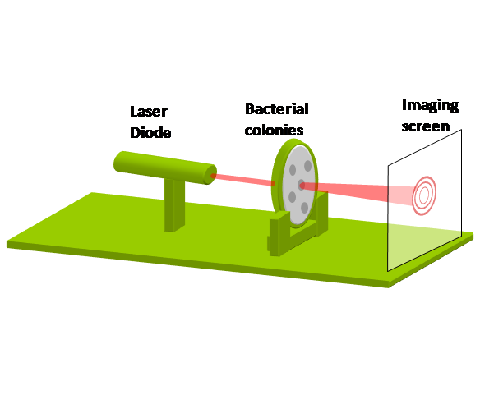
- (b)
Figure 1. Two prototypes of the first generation system.
(a) Initial conceptual realization (b) Semi-automated system

As shown in Figure 1-1, the initial forward-scatterometer provided the results to pursue the next step of evaluating more types of bacterial species. However, the overall system was operated manually without microscopic positioning system which limited the throughputs of the capturing scattering pattern. In addition, the image was taken via a stand-alone digital camera which had limited image resolution. To provide more versatility as with sufficient precision and throughput, we have upgraded the forward-scatterometer with some enhancements.
The instrument operates using a laser diode module of 635 nm wavelength, approximately 1/e² beam diameter of 1 mm and the output power of the operating condition was measured to be 0.7 mW. The Rayleigh range of the beam waist is much longer than the sample thickness of 0.1 mm at the center. Similarly to the previous versions, the latest instrument called “BEAM” is equipped with the 1 mW 635 nm laser diode and two simultaneous reader combinations (gripper and camera). The monochromatic CCD image sensor is manufactured from Basler and has its own thermoelectric temperature control to ensure the lower level of noise
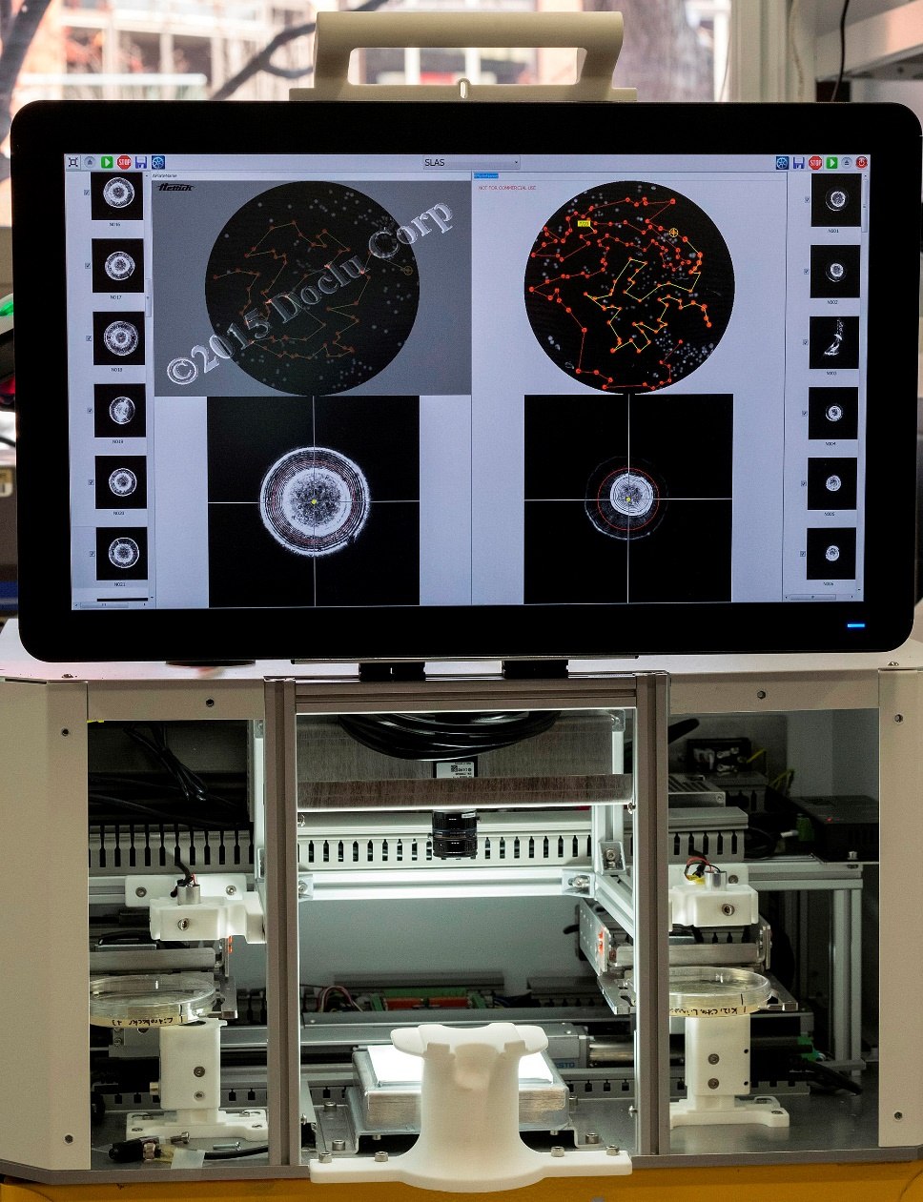

Figure 2. Prototype of BEAM system showing two detection stations (right and left) and a central light illumination.

2. Operating the BEAM Instrument

2.1 Plan your experiment and barcode print
Even before you scan your media plate, you should plan your experiment and type in the as much detailed information as possible to the database system. The first step after designing the experimental layout is to prepare your dishes and place barcode labels on all dishes. The flowchart below describes the overall procedure.
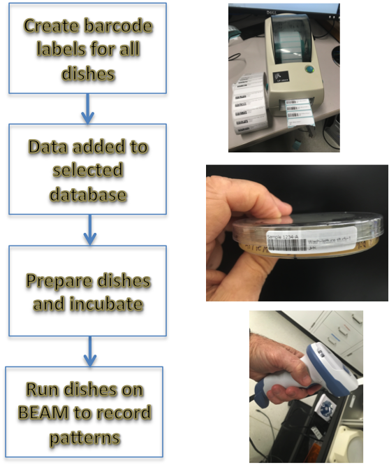
Figure 3. Flow chart to print the barcode labels for the sample plates.
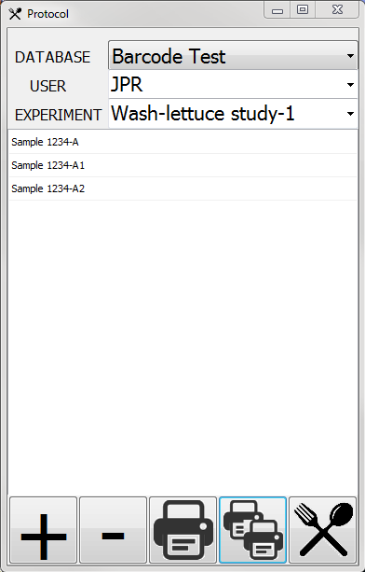 | DATABASE : A user may select a specific database or a common database can be assigned to each group.  USER : Individual user (your name will be here – this is a dropdown of all available names. Be sure to use a consistent nomenclature as JPR is different to JpR or JPR1  EXPERIMENT: Specific experiment title (i.e. antibiotic resistance test, Listeria species test, etc)
 | After clicking  and adding three plate data, the screen will look like the figure in the left.
 | This icon will add a new plate data and barcode to the barcode printing program. Once you click this, Figure 2-3 screen will pop up.
 | 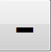 This icon will remove a new plate data and barcode to the barcode printing program.
 |  This icon will print single barcodes.
 | This icon will print multiple barcodes.
 This icon is a utility that allows the user to set up a new database, set up the printer and select either 1D (default) or 2D barcodes

Figure 4. Screenshot of the barcode printing program and its functionalities.

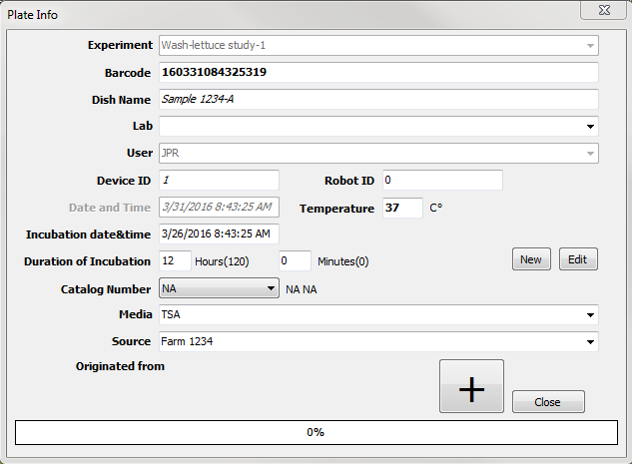

Figure 5. Screenshot of the database input. Detailed information will ensure users can easily locate their experimental data when they have large numbers of datasets to search. Entry into this database should be detailed and deliberate as these become the metadata for all experimental datasets and all these fields can be used to search for or select datasets.

2.2 Basic layout of the Graphic User Interface
All the operations of the BEAM are controlled via the graphic user interface (GUI) panel called Bugbuster or  icon. When the Bugbuster icon is clicked, the program will show the initializing screen and it will open up a user interface such as Figure 2-3.
Control buttons
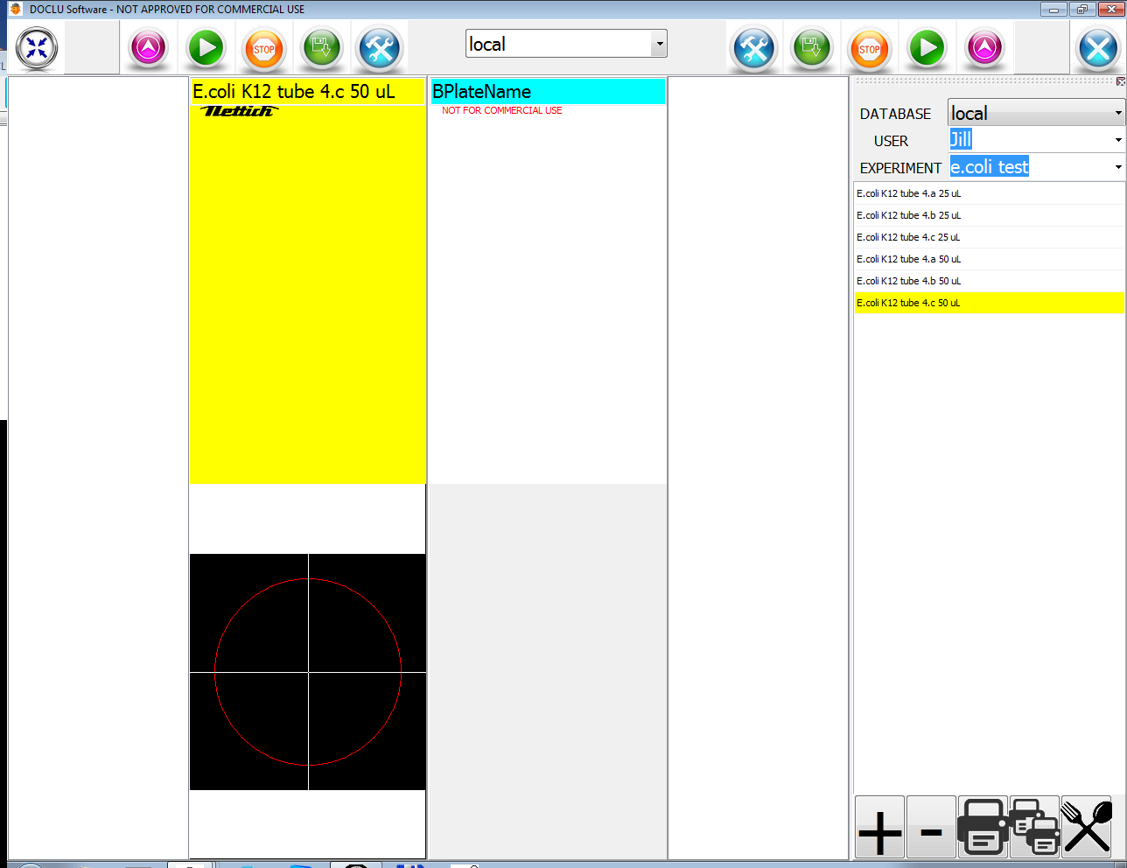
Thumbnail
Image for right
Thumbnail
Image for left
Left unit panel
Right unit panel
Database panel

Figure 6. Overview of the main graphic user interface for Bugbuster program.

Since the BEAM is equipped with dual readers, each side is controlled independently. The left panel has two sub-windows (thumbnail image and plate image) and the same for the right reader. The right most panel is called the database panel and this is the very first step to complete before doing any type of experiments. On the top, there are four large and one small buttons. This panel can be independently operated without the Bugbuster program, but the computer on which it is operating MUST be on a network connection that has access to the SAME database that the user will access when they run their samples on the BEAM.

Table 1. Detailed description of the Bugbuster operation buttons.

Button | Function | Explanation
 | Eject | This icon will call the grippers to come to the plate locating area in the center of the instrument. Since each reader has separate controls, you must click the appropriate eject button to either put your plate in or remove your plate from the BEAM. You cannot operate both sides simultaneously!
 | Run | By clicking this, you will be operating the scanning and scattering features automatically for one side or the other whichever side you selected.
 | Stop | If for any reason you want to stop the BEAM from capturing patterns, you can click this anytime during the operations.
 | Save | This button allows users to save the plate data into the database. The database window will automatically pop up with the pre-filled information you’ve entered from the database panel prior to performing your experiment.
 | Minimize/maximize | This button will fill the windows screen (full screen) or collapse the windows to a smaller screen. This is a toggle.
 | Settings/options | This button will pop up the windows for more advanced options. These options should be selected with great care and significant knowledge. They are not recommended for inexperienced users.
 | Power | Will close down the program

When you run Bugbuster software it will open three separate windows by default.
- Main operators window (Figure 2-3) : this will be the windows most used
- Either clicking the option button or ALT+TAB button, you can navigate to the individual control window of each readers (since dual readers, there are two separate windows)

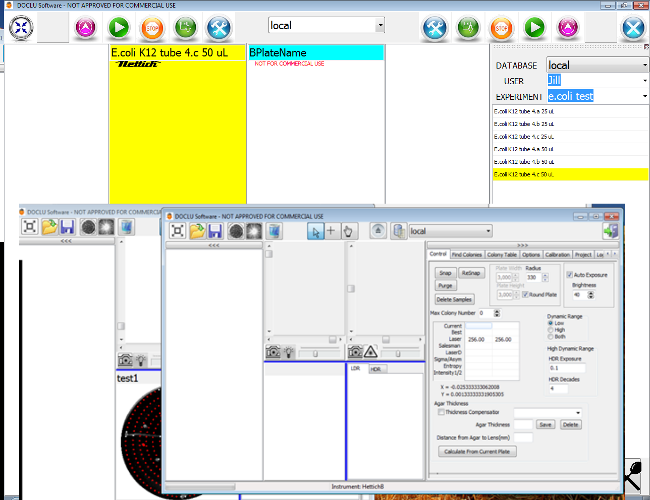
Right arm control
main windows
Left arm control

Figure 7. Multi-window options for Bugbuster. This option allows users to access more detailed control of the individual scanning arms (left and right) and also various experimental parameters.

Main icons
Control and Option tabs
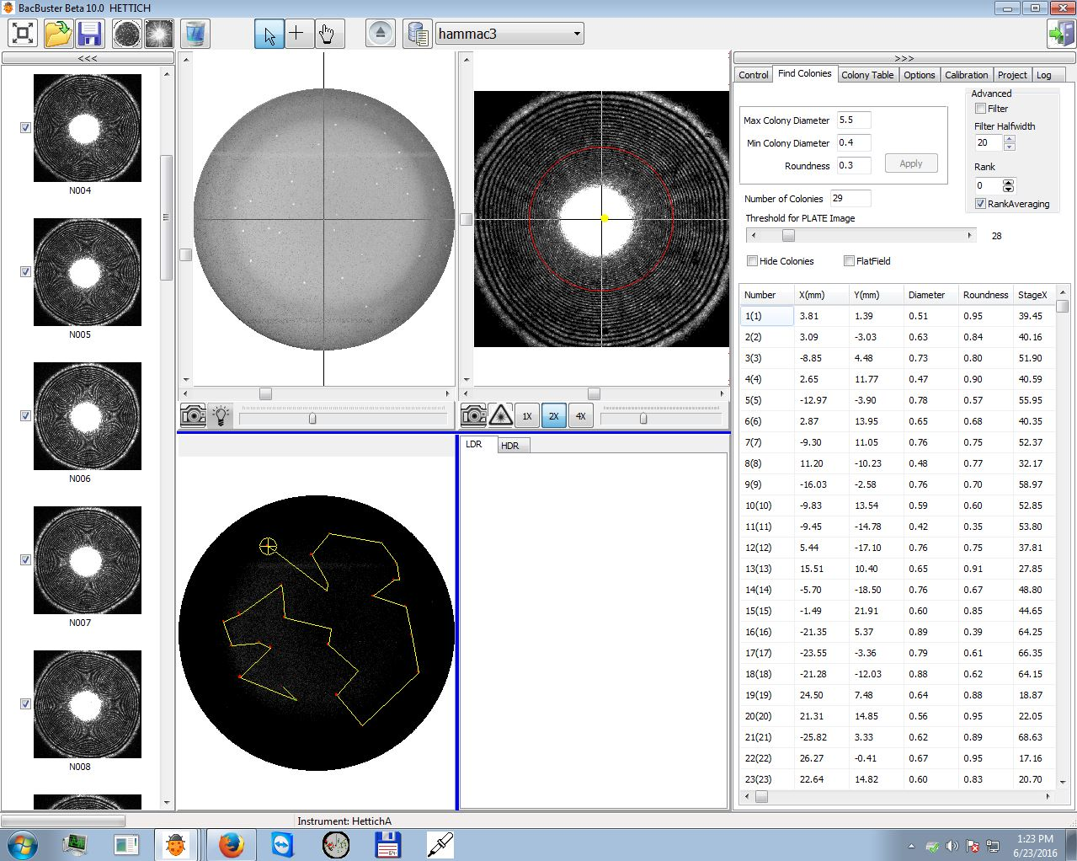
ELS screen
Colony location screen
Captured ELS Patterns

Figure 8. Screenshot of the individual stage controller interface.

The basic structure of the Bugbuster program is divided into four sub-windows and command icons (Figure 2-3).
- Command icons: All Bugbuster menus are either in the tabs or as icons. This panel lists all the most frequently used commands in terms of icons.
Table 2. List of icons and functionalities for the individual stage controller.

Icon | Action
 | Open the previously captured data files
 | Save current data. You can choose to save data into a database or as a separate image files (PNG format). This is useful if you want to capture an image for publication or slides. You can save an entire directory.
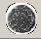 | Colony locator icon. If you move the mouse on this image, a balloon will pop up with ‘take scan image’. You must run this operation first to locate the colony and filter out the outliers (i.e. colony diameter too big/small or doublets) from the scanning sequence. Outliers are excluded by choosing the diameter range and circularity value from the ‘Find Colony’ tab.
 | Scatter image capture icon. This step has to be performed after the colony locating. This step calculates the shortest pathway to travel among the selected colonies using TSP (Traveling Salesman Problem) algorithm and images will be shown in the icon panel (1st panel from the left) and live scatter images (3rd panel from the left).
 | Delete current data. This will remove all the current data. Once removed it CANNOT be retrieved.
 | Pointer tool. Typical pointer tool. If you use this to click the captured scatter patterns (small icons on the 1st panel), it will highlight the corresponding colony on the 2nd panel (colony locating screen). This action will not include any instrument movement.
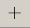 | Marker-tool. Similar to pointer tool, but this includes instrument movement. For example, if you use this tool to click the captured scatter patterns from the 1st panel, the BEAM will move the sample plate (selected) to the exact coordinate that is aligned with the incoming laser.
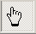 | Select/De-select tool. This is useful for manually -selecting or de-selecting the colonies. Once the colony locating is done, sometimes you still see some “blobs” being selected even though that may not be real colonies. This happens mostly for the spots that are located close to the edge of the petri-dish. Once you click those spots, they will be de-selected (color will be changed from red-blobs to green-blobs) and removed from the scanning sequence.
 | Park tool. This will allow you to park the BEAM (selected side) to the original position.
 | Database icon. This will allow you to save the captured data in a database. Currently, this function is set to operate only with local databases. That is all the data are saved into the local computer. You can copy the data to a backup source using standard backup procedures.
- Captured image preview panel: -Located on the left side of the GUI, this vertical layout displays all the captured ELS patterns in a sequence. Each image is shown as a small icon and there is a click mark that can be used to include (check) or remove (no-check) from saving into the database.
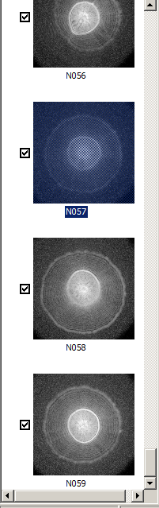

Figure 9.Scatter patterns preview panel.
Check mark
Colony number
- Colony locator panel: This panel consists of two separate windows. The top window displays the monochromatic raw images from the plate (top) imaging camera. The large white dot in the center is the image of the laser. Colonies that exceed the threshold value of the agar background will be shown as white color while the background will be displayed as black. This depends on the plate and media you use. Also, there is a slide on the bottom that you can move to change the threshold value which will change the number of visible white blobs (colonies). There is a camera and LAMP icon . The first will allow you to see the live image from the top imaging camera while the second icon will allow you to manually turn on and off the light source.
- 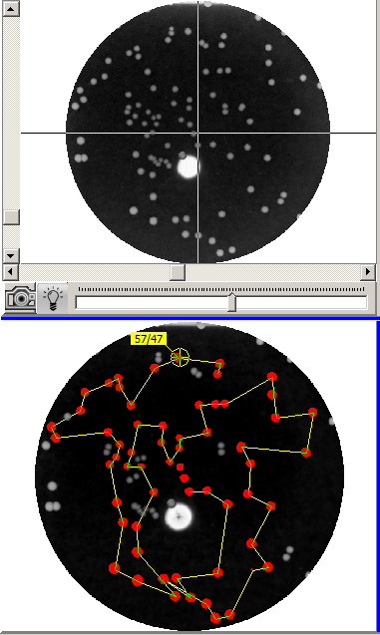
Slider for camera exposure time of the top camera
Control icons
Processed image that shows selected colonies and scanning sequence
Raw image from Top camera
Figure 10. Colony locator preview panel.
The bottom panel displays the processed image from the top. This will contain the scanning sequence of the colonies and all selected colonies will be shown in red color. The cross-mark designates the colony that is currently being captured along with the numbers. You can see that some colonies are excluded from the scanning sequence. This means that they are outliers which do not meet the selection criteria (i.e. diameter range and circularity)
ELS patterns panel: This panel will display the current ELS patterns. The top panel will show you the live and raw images while the bottom window displays processed images if you selected some options from the option panels. Top window includes three icons. Colony map window: (top right) based on the criteria of colony diameter and colony roundness from the option menu, this window displays the center location of the colonies on a two dimensional map. icon will enable a live view of the bottom camera. When is clicked for ELS pattern captures, you will notice that and icons will be automatically turned on (color changed to yellow). The laser icon allows you to manually control the power of the laser.

- The bottom window displays the processed image from the top window. For example if you select Options>Colorify from the option panel, the monochromatic image will be changed to false color image. Sometimes, false color image displays better structures than the grey scale images.
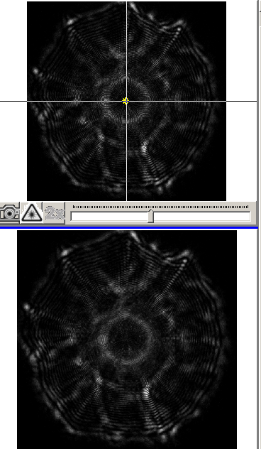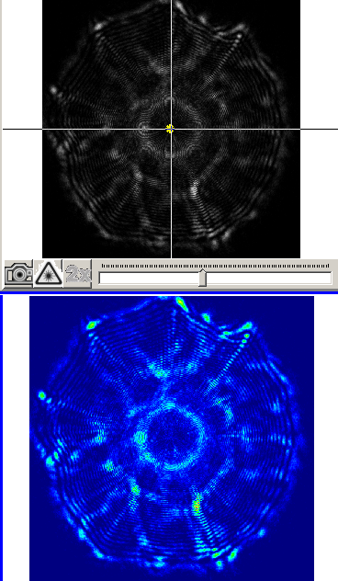
Figure 11. Example of Colorifying: (Left) before (Right) after Colorifying.

HDR and regular image
A function that is included is the high dynamic range (HRD) function that can be found in the control tab. This function was included to accommodate a situation where some colonies show large dynamic range of data (that is minimum and maximum signal spans large order of magnitude)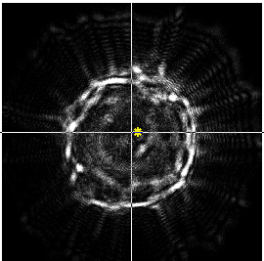 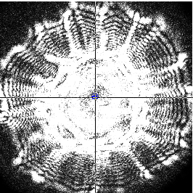
Figure 12. Example of regular (left) and HDR image (right) of the identical colony. Weak signal on the outside rim region is more amplified in the HDR images while there are some speckle noises that can be observed. This function is useful when the colony is optically opaque and you still want to observe the scatter patterns.

- Control and options panel: This includes several options that can be selected by users. While most of the settings were already optimized for better performance, we will remark on some of the parameters that users can change if needed.
Control tab: This shows live information regarding the lasers and options for accurate locating of the colony locations. If you follow the standard operating procedure of the plate preparation, your agar thickness will be close to a set value where the BEAM was optimized for high speed scanning. Snap/resnap/purge icons are for calibration purpose or when you need to manually correct the image centeredness. Radius option describes the image radius of the plate image in pixel unit and 1250-1300 is the correct range. Auto exposure and brightness option is used to control the image exposure. This this option clicked, each image will be adjusted automatically based on the brightness value selected.
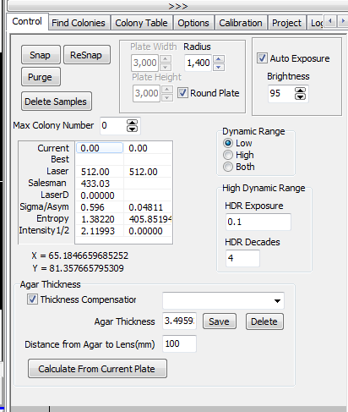
Figure 13. Control tab. Most of the options can be set as shown. Radius determines the pixel radius of the Petri-dish edges which has a set value of 1400 pixels.
Find colonies tab: This tab is responsible for choosing the colony selection criteria. The box on the top shows three parameters that users can choose: Max and Min colony diameter and Roundness (circularity). Diameter ranges are used to provide repeatable ranges of colony diameters for better signal to noise ratio while the roundness value is used to exclude outliers (doublet and triplet, etc.). The Threshold bar displays the grey scale value (0-255) where the background cut off value was set. Depending on this cut-off you will have different number of colonies and ‘Number of Colonies’ and table will automatically change when you move this slide.
Figure 14. Maximum and minimum colony diameter determines the interval of colony sizes that will be captured while the roundness parameter is majorly used to exclude outliers.
Colony table tab: This tab will display all the information related to the selected colonies which includes X, Y locations, diameter, and roundness. If you want to export this into a file, you can right click the mouse when the pointers are on top of the table and you can save the data in text format.
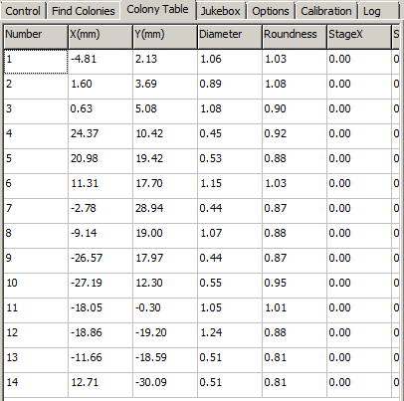

Figure 15. Colony table tab displays the number, XY location, and roundness parameters.

Options tab: This tab provides several options for users. Most of the options can be left as current settings. One thing the users can change is the ‘Get Center Mode’ option. This provides you with options to perform ELS pattern centering with two different modes. Typical colonies that we are dealing with can be run with ‘Bacteria’ while calibrating with the calibration plate ‘Dots –‘ option is useful. ‘Finding Center Threshold for LASER Camera’ is a slide bar that you can control to control the threshold for the centering algorithm. ‘Max steps’ decides the maximum number of correction steps that BEAM will perform to provide circularly symmetric ELS patterns. ‘Colorify’ option will provide you with false color images of the ELS patterns.
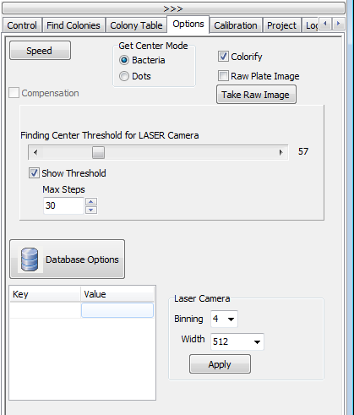
Figure 16. Options tab displays several control options for scatter camera.

Calibration tab: This tab provides automatic calibration of the instrument. First you need to insert the calibration plate on the BEAM. Then simply click the Calibrate BEAM button and wait until you see the pop-up windows that indicates the task is completed. This can take several minutes. At the first installation, technician will perform the calibration with the designated calibration plate. Once completed, users don’t have to re-calibrate. However, after extensive usage or unusual event (moving the instrument etc), re-calibration might be required.

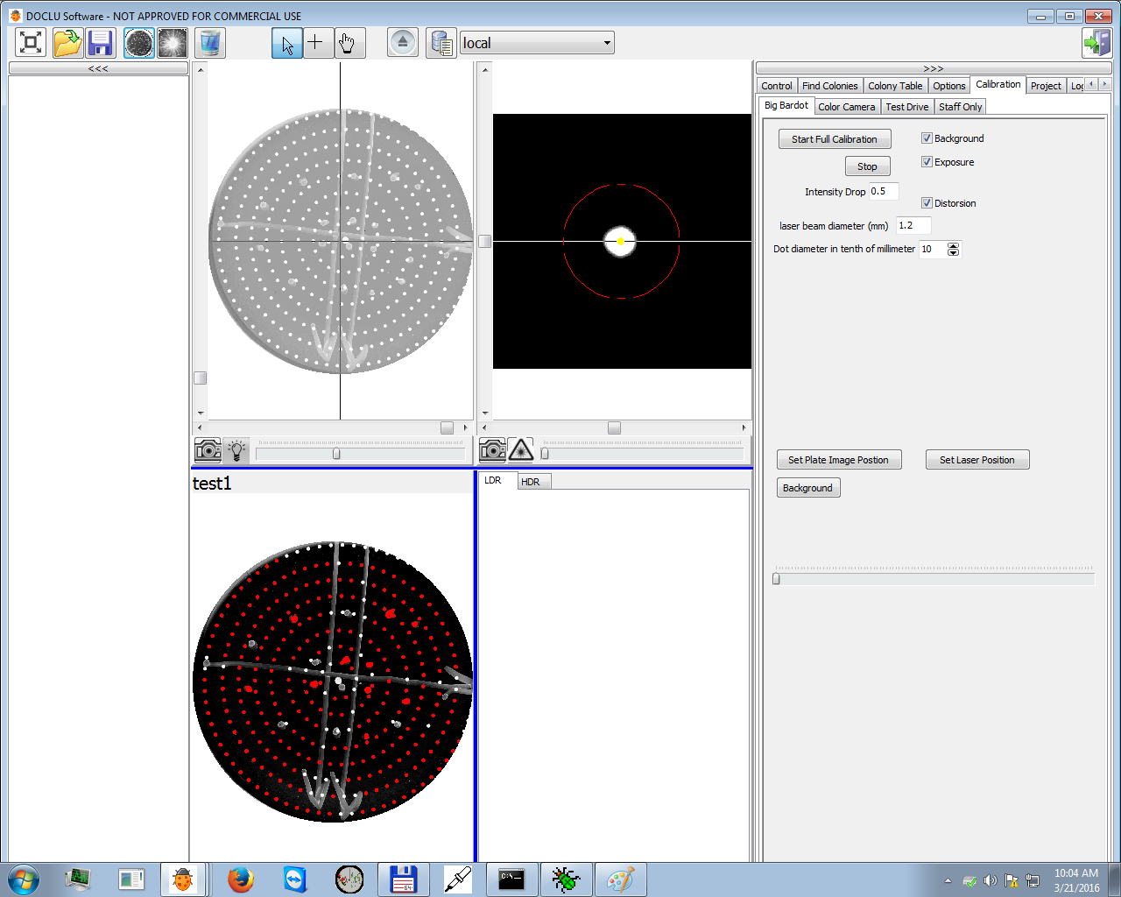
Figure 17. Calibration tab menu allows a full calibration of the stage of the BEAM.

2.2 Using database options
First step toward using the database function is to use the (save icon) to save the all measurement data. When you click this icon a new window will be shown (Figure 2-15). It is important to provide as much information as possible since each field (dish name, experiment, lab, user, etc.) will be shown in the database and can be used to sort and find your relevant experimental data. Use intelligent names with meaning and be consistent. Once names have been used, they are available as dropdown menus so that you must be consistent with naming conventions. This is critical when using a database. After you have filled in the information click one of the following:
Save : data can be saved as .PLT file (standard data format of the instrument). A PLT file is a proprietary file that includes all of the information from the plate, but it is in a readable more.
Export : you can export the individual images, plate image, and statistics as a separate files.
Save to Database : this icon will save all the data into your database
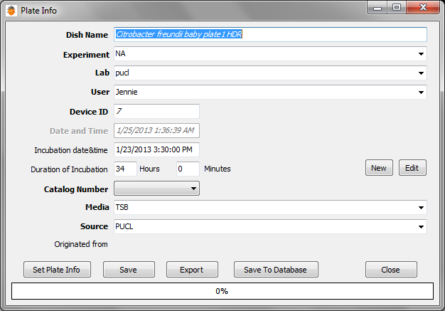
Figure 18. Plate information window to save all the scanned data into the database.

Once a series of experiments is complete, you can click the (database) icon. Next to the icon, a dropdown menu will show two options. One is local database and other is local-cleaned database
Local: this database is the default database into which all the raw data are saved. This can be considered temporary storage and it is good practice to clean up bad scans, etc. and then save the “cleaned” data to the “Local-Cleaned” database. Once data are transferred, it is suggested that the temporary database is emptied as it can become a huge data storage problem.
Local-cleaned: this database is the ‘cleaned’ site in which you have removed all the bad images that were included in the original run.
Then the database window will be opened
Model window
Preview thumbnail

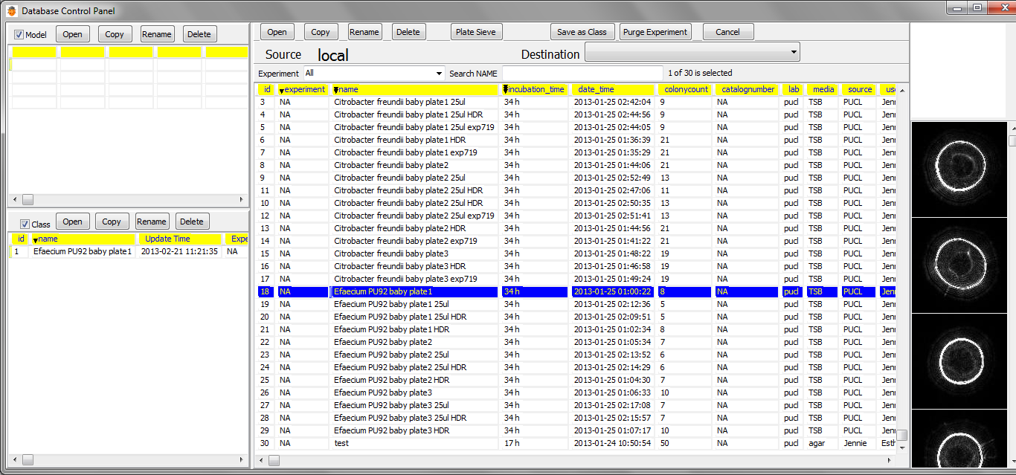
Class window
Captured data (top row shows the attributes)

Figure 19. Database window. Sub-windows include model and class windows and thumbnails.

Figure 2-17. Menus for the database window.

Some important functions for the icons are explained.

- Open/Copy/Rename/Delete is the usual function to edit the database.
- Plate Sieve: this is a powerful tool to show the scatter image, colony diameter, and if you performed time-resolved experiment, you can observed the time-series of scatter patterns variations (please see Figure 2-17 and 2-18). Plate Sieve is really only used for time-based series using automated incubators.
- Save as Class: this menu will allow you to save the images as a class. For example, if you save a series data into Listeria innocua 12 hour-BHI, this class will be later re-used as a fingerprint (reference database) to compare against the unknown samples.
- Purge Experiment: removes the experiment that you’ve selected.

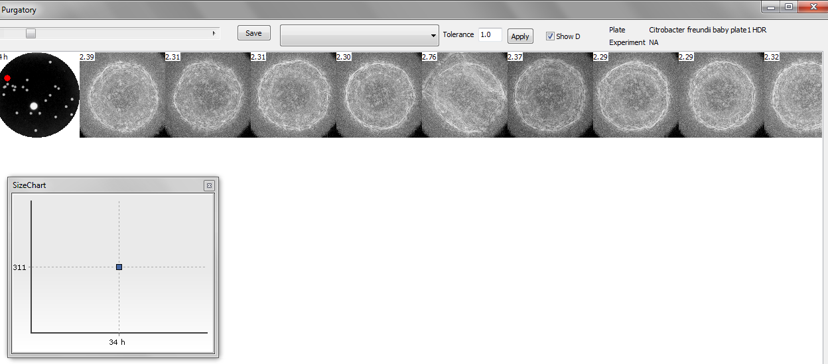
Figure 20.Screenshot of the Plate Sieve menu. Plate image (left) and scatter patterns (right) are shown. The Red-dot on the plate image corresponds to the particular colony from which scatter patterns are identified.

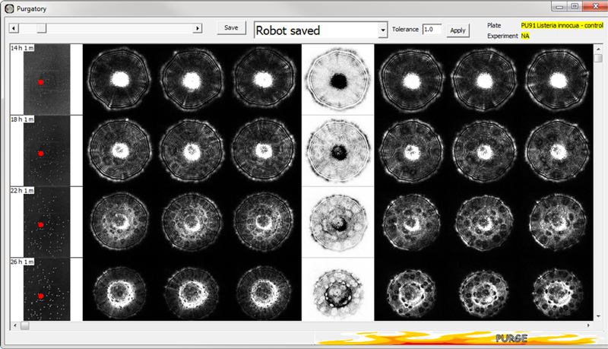

Figure 21. The Left column shows the time point and the red-dot corresponds to the same colony at different time points. When you perform a time-resolved experiment, Plate Sieve is a excellent feature to see how the patterns evolve versus incubation time.

If you click , a new window will pop up.

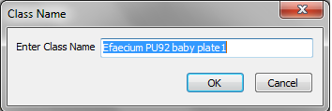

Figure 22. Class name window. If you input the class name, data will be saved into the database using this class name.

Figure 23. Once you save the data using the save as class icon, we can see that a new class named ‘E.facium PU92’ is shown on the main window.

3. Classification by Baclan Software
In the computer, analysis and classification software (called Baclan) is pre-installed. This is concomitantly developed along with BEAM operating software such that once the data are saved using the database option; Baclan streamlines the analysis and classification process.

The classification steps consists of two processes. The first is building an ELS library and the second is performing the actual classification. To make the most of the Baclan function, all the data that are captured should be saved using the database options. For the first step, click the 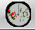 (Baclan icon) to start.
Statistical information of each colony
List of Classes and plates
Plate image
/classification results

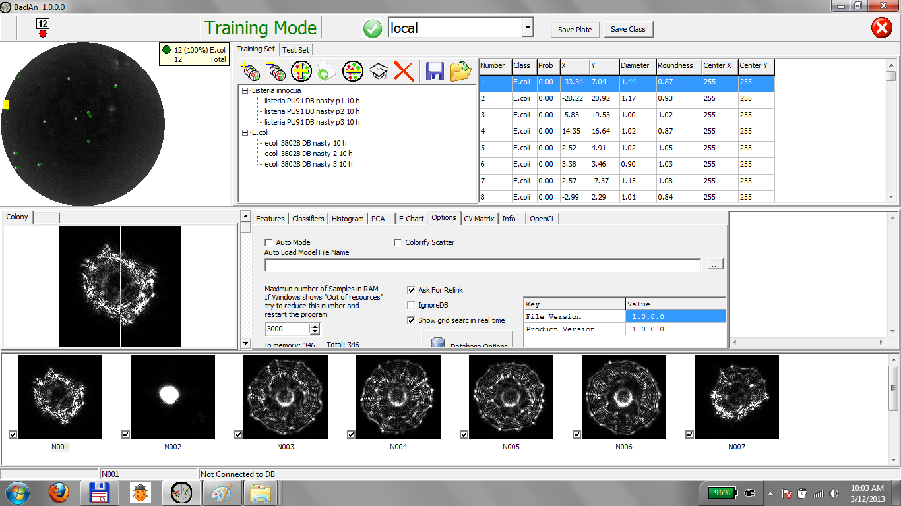
Thumbnail images
Figure 24. Initial window for Baclan.

Here each function of the icons is explained.

Icon | Mode | Action/Function
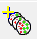 | Training | Create or Load class. If you select this, you can create a single class or load an existing class file. Class is defined as a data file for a single organism. For example, you can generate a class file based on a genus (Listeria, E.coli, Salmonella) or species (Listeria innocua, Listeria monocytogenes, Listeria ivanovii). Class generally consists of multiple plate files (which uses the  icon)
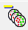 | Training | Remove class. Deletes the class from the Baclan program
 | Training | Add plates. This icon is used to add plates into classes. Typical experiments includes replica of data so you will generally have multiple numbers of plates files added into the same class. For example, Listeria innocua class you will have plate 1, plate 2, and plate 3 as a replicate datasets.
 | Training | Import plate from Directory. This function enables you to import the image files that were exported from other light scatter instruments. For example, if you have series of bitmap images from the older generation instruments, you can specify the directory and import the images into the new database.
 | Training | Remove plate. Deletes the current plate data from memory only (it does not delete data files).
 | Training | Teach. This function trains the classifier using the parameters that you have specified on the “Features” tabs. In this tab, generally we selected Zernike moments with order 10 and Haralick Texture with minimum 1 maximum 4 and step 1.
 | Training | Delete all data. This icon will clean the screen that will delete all the classes and plate data from memory only.
 | Training | Save model. Model is defined as a set of classes that you have generates to accomplish a certain test. For example, depending on your aim, you can generate  Listeria species model – class will be 7 Listeria species.  Multi-genera model- you can include E.coli/Listeria/Salmonella (all in genera level) to classify  E.coli serovar model –each class will be your own o-antigenic serovars.  In all these example, each model should be saved as a separate file.
 | Training | Open model. Imports the model that was previously saved.
 | Testing | Add plates. Adding plates in the test mode means you are importing the data that needs to be classified.
 | Testing | Import directory. This function allows you to directly import the old data format. The only constraint is that the output files must be as separate BMP or PNG files.
 | Testing | Export as BMP file lists. This function allows you to export the database files into separate image files and text file. Text file will include the statistics of the individual colonies.
 | Testing | Remove plate. Deletes the plate data
 | Testing | Classify. This function is comparing the test data against the training database thus providing the classification .
 | Testing | Save report. This function will report the classification result at the same directory of the test data set.
 | Testing | Print or Export. This function will allow you to print the plate images along with the colony numbers overlaid. This is especially beneficial when you need to pick individual colonies that show interesting ELS patterns and trying to perform further analysis. The printout should be close to the actual size of the plate so it can be placed beneath the plate to select colonies.

Training and building the library
The first step towards the classification of ELS patterns is to generate a fingerprint library. First click the (add class) icon to open a new window.

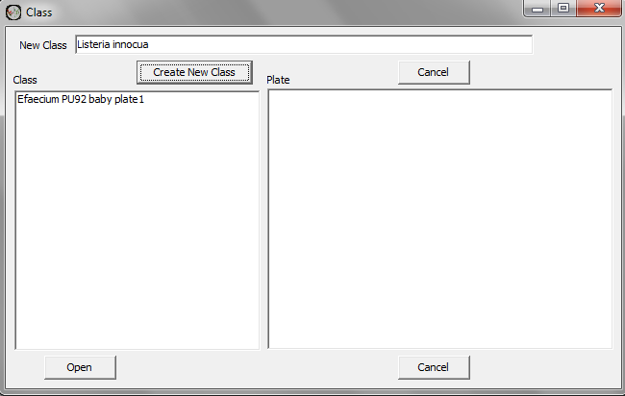

Figure 25. Class window. You can type the new class name and click “create new class” or click the existing class and open it.

After you create or open the class, you will observe a new class has been added into the main window. You can see “Listeria innocua” class has been generated.

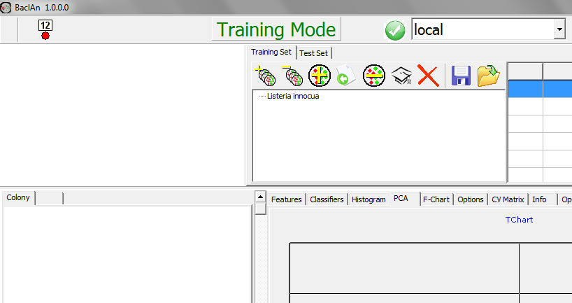
Figure 26. Adding a class to Baclan.
Now you can add different sets of plates to build a Listeria innocua library (for example). To do this, please click (add plates) icon. This will pop up a database control panel which displays all the experiments that you’ve conducted and saved using the “Save to database” option (please refer to Figure 2-14 and 2-15).
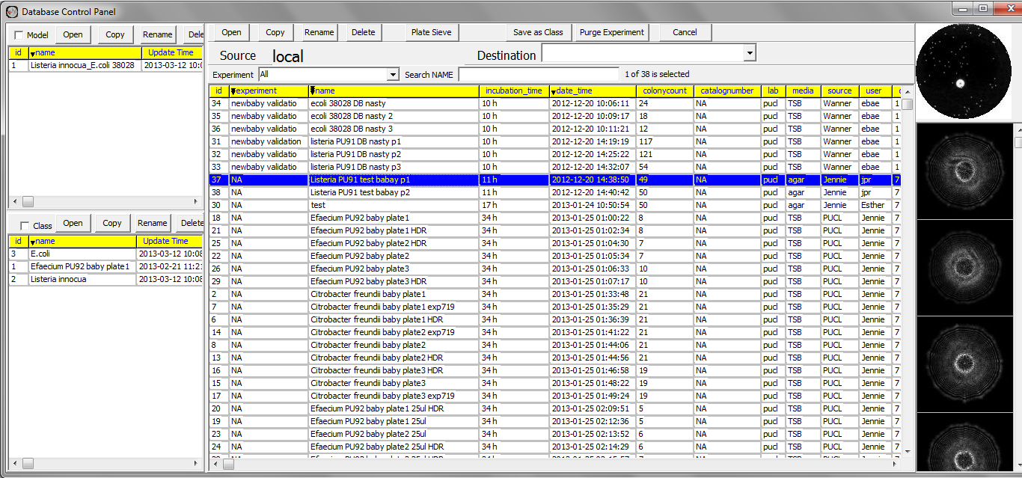
Figure 27. Adding plate data into a class using Baclan.

You can click the data set and click “open” on the top left corner.

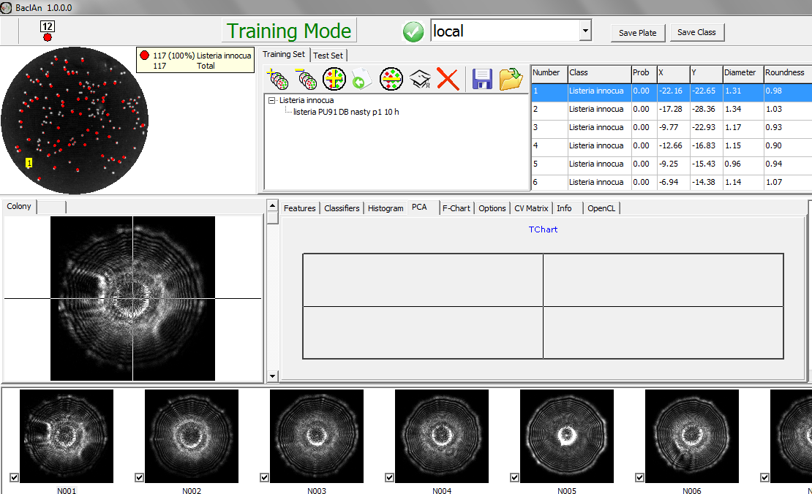
Figure 28. After adding plate data into a class using Baclan.

Figure 3-5 shows the class (Listeria innocua) and plate (Listeria PU91 DB nasty p1 10h). You can continue to add more plate data and/or add different class to build the entire library.

Figure 3-6.After constructing and importing data for “two class” library.

Figure 29. shows the result after adding two classes (E.coli and Listeria) and each class contains three different experimental data sets (plate scan data).

Please click (teach) icon. After this action, Baclan will train the fingerprint library to figure out the optimum classifier based on the given parameters (Zernike and Haralick). When the training is completed, the grid search results will be shown which defines the optimal parameters. If you click the CV Matrix tab, it will provide the cross-validation results that can be used as a test result for the performance of your constructed library.

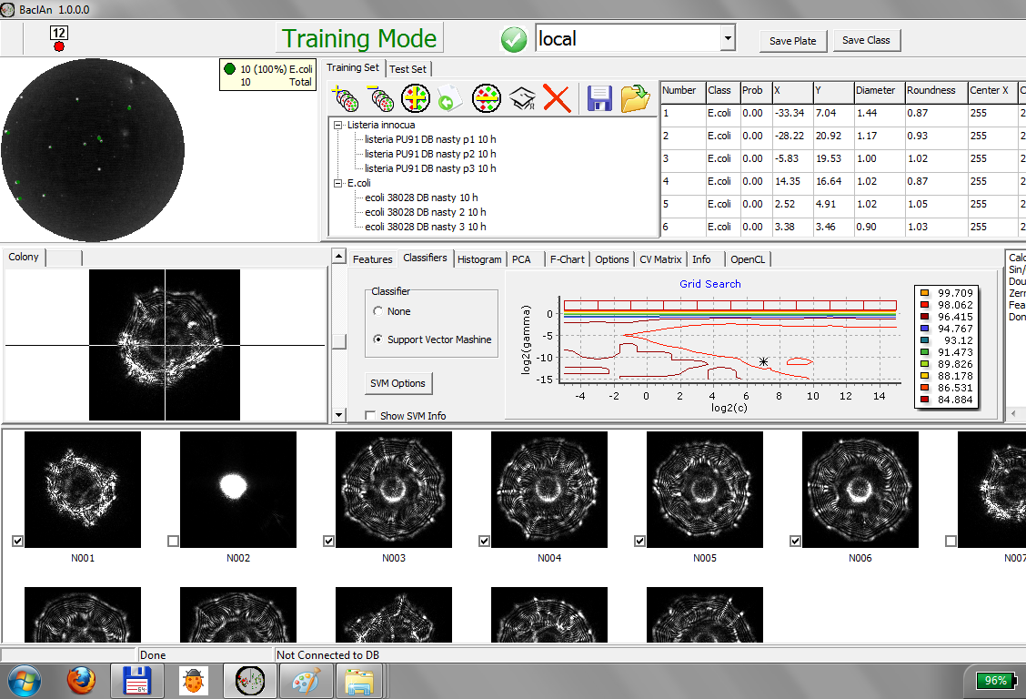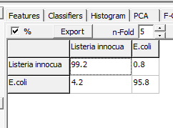
Figure 30. After the training is completed.

After the training is completed, please save the result by clicking the (save model) icon. This action will ensure that all the training data are stored so that you do not have to re-train the library for this model.

Classification
After the training is completed, now you are ready to perform the classification. If you click the Test Set tab, the program will switch to test mode. If you are starting a new instance, you will need to open a training set model from the saved model.

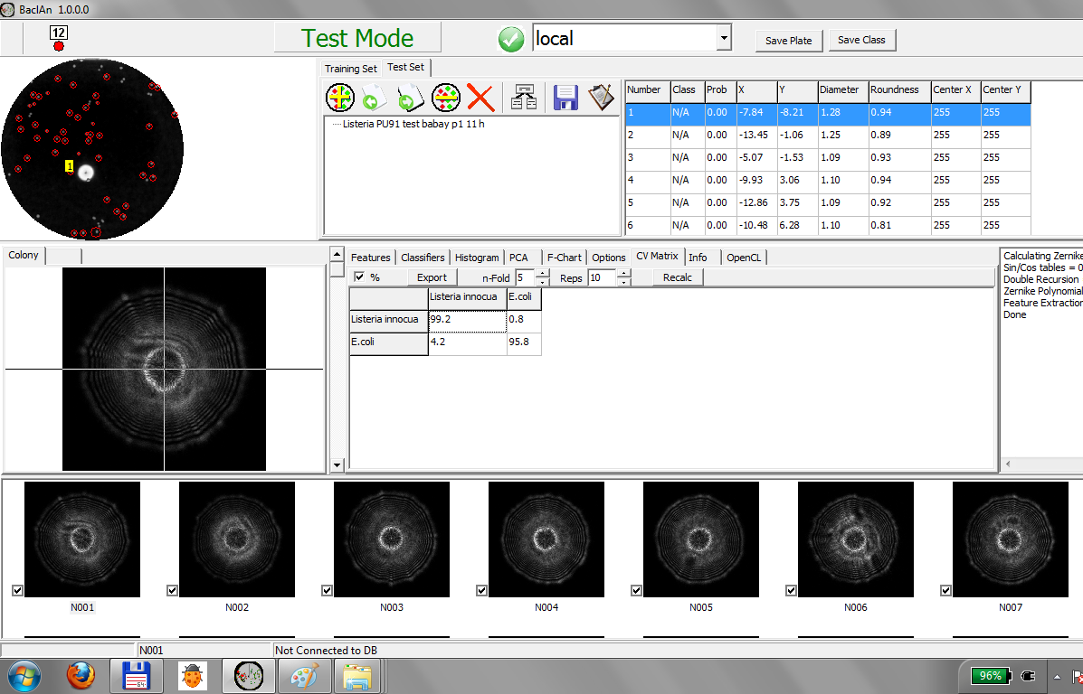
Figure 31. Screen shot for a test mode.
Now click (add plates) icon. In test mode, adding plate means you are importing the data that you need to classify. This icon will open the database control panel again and you need to select the correct dataset that you want to classify.
Figure 32. Database control panel.
After you open the data, please click (classify) and the classifier will compare the test data against the training data.
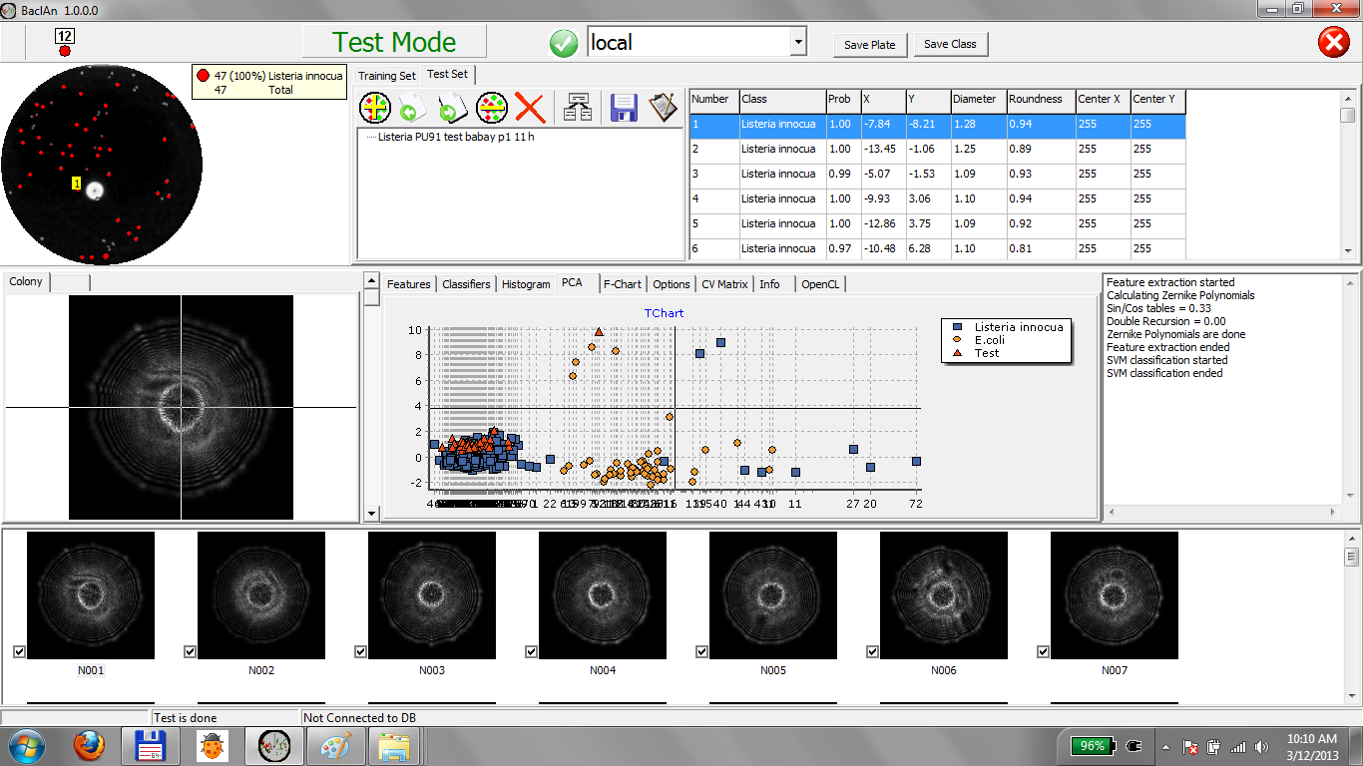
Figure 33. Classification results for Listeria plate.

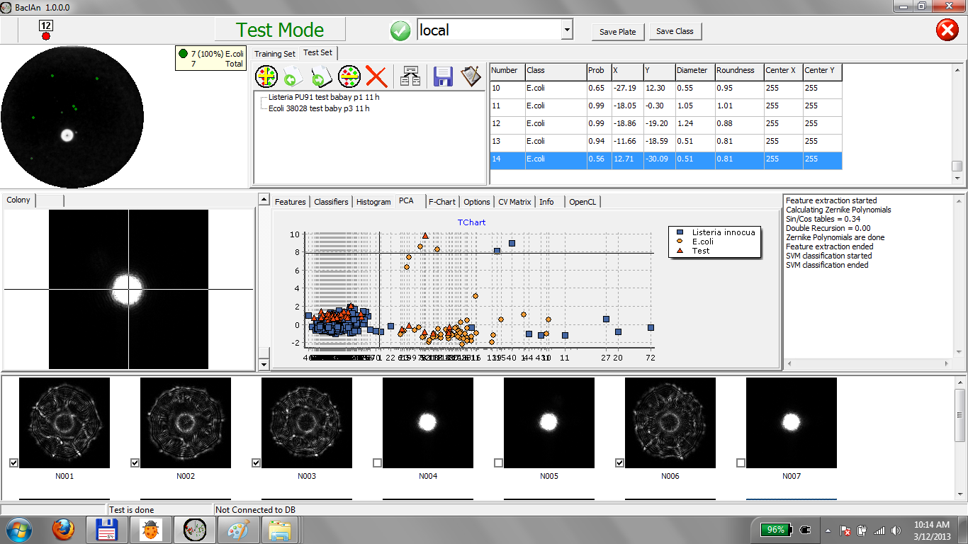
Figure 34. Classification results for E.coli plate.

Quick start procedure

In this section, we will present a quick start procedure to operate the instrument. If you need detailed explanation and information on each menu and options, please refer to the previous section, standard operating procedure.
Quick start procedure
Step | Actions
1 | Turn on the power of the BEAM (switch on back). Double click on the BEAM shortcut and wait for the initialization step.
2 | Place a petri-dish on the sample holder with lid facing upward ONLY. NEVER place inverted petri dishes into the unit.
3 | Click the colony locator command and wait for the results on the colony locator panel.
4 | Check other options (colony diameter, scanning method etc.) for correct settings.
5 | Using de-select tool, click any un-necessary colony-like spots that are positioned around the edge of the petri dish.
6 | Click the ELS capture command . You will see the scanning route displayed on the colony locator panel and ELS capture screens will display the ELS patterns as they are collected.
7 | Once the scanning is complete, save the data using
8 | Once all of the scanning is finished, park the instrument using

4. Operation of the remote monitors
Remote monitors are a stand-alone tablet-style computer that has an IP65 rated which is good against any accidental water/liquid spill that can happened during the normal sample preparation inside the hood of the microbiology laboratory settings.
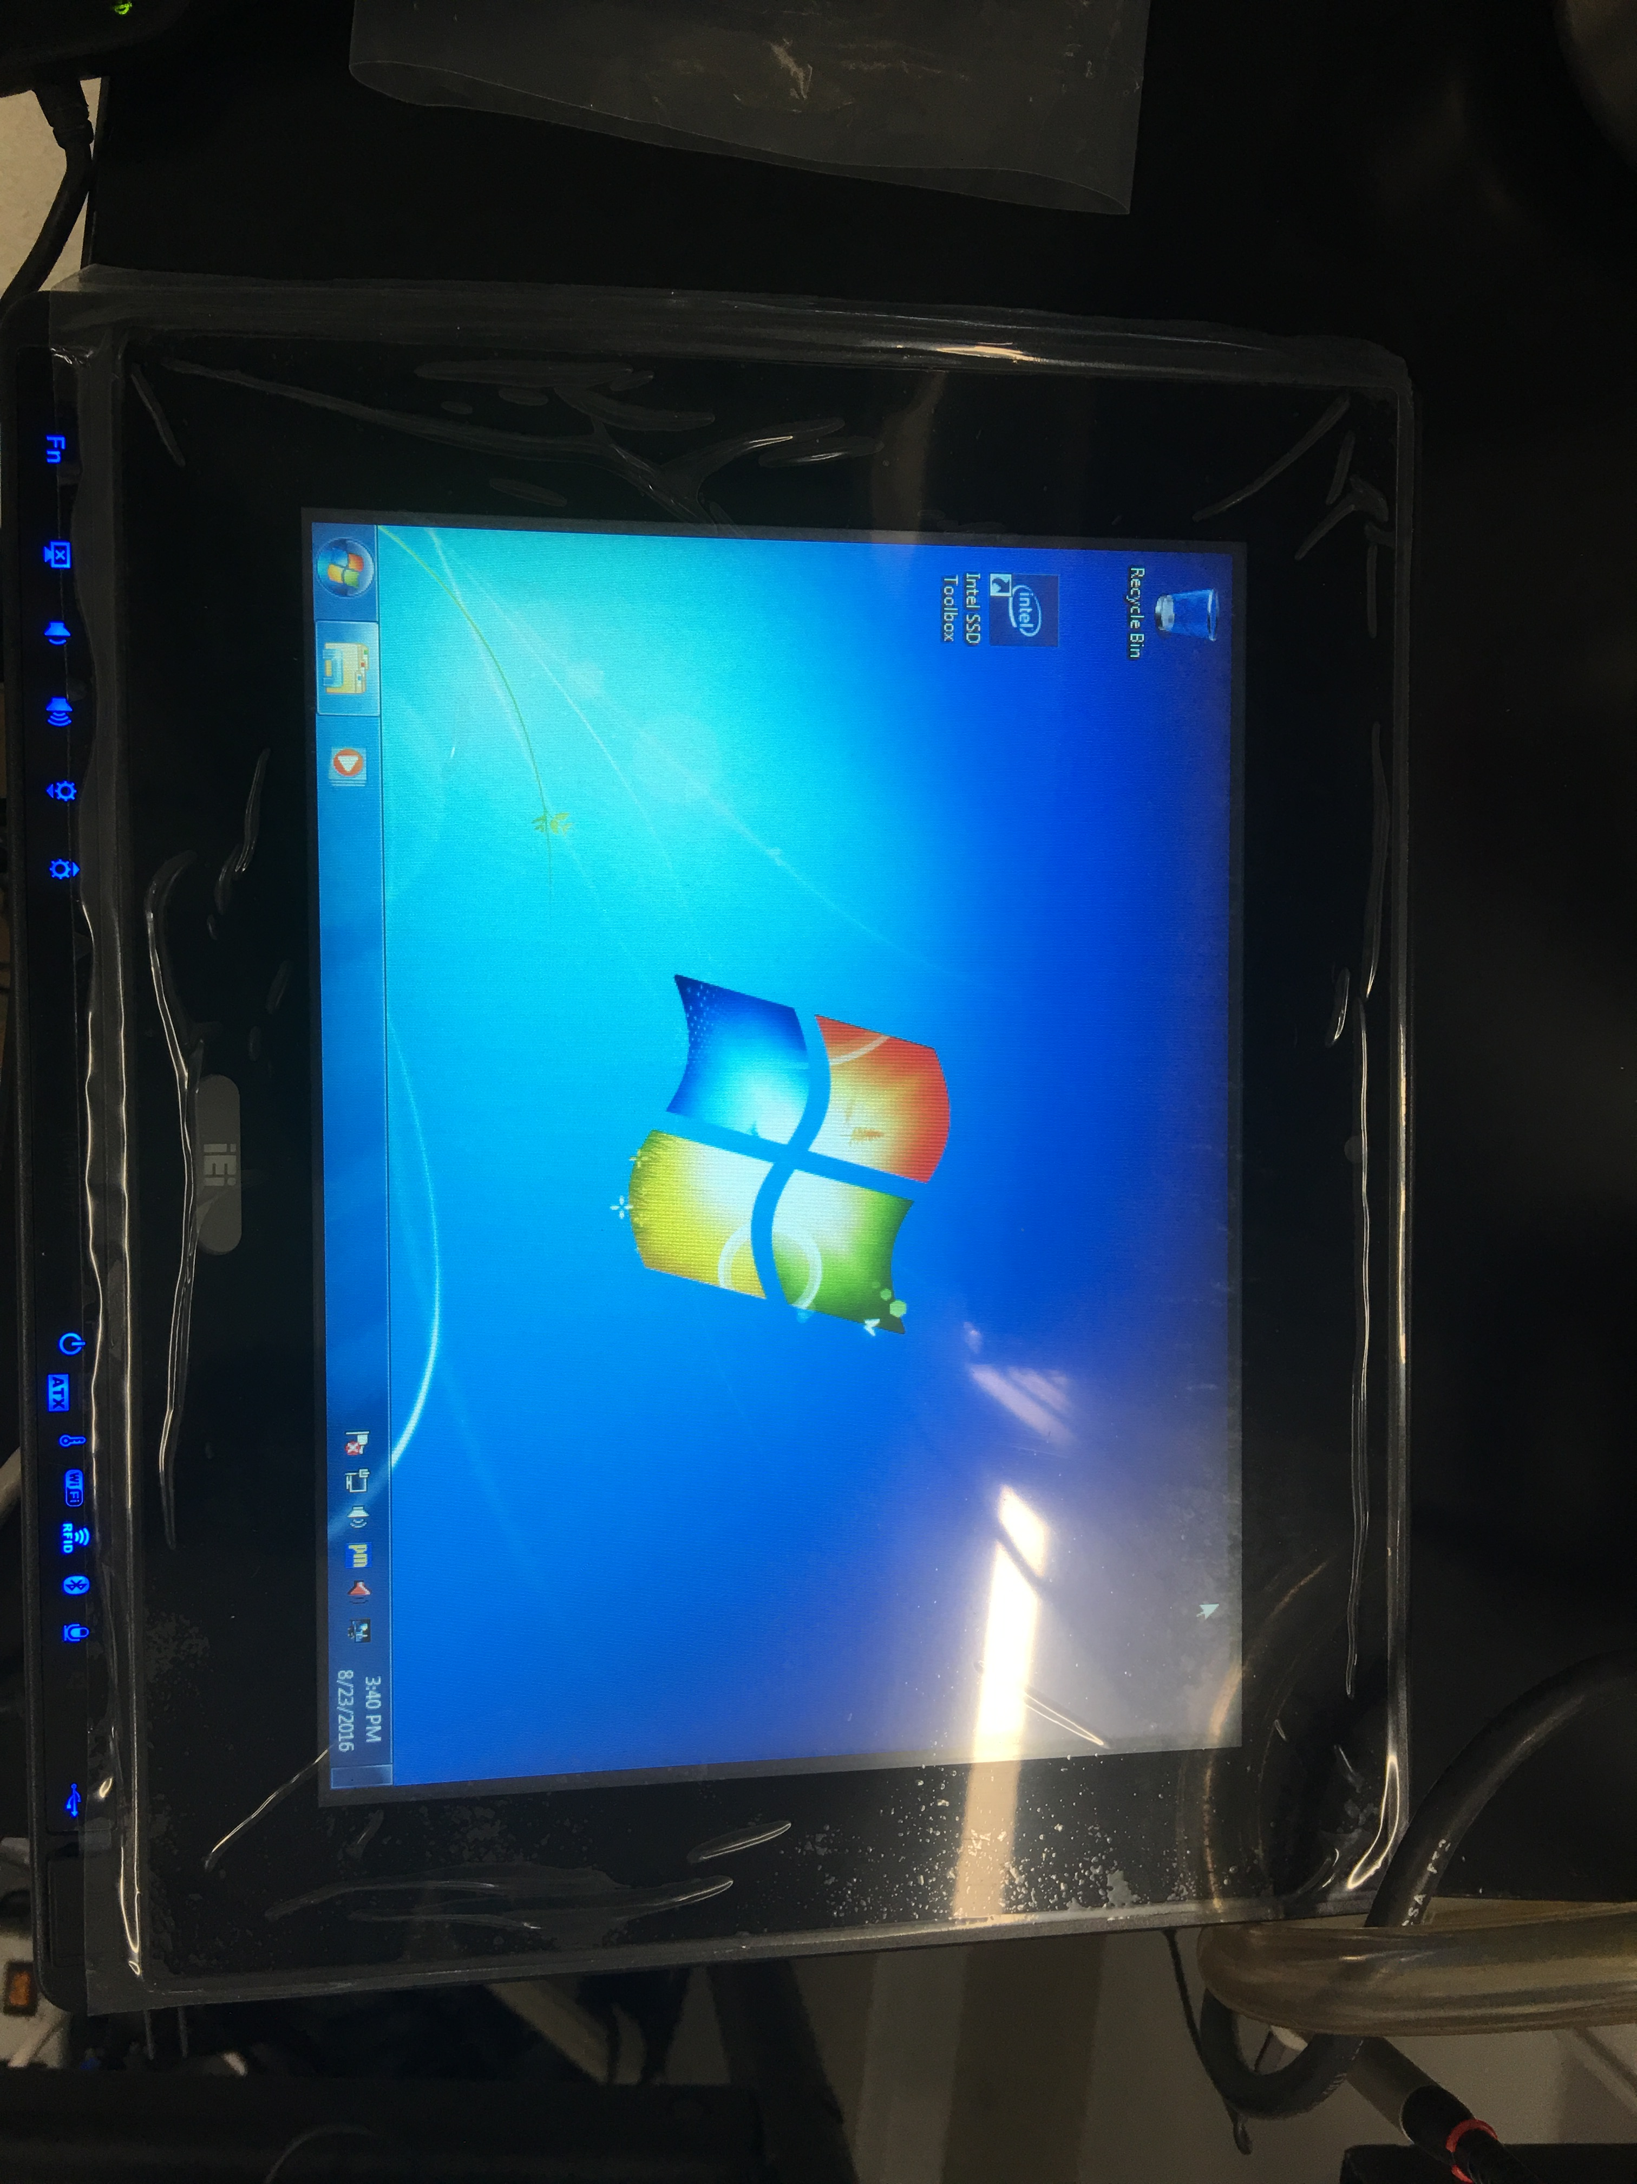
Figure 35. Picture of the remote monitor.

The main function of the remote monitor allows user to pick a particular colonies for further biochemical/DNA analysis without hassle. Once the plate is scanned and their scatter patterns are saved in the database, you can take the plate into the hood and place them on top of the remote monitor screen.
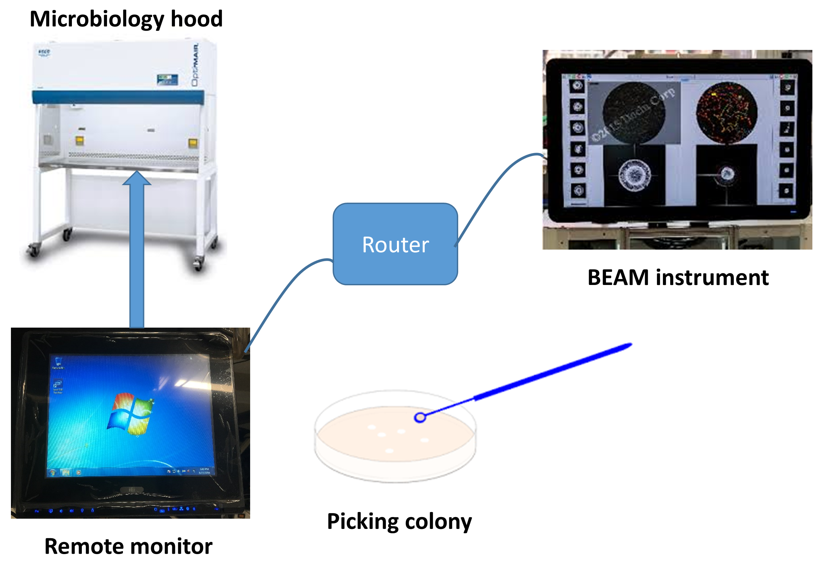
Figure 36. Concept of the remote monitor for BEAM.

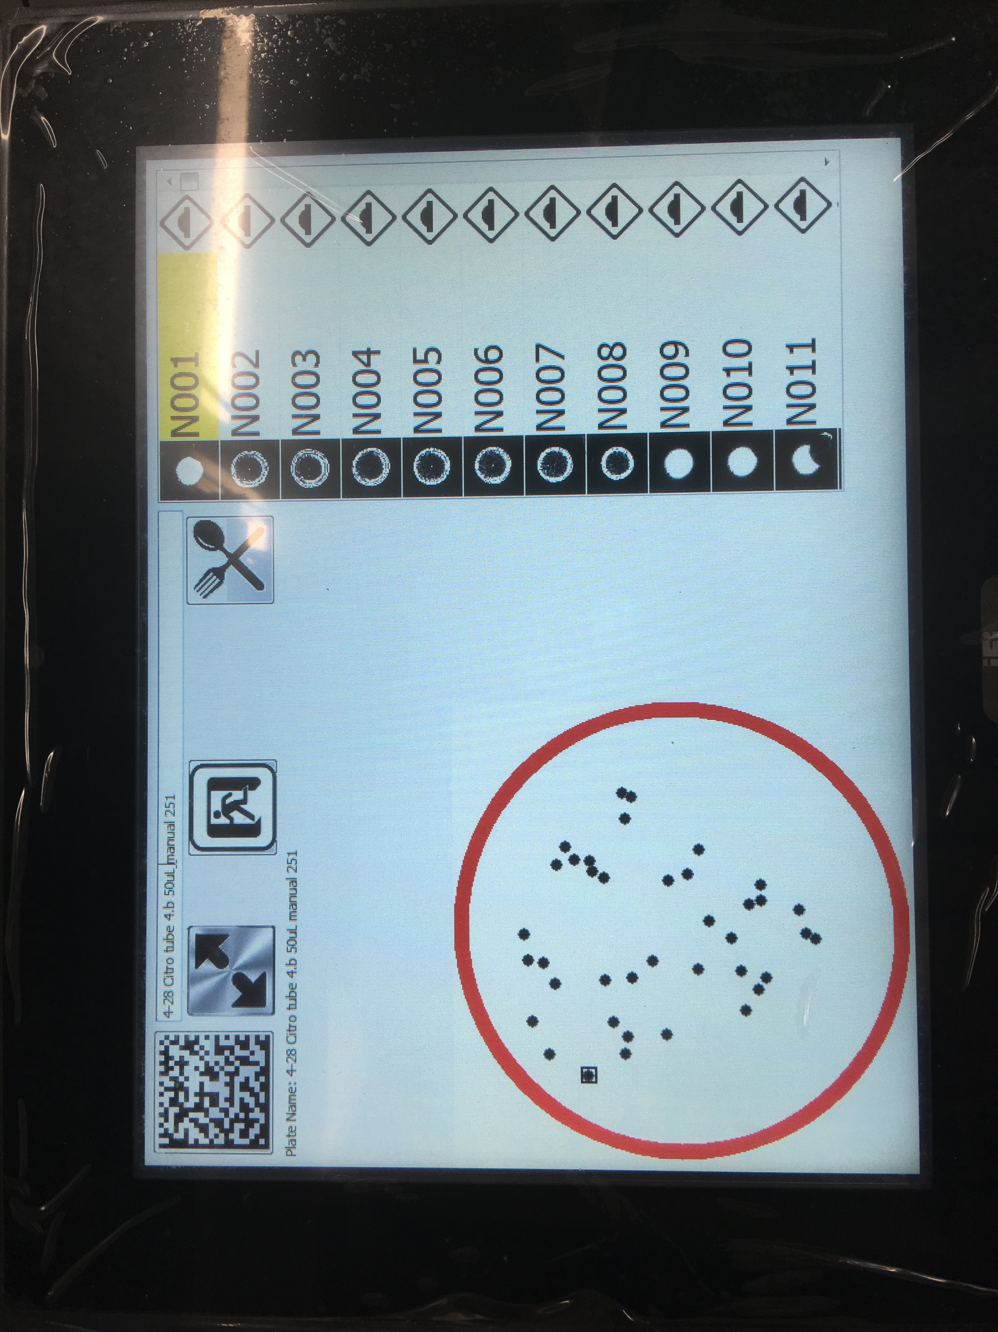
Black square is highlighting the N001 colony which is selected on the right
Users can plate the round plate directly on top of the screen and pick the right colony
Figure 37. Screenshots that shows the imported plate data which includes colony location and scatter patterns.

Once the colonies are picked, user can click the diamond-shaped button to mark them off.
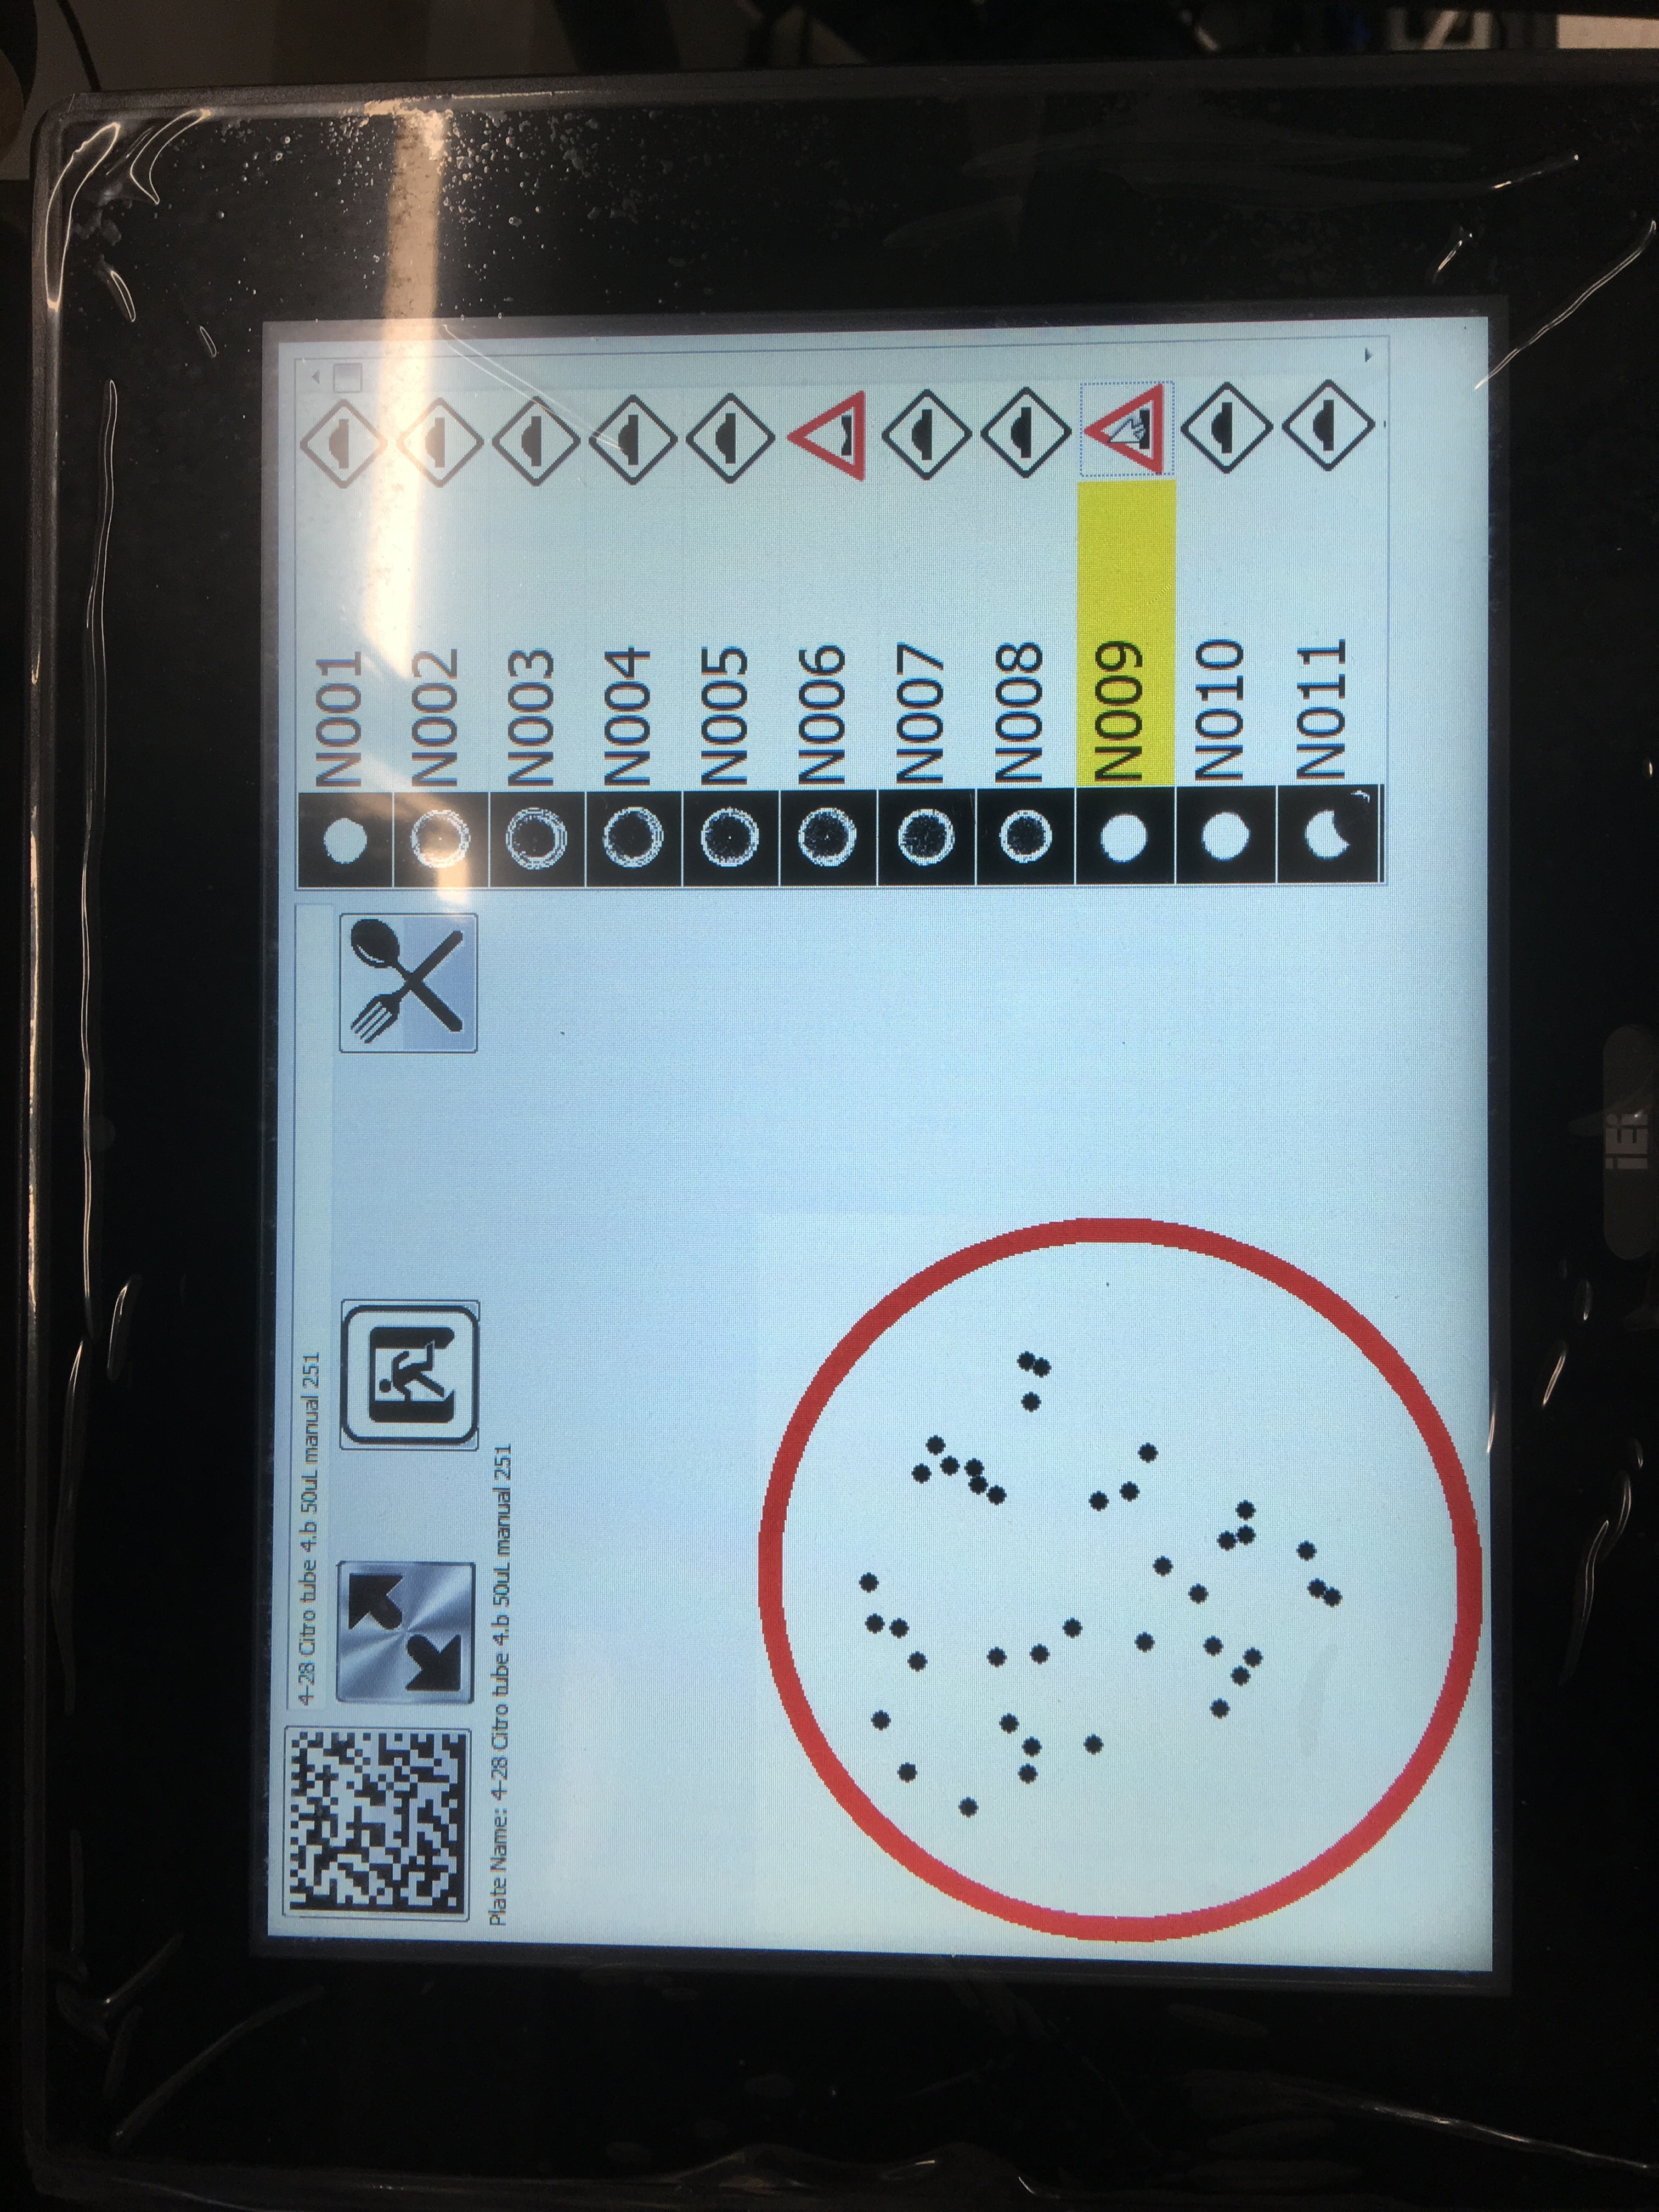
Figure 38. After scooping up the colony, users can mark the diamond -shaped button to mark them.

Notice: Users operate this instrument at their own risk. No warranty is offered or implied as to the accuracy of any of the algorithms. This instrument is a prototype and represents technology under development. By operating the software and hardware, the user accepts this agreement.
This page intentionally left blank.

This is the last page of the document.

