SOP S007
RULES FOR PREPARATION OF WORD, PPT AND XL DOCUMENTS
Rule 1: put the name of the file into the footer so all printouts identify the name and location!
Rule 2: Refer to Rule 1
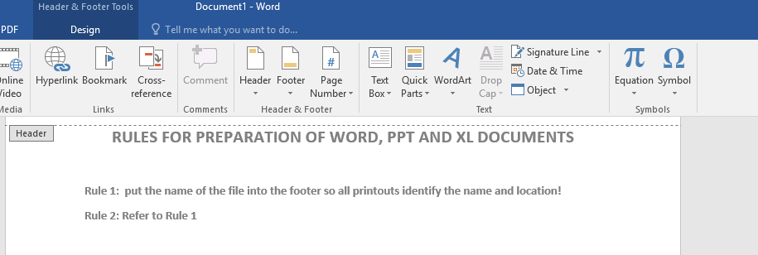
Go to the bottom of the page where the footer is DOUBLE CLICK
Got to top
Click INSERT QUICK PARTS
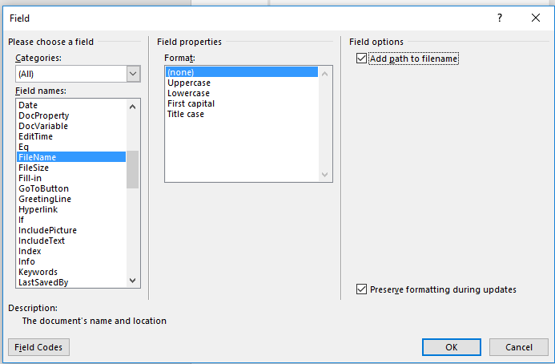

Select FIELD
Filename – then on the right side
Click add path location
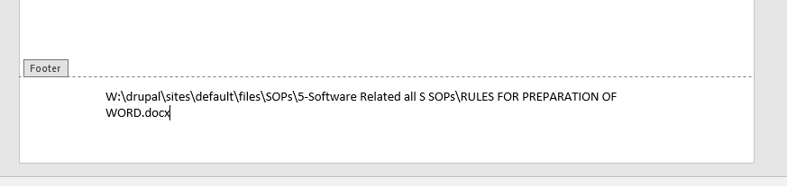

SOP Created By___JPR
Date Created Aug 1, 2019 Verified by _____________
Date Verified ____________

