SOP-M013

Basic Bardot Operation

Objective: To view Scatter Patterns of Various Bacteria Colonies

BE SURE YOU ARE ON THE CFSE DATABASE BEFORE YOU BEGIN.

1. Click on the Lady Bug Icon on the lower bar to open the Bug Buster Software.

2. Place the plate with Agar side down in the provided holder.

3. Click the “Take scan image” icon on the upper bar. The colonies will appear as red dots.

CFSE

If there are any multiple groups or odd shaped colonies, you can use the “Hand” icon to turn
the colonies from red to green. Now the Bardot will only scan the red ones.

CFSE

If you want to start your scan with a particular colony, use the “Plus Sign” icon. Go to the
specific colony you want and click once with the mouse.

4. Now you are ready to start scanning. Click on the “Take scatter pictures” icon.

CFSE

Saving Data:

Here is an example of the information needed when saving the data to the database.

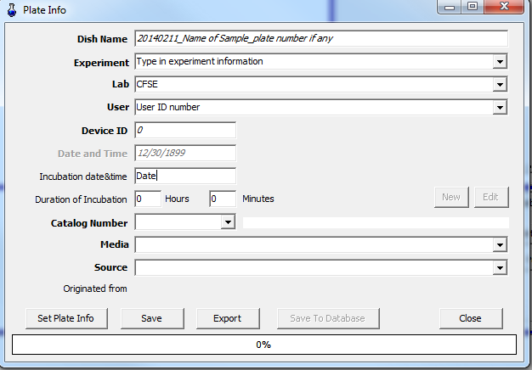
Save to Database

After all the information has been entered correctly, click the “Save to Database”

Note: The information MUST be entered in the same way each time.

Analysis:

Use the “Bacterium Analyzer5” software. Icon is on the lower information bar.

CFSE
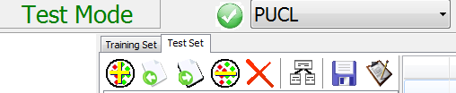

Be in Test Mode / Test Set Tab / and then click on the “Add Plate” icon. A window will open
displaying your plate information.

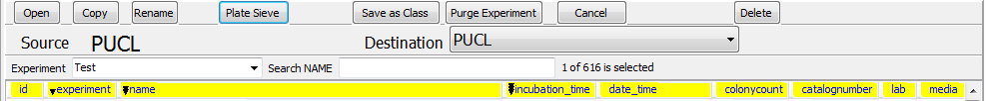

Using the drop down arrow, choose you experiment name.

If you have several plates and want to combine the data for comparison, use the “Plate Sieve” tab.

This could take a few minutes if there is a large amount of data.

