SOP M002: Create and print labels
- Open the program for label printing See ARROW
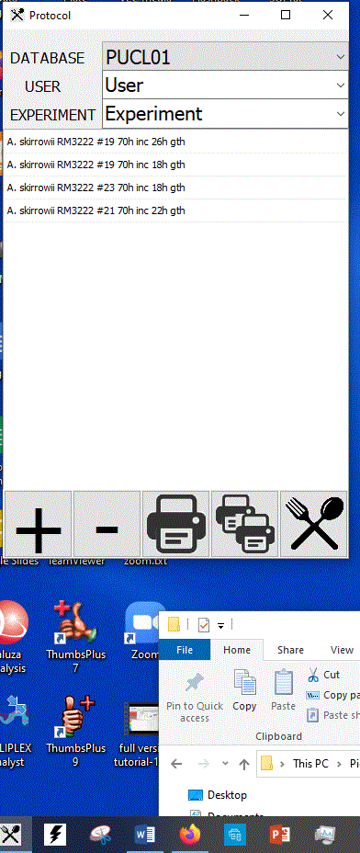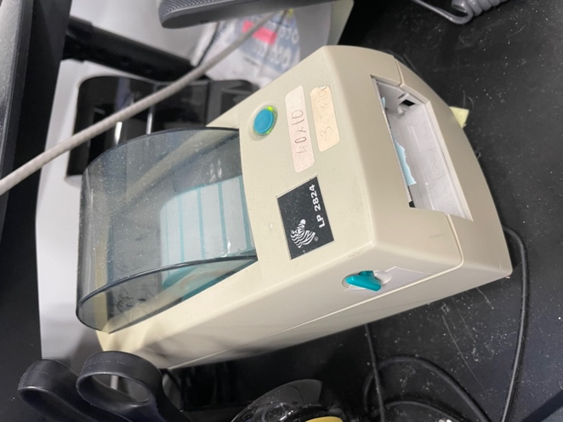
The printer is the Zebra LP 2824 pictured

- Select the database you need , change the name of the user (select from dropdown) and then type in the name of today’s experiment -under EXPERIMENT
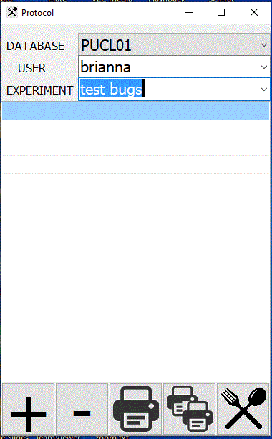
- Click on the PLUS + sign and this opens a new window. The experiment name you typed is already populated.
- Under DISH NAME – you need to type in what this experimental plate is called and also any info below that is relevant. When you click the PLUS + on this form, the name is added (see next form – I added Demo 1 and Demo 2)

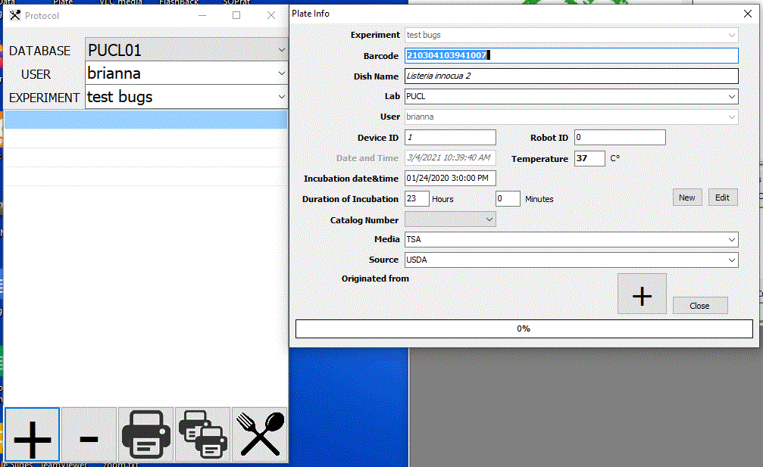

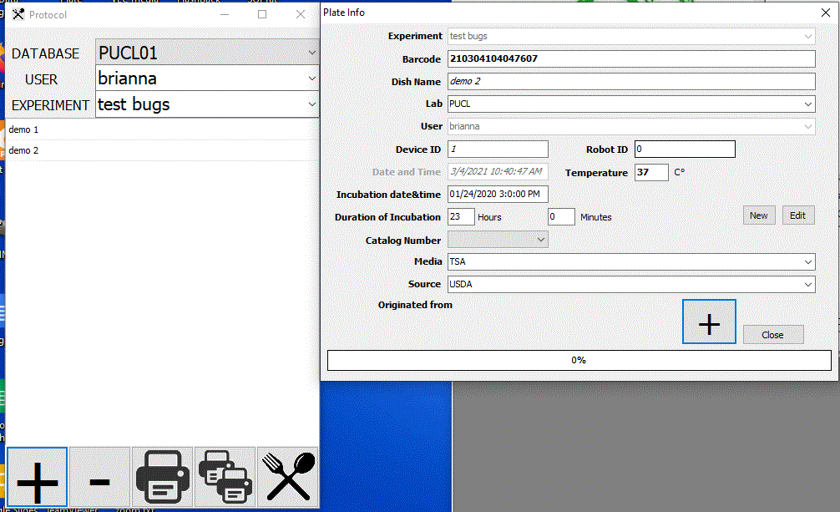
- When all the plates are entered you can print on the ZEBRA printer. Make sure the labels are loaded -- you might test it by clicking on the large printer icon – if that works then you can select multiple labels using the multiple printer icon.

SOP Prepared by: JPR Check by: BD
Date edited: 8/24/22 11:48:00 AM

