SOP-E045

BioMek 2000 – Compound Protocol
Cyan/Hypercyt + Analysis

Objective: To test serial dilutions of certain compounds

Protocol for half plate runs only. One plate of – Redox dye and the other plate - JC1 Dye.

Automation Plate Layout:

- Format for a 384 well plate is as follows:
  - Columns #3 through #13 have chemical compounds at 9 concentrations, uM
(300, 100, 33.33, 11.11, 3.70, 1.23, 0.41, 0.137, 0.046) b. Columns #12 through #20 are duplicate sets.
c. Method: Drug Dilution_Redox (or JC1)

- Columns #1,2, 21-24 are controls: Cells + medium + Dyes, no compounds

  - For the Redox plate, use 20ul of 100% Ethanol in row “O” wells #21 - #24
  - For the JC1 plate, use 2uls of 10mM of Valinomycin in row “P” wells #21- #24.

- Dye Panels: Panel 1, Redox: rows A,C,E,G,I,K,M,O. Panel 2, JC1: rows B,D,F,H,J,L,N,P.
  - Duplicates per each dye.
b. Method: 30 uls (or 35 uls depending on tips used) of Redox (or JC1) row A (or row B)

- Cell Concentration: 1x10^7/ml (Approximately 20,000 cells total per well)
  - Method: Cells to drugs_Redox or JC1 (20uls per well)

Assay:

BioMek 2000 Robot:

1. On the monitor, Open the Bioworks Icon folder (If missing go to : my computer c:\ Documents and Settings \ All users \ Desktop \ Bioworks)
2. Click on Workstation Server
3. On the back (lower left side) of the Biomek 200, switch on the Robot.
4. Wait until the light on the workstation Server window turns green and is connected with the computer. This takes a few seconds.
- Once they are connected, just minimize the window. DO NOT CLOSE or it will not be connected.
- On the Bioworks window, click on the Edit(2) option.
- Go to Method \ open \ select your method (protocol) you wish to use \ open.
- If this is the correct method, highlight the first line starting with Pipette \ click on the Run Button
(It looks like a man running)
9. Biomek 2000 Configuration Window appears. If correct, ‘Accept All’. This will start the procedure.
10. Repeat steps 7 – 9 each time you need a new Method for the experiment.

Procedures:

1. Chemicals prepared the same day as assay in a 96 well plate (Method: Drug Dilution)
Medium: RMPI-1640 + 10% FBSc or NBSc.
3 fold serial dilutions in the medium, 100 ul of 2x concentrations of chemicals.

After the medium has been added to the 96 well plate, there will be a pause
in the procedure. Add 3 uls in column 3 of the prepared compounds manually.
Agitate up and down several times to mix them with the medium.

Hit ‘okay’ to start the drug dilution steps.

2. Transfer chemical + medium to the 384 well plate (Method: Drug Dilution)
3. Add Cells to the 384 well plate - 20uls (Method: Cells to Drugs)
4. Incubate plates for 6 hours @ 37°C, CO₂ incubator.
5. After incubation time, cover plate with a breathable tape and spin down the plate @*250 rpm, for 5
minutes @ 37°C.
6. Aspirate the supernatant (Depending on what tips you are using, Method: 20ul Tips_Aspr_Row A(B) or Method: Aspir_Supr_Row A(B)_50ul Tips)
7. Gently vortex plate on the vortex in room 122B for a few seconds. This will break up the cell
pellet some what before adding the dyes.
8. Use 30uls of dye if you used the 20ul tips for the aspiration step. Use 40uls of dye if you used the
50ul tips for the aspiration step. Method: 30uls (or 40uls) of Redox (or JC1)_Row A(B)

Positive Controls: Once the dyes have been added to the plates, you need to add the controls.

Redox plate: Add 20uls of 100% Ethanol to row “O”, wells #21 - #24.

JC1 plate: Add 2uls of 10mM Valinomycin to row “P”, wells #21 – 24.

10. Place in the 37°C incubator for 10 minute incubation time for the dyes.
11. After dye incubation time, shake plates for 12 seconds @2200 rpms on the plate shaker in
room 222.
12. Cover with breathable tape and spin plate @*250 rpm, for 30 seconds to remove and bubbles.
13. Plates are now ready to run on the Cyan/Hypercyte System.

Dyes are made in PBS in 0.1% BSA (SOP-P065 – front cover of the BioMek 2000 Binder)

Calcein : 30,000 dilution of 1 mg/ml, final 0.03 ug/ml.
Redox Dye
mBBr: stock 40mM, final 40uM
Mitosox: 10mM in DMSO, final 10uM

JC1: stock 5mM, final 5uM

Flow Cytometry – Cyan:

1. Instrument must be on 30 minutes prior to receiving samples.

2. Turn on the Monitor (lower right hand corner) / lab password: flow(sp)lab / click arrow

3. Open the Summit 4.3 Icon / click on New / and put the date (yy/month/day: 201308006r for Redox
Or 20130806j for JC1)

4. File / Protocol / Load / click drop down menu / Data (D) / QC / QC_flowcheck_Beads_date

5. Control Panel / Instrument / Startup – remove tube from Cyan, close lever / System Clean / window
opens (check the amount of cleaning solution, if okay / click yes

6. After the 13 minutes system clean, de-bubble twice.

7. Now you are ready to run the Flowcheck Beads. / open lever / insert tube / close lever / Hit F2 on
the key board / set a stop count or just hit F2 again after 5000 events / Record Settings.

8. File / protocol / load / Sky Blue Beads / run beads / Record settings

9. To check the Laser Delay on the Cyan, refer to the ‘SOP-P077’ posted next to the Cyan. / Record
settings.

10. File / protocol / load / Data (D) / BioMeck 2000 / Redox.plo

11. Run Level II beads for standardize the voltage and gain. Be sure to add the ND filter on the
FL1(525) filter and remove the FL2(590) filter completely from the Cyan.
(The ND filter is in the plastic tray on the work bench next to the Cyan. It’s a small plastic circle
with a black marker circle drawn around the edge. Place it in the top opening, press in gently.)

12. Now open / the Redox or JC1 protocol: File / protocol / load / Data ‘D’ / BioMeck 2000 / Redox.plo or
JC1.plo / run the Level II Beads / record settings.

You may need to lower or raise the voltage to get the Level II beads as close as
possible to the target settings.

As of 1/11/20132 – Target settings

a. Redox: calcein – means 160 b. JC1: 525 line – means 13
mBBr – means 147 590 line – means 224
Mitosox – means 76

13. From the bulk cells remaining, you will need to make the following tubes:
Refer to SOP-P095 for tube prep – (copy in the front of the BioMek 2000 Binder)

a. Cells only, unstained
b. Cells + Redox dye (optional: cells + redox + 100% Etoh) Add the dyes, vortex, place
c. Cells + JC1 dye in 37°C water bath for a
d. Cells + JC1+ Valinomycin 10 minute incubation time.

Use these tubes to check the light scatter and to see if the dyes are working

14. Run the appropriate tubes with the correct protocol. Run the “Cells only, unstained” for both
the Redox and the JC1 protocols. SAVE DATA

15. Under Acquisition tab on the control panel, you will need to save a path way as follows:

Save path / my computer / Data (D) / BioMek 2000 / make new folder / date: yy/mo/day / okay

Note: Cyan / Hypercyte: See protocol “SOP-P070a” When the system is completely shut down
and needs a complete start up and some troubleshooting.

Flow Cytometry – Hypercyt:

1. Check the Sheath Tank, Waste Tank and the Cleaning Container.

a. Sheath Tank: Contains Millipore Water
b. Cleaning Container: Contains 2% Contrad 70
c. Waste Tank: Collects the cells, sheath and the cleaning solution.

Note: When the waste container is half way full, undo the quick connects, pour in about ½ cup of
bleach and let sit for 24 hours. Take the empty waste container and snap in the quick connects.
Take a post-it note labeled “Being Bleached” and place it on the waste container.
After the 24 hours, pour the waste down the sink with running water.
(a full waste container is too heavy to lift to dispose of waste)

2. Turn on the Monitors (lower right hand corner) / lab password: flow(sp)lab / click arrow

3. Open both the icons “Hypercyt®Controller” and the “Hypercyt®Designer”

4. Clamp the sample tubing on the peristaltic pump by pushing the white lever on the right closed.
Be sure the tubing is half way up the wheel.

Buffers needed: They are kept in the mini-fridge in 15cc tubes labeled accordingly.
Place them in the provided holder on the Hypercyt.

a. Station 1 - PBS + 0.1% BSA: Used for priming and during the shaking of the plate steps.
b. Position 3 - 2.0% Contrad 70 (Company: Decon Labs, Inc, Cat# 1003) : Used in the ‘Clean’ step
c. Position 4 - Sterile, Filtered Millipore water. : Used in the ‘Clean’ step

5. On the Controller Window, click on the tab “prime”. This is to check the segment pattern. If it is not a
consistent pattern, you can adjust the pressure on the sample tube by turning the black knob
behind the wheel. If you still are having a problem, you may have to replace the tubing. Instructions
are in the manual.

6. If the segments are looking good, continue priming for 2-3 minutes.

Steps to communicate the Hypercyt to the Cyan:

a. Click on the Hypercyt®SummitAutomater icon
b. Set up / Data (D)/ BioMek 2000 / look for the day’s date / okay / hit start on the
Cyan Monitor / and Reset on the Hypercyt®Controller Window.
c. The green light on the Hypercyt®Controller should come on. If not try again.
d. The two soft wares should be communicating now.

DO NOT CLOSE THE AUTOMATOR BOX, just click anywhere else and it will minimize

7. On the Hypercyt®Designer Window, go to New Experiment / BioMek 2000 / new folder – put the
day’s date (yy/mo/day)plus either a r for Redox or j for JC1.

First: Select the plate type by the drop down tab / select 384 well plate.
Second: In the ‘name’ space, type – 20130806r (or j) (YYYYMMDD) / hit create

Summarize Proper Labeling - IS VERY IMPORTANT:
Experiment name: 20130806r (or j) (YYYYMMDD)
Plate name: p0001a
Analysis name: BioMr (or j)

8. On this window, click on the experiment setup tab / plate model / AMG2_Greiner PPN 384 V-Bottom_40ul

9. Now click the sample settings tab:

a. Check Enable Automatic Prime / Duration – 30 sec / Cycle up/down
b. Check Enable Pre-plate Shake / Duration – 30 sec / RPM @3000
c. Sample order - Click all rows to be sampled left to right.
d. Shake – Inter-well Shake / RPM @3000 / Probe station – S1 / After ever 12 wells /
duration – 5 secs.
e. Flush & Clean – Flush Durations for 60 secs.

Plate Layouts are shown on the ‘Print Out’ provided for each dye on the back of this sheet.

10. Once settings are chosen, save experiment. On the Hypercyt®Controller window, go to
File / open experiment. The one you created will be highlighted / Open.

Running Plates:

1. a. Disconnect the tubing on the front of the Cyan. Leave the metal piece connect with the left
side tubing.
b. Take the Hypercyt sample tubing and connect it to the metal tubing on the Cyan.
c. Open lever and put the half plastic tube on. Push it up until you feel it is secure. Close lever.
(the half plastic tube is located just to the right in a holder)

2. Prime once again for 1 minute while plate is being shaken on the plate shaker for 12 secs @
2200 rpms. Do this step twice.

3. Place the plate on the Hypercyt and hit ‘Run’ on the Hypercyt®Controller window. The Cyan and the
Hypercyt will automatically start running.

Note: It will take approximately 45 seconds before you see any data on the Cyan Screen.

4. Once the plate is completed, go to Acquisition/save data. Wait until the Cyan has attached the FCS files
before doing any analysis. There will we a green check mark in the plate window on the Hypercyt®
Controller window. See example below.
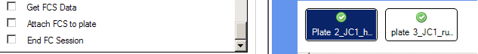

Data Analysis:

1. Open HyperView®Analysis icon on the Hypercyte monitor.

2. Click ‘new analysis’ / Browse / Click on the experiment (plate) you want to analyze. (Be
sure you are in the correct folder.) / Open

3. In that window there is a name box that says Analysis. Type in BioMr or (j) / Create

4. At the top, be sure the plate number matches the one you want to analyze.

a. Go to noise gate tab / change the ‘X’ axis to SS Lin(10^3)
b. Draw a polygonal gate around the whole population, omitting the small
amount of noise in the lower left corner.
c. Hit ‘Well Finder’ / left click in the data window / move the wheel on the
mouse until all the peaks have gates around them.

Gate Symbol Hand symbol to move gates
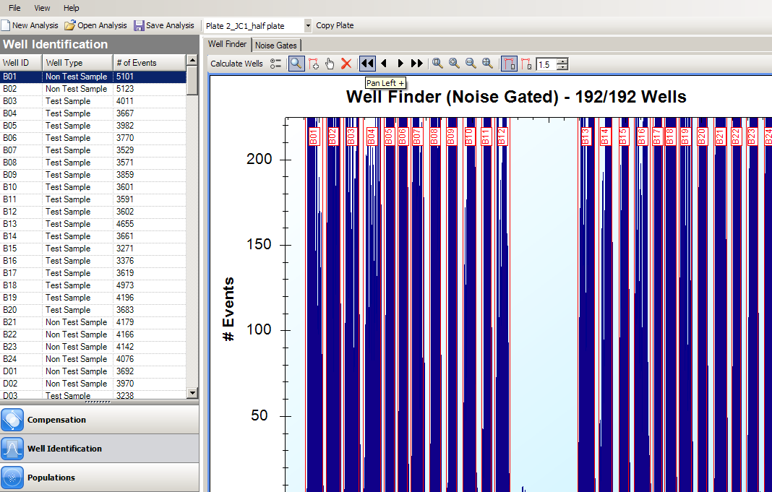
Symbol to delete gates

5. Above the peaks, it will say “Well Finder (Noise Gated) – 192/192 Wells”
If not, you will need to look for the missing gate or peak in some situations.
6. To look at the individual wells, do the following steps.

a. Click the left single arrow until you see the beginning of the peaks.
(either row ‘A’ for Redox or row ‘B’ for JC1)
b. Now click the right single arrow and look at each peak to see if the
gates are on each peak correctly. If not, click on the gate symbol, then
click on the peak or the empty space where the gate is needed.
c. If you need to move a gate, click on the hand symbol and the move the
gate where it is needed.

7. When all gates are correct / Hit Save Analysis.

8. Click on the Population tab / Click the ‘Add 2D Histogram’ icon / change ‘X’ axis to
SS Lin(10^3) / draw a gate around the population / this now becomes “Population 1 Gate”

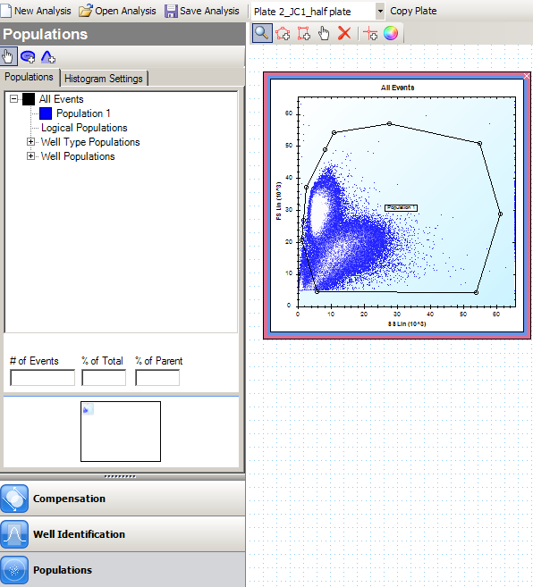

9. Click on the Statistics tab.

a. Check the Population 1 Box.
b. On the parameter menu / check FS Lin Box Mean and FS Lin Box Count
(This is to check the accuracy of the counts per well)
c. If you want fluorescence, check any of the other parameter boxes.
d. Now hit ‘Apply’

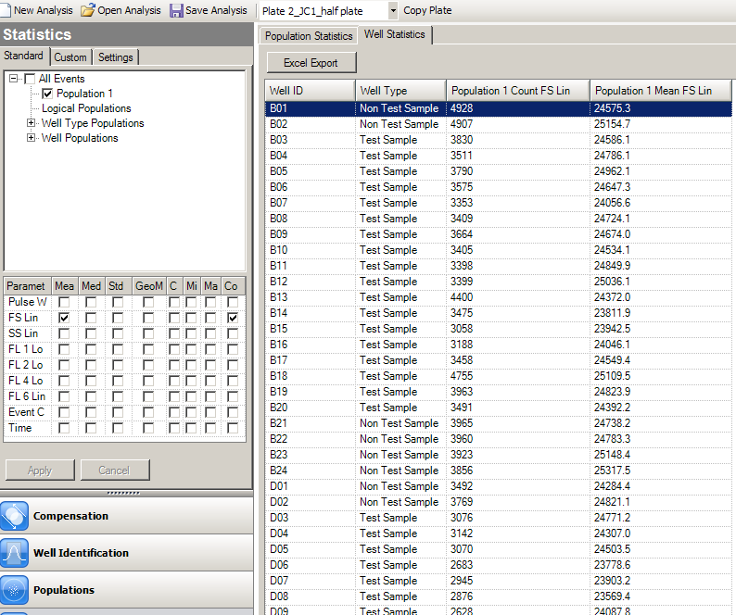
Statistics

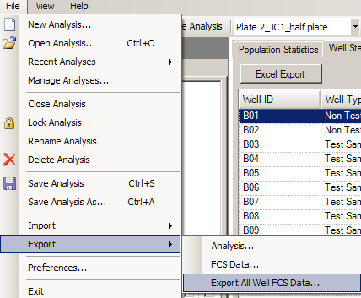 Export FCS Files:

1. File / Export / Export All Well FCS Data

2. Under Population Statistics / Click the
Excel Export Box

3. Click the drop down tab / scratch / projects
BioMek 2000 / your folder / right click on the
Plate name / Rename / control ‘C’ / in the file
name – control ‘V’ / (underscore)_STAT /
Open folder / SAVE

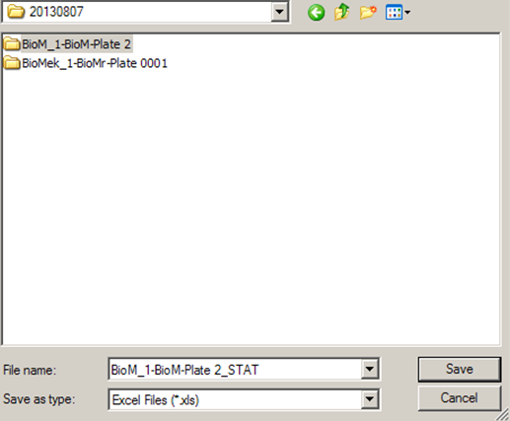

-----------------------------------------------------------------------------------------------------------------------------

Created by: Cheryl Holdman

Verified by: Date: 8/2/2013
Print Name
Sign Name

