SOP-E042

Scanning of Optical Filters With USB2000

Objective: To determine the spectral transmittance properties of an optical filter.

Procedure:

1. Ensure that filter scanning equipment is set up as in Figure 1.

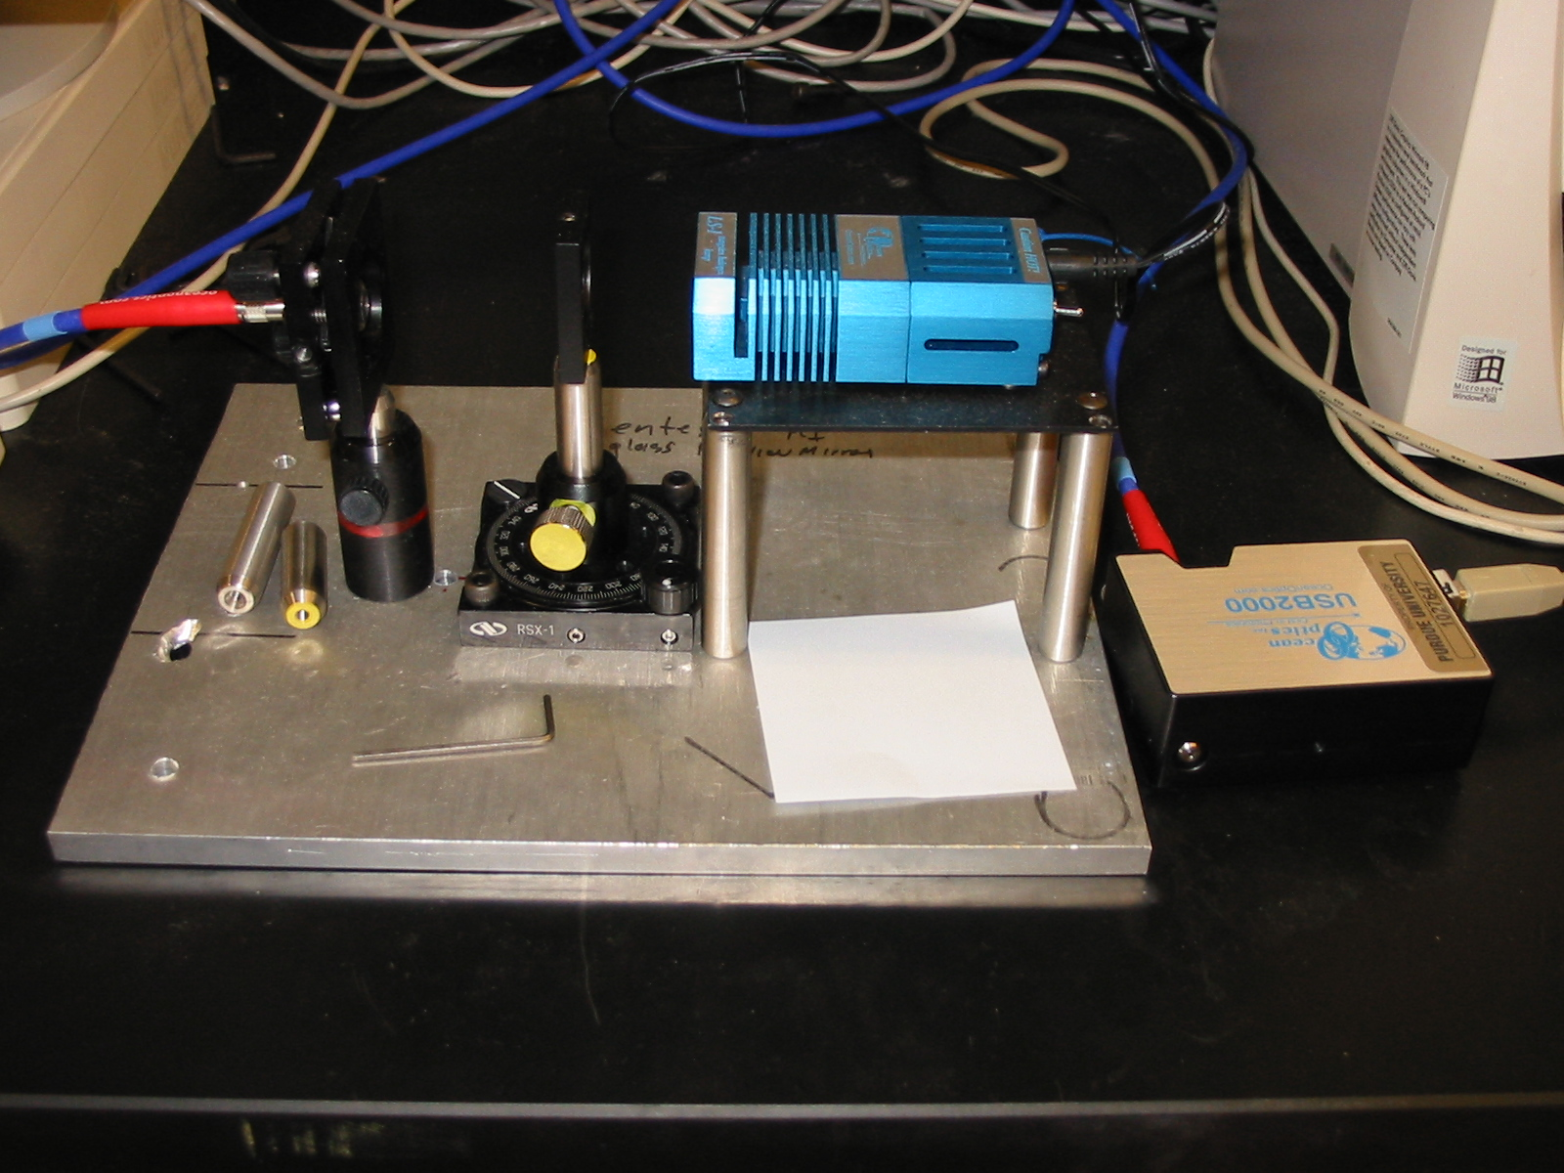
USB 2000
USB Out
Filter Holder
Fiber Optic
LS-1
On/Off Switch
Fiber Optic In

Figure 1

1a. The direction that the light travels is indicated by the large dotted yellow arrow. Light is emitted from the LS-1, travels through the filter in the filter holder and is collected by a collimating lens that focuses it into the fiber optic.

1b. The output from the fiber optic should be connected to the USB 2000 fiber optic port. Remember, fibers break easily, so do not bend the cable at very sharp angles.

1c. The USB 2000 is connected via USB cable to a computer.

1d. Ensure that the LS-1 light source is turned off (switch facing away from power cord) before connecting the power cord.

2. If needed, install the spectrometer operating software, OOIBase32, from the Ocean Optics CD. Alternatively, the software may be downloaded from http://www.oceanoptics.com/Technical/softwaredownloads.asp

3. Run OOIBase32 by clicking on the OOIBase32 icon on the desktop, or by clicking on the windows start menu → All Programs → Ocean Optics → OOIBase32 → OOIBase32.exe.

4. Turn on the LS-1 light source with no filter inserted.

5. Adjust the integration time by clicking on the up and down arrows next to the “Integ. Time (msec)” box. Adjust the integration time so that the maximum number of counts at the peak wavelength reads just under 4000 (ensuring that the lamp spectrum does not “flatline” at the maximum value).

6. Pause the data acquisition by clicking on the camera icon near the top of the screen. Figure 2 depicts a sample reference spectrum.

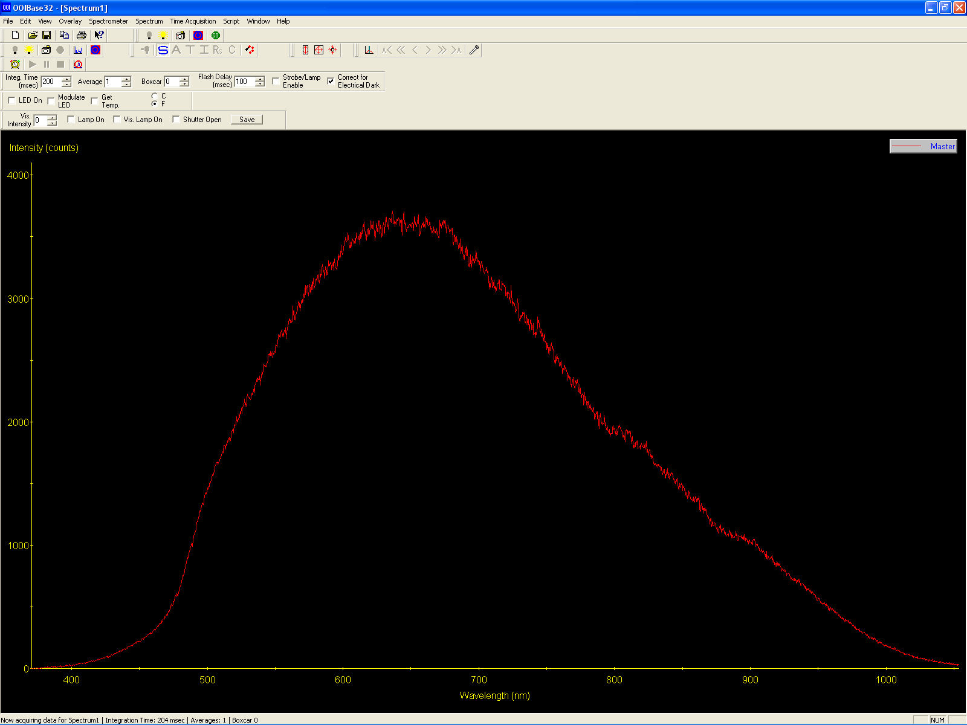

Figure 2

7. Click on the light bulb icon to save the current spectrum as the reference light source.

8. Under the File menu, select save → reference and save this reference light source signal in a new folder in T:\Filter Scans\mm-dd-yyyy. The reference file should be named as “Reference #”, where the # is a number that indicates whether this reference is the first, second, etc. reference taken on this date (for example, if today is July 30, 2004, and this is the first reference spectra, create a new folder labeled 7-30-2004 and save the reference in it as Reference 1).

9. Click the camera icon again to resume data acquisition (you will notice that this button appears depressed when the spectrum is paused and up when the spectrum is not paused).

10. Turn off the LS-1 light source.

11. Again, pause the data acquisition by clicking the camera icon.

12. Click the grey light bulb icon to save the background, “dark”, signal. Figure 3 depicts a sample dark signal.

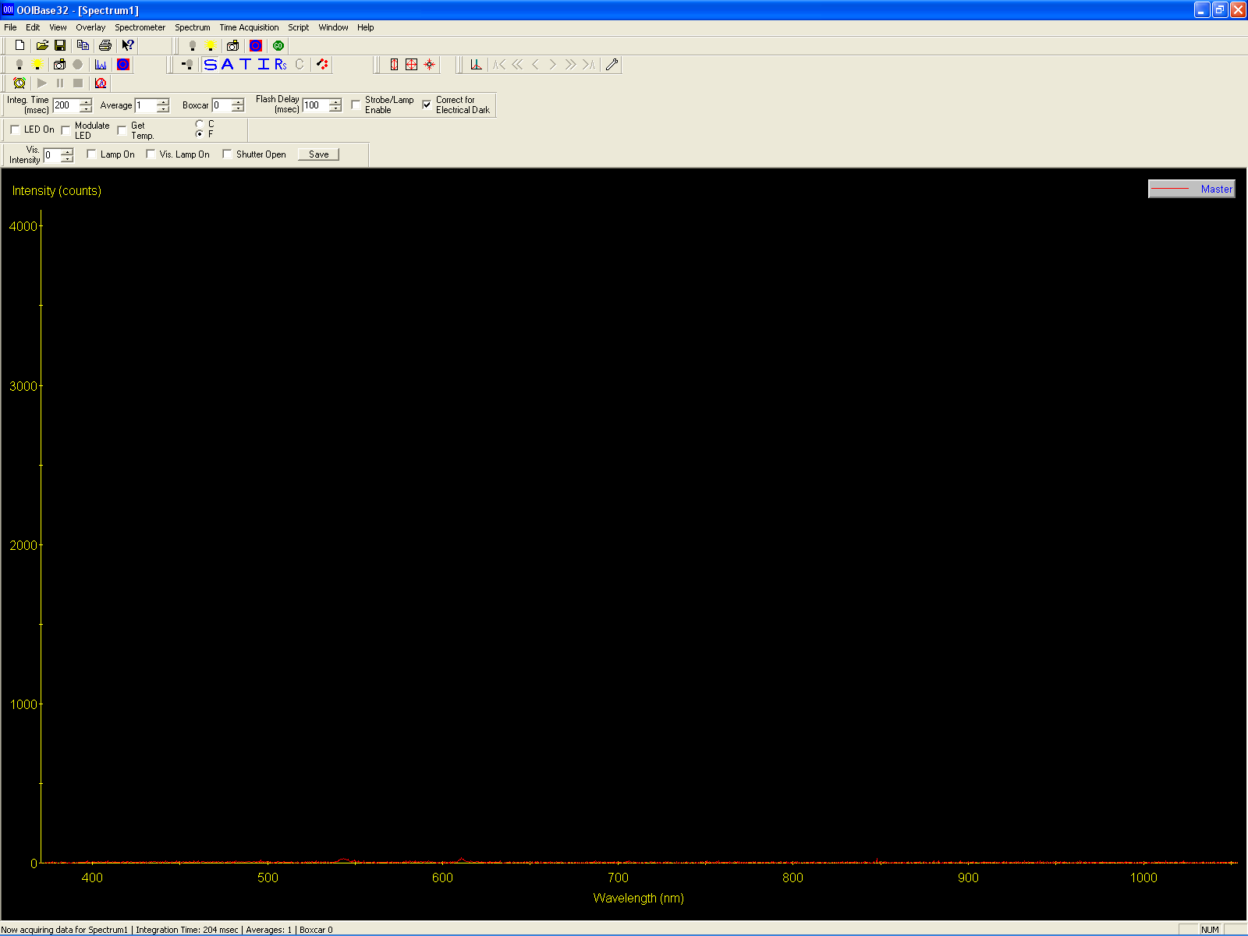

Figure 3

13. Under the File menu, select save → dark and save this dark signal in the same directory. Save the dark signal labeled as Dark #, where the # indicates the first, second, etc. reference dark signal saved on this day.

14. Click the camera icon again to resume data acquisition.

15. Turn on the LS-1.

16. Change the analysis mode to transmission mode by clicking on the large blue T icon. You should now notice that the left axis changes to % Transmission and, with no filter in place, that the transmission is 100% for every wavelength.

16a. If the LS-1 has just been turned on, the reference spectra will change slightly as the light source heats up. This will cause the reading with no filter inserted to vary somewhat from 100% (it is usually lower). If this happens, simply follow steps 6-9, saving the reference as a new file.

17. Insert the filter to be measured into the filter clamp and tighten with an allen wrench, as shown in Figure 4.

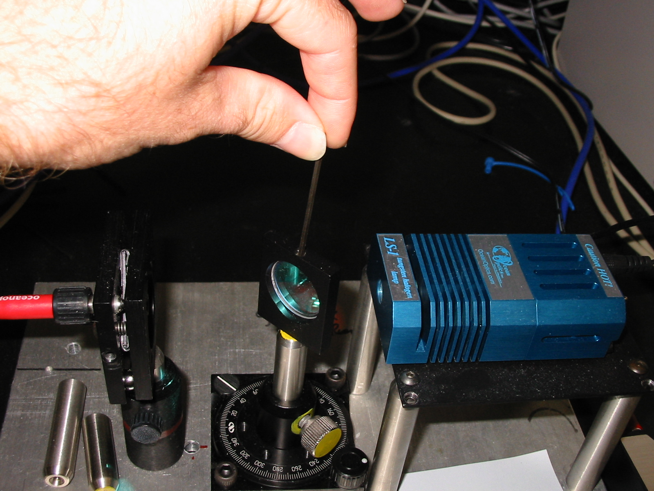
Tighten Here
Orientation Knob

Figure 4

18a. Turn the orientation knob to 0 degrees if you are using a filter that is positioned orthogonal to incoming light.

18b. Turn the orientation knob to 45 degrees if you are using a dichroic or beam-splitting filter.

Note: Filters are delicate and usually expensive. Care must be taken not to scratch or crack filters, either by over-tightening or during handling. Do not touch the front or back of a filter, only the sides. If you must touch the front or back of the filter, use lens cloth to do so.

19. The transmission spectrum for the optical filter should now be visible in the OOIBase32 screen. If you feel that the spectrum is incorrect, check the filter orientation. The transmission spectrum may not be, however, what you expect, as transmission properties change with use and time.

20. Pause the data acquisition again by clicking on the camera icon.

21. The filter transmission spectrum may now be saved by clicking on save → processed, under the File menu and saving the spectrum in the same folder as the reference and dark spectra. The file should be named as follows: “Type of Filter” “Characteristic Wavelength” “Cut-Off Type”, “Orientation”, “Corresponding Reference Spectra #” (for example, when saving the scan of a 450 nm dichroic long-pass filter, scanned at 45 degrees using reference spectra #1, the filename would be: “DI 450 LP, 45 deg, Ref #1”).

22. The spectrum may also be exported to the clipboard in windows metafile format by selecting Copy Graphical Spectra, under the Edit menu. Furthermore, the data set describing the spectrum may be copied to the clipboard for use in spreadsheet programs by selecting Copy Spectral Data → All Spectrometer Data from the Edit menu.

23. To test another filter, remove the first filter, click the camera icon to resume data acquisition, check that the transmission is 100%, and then insert the next filter.

24. When testing is finished, close the OOIBase32 program and remember to shut off the LS-1 light source. If the LS-1 is not shut off, it could overheat.

-------------------------------------------------------------------------------------------------------------------------------

Created by: Silas Leavesley

Verified by: Date:
Print Name
Sign Name

