SOP-E034

Operation of the AMSCO Autoclave

Objective: This SOP describes basic operation of the AMSCO autoclave for steam sterilization of liquids, glassware, and plastics for laboratory use.

This autoclave is located in HANS room B021. Model # 20” VAC PWR SD. Purdue Property # 866598

For using a pre-programmed cycle:
Procedure:

1. At the main menu touch the CYCLE SELECT button.
2. This will advance to display the CYCLE SELECT screen. Press the button for the preprogrammed cycle you would like to use. The settings for each cycle are shown on a piece of paper attached to the front of the autoclave.
3. Pressing a cycle button advances to display a screen listing that cycle’s parameters.
4. Pressing START CYCLE will initiate the cycle selected and advance the display to the first in-cycle status screen.

To change the preset cycle values:
Procedure:

1. Press OPTIONS on the main screen.
2. Press CHANGE VALUES.
3. Press CYCLES to select the cycle to be modified.
4. Press the cycle button corresponding to the cycle to be changed.
5. The next screen allows the operator to choose the type of cycle that will be assigned to the selected cycle button. The current cycle name and assigned cycle type are shown at the bottom of the display. Press the button for the type of cycle you wish to program.

NOTE: Some programmable values are different depending on which type of cycle is selected.

6. The next screen(s) will list the programmable values for the type of cycle selected. (There may be 1-3 screens of programmable values depending on the cycle type)
7. To change the value, select which value you wish to change by pressing it.
8. The next screen allows you to key in the value you wish. It may be a character screen or a numeric screen, but either way just key in the change. Use the arrow keys to move the curser left or right. Press RETURN to save the changed value.
9. When you have made all the changes on the CHANGE VALUES screen you wish to change, press NEXT (if there is a next) and change those values as above.
10. After all cycle value changes have been made, press CYCLE MENU.
11. Remaining cycles may now be modified if desired as above.
12. Once all changes to the cycles and cycle values are completed, press MAIN MENU.

Discussion:

(a) It is very important to keep the chamber door closed between cycles and when sterilizer is not in use.

(b) After sterilization most goods should be stored for no longer than 30 days, depending on wrapping materials.

© Put items to be autoclaved in a pan in case of meltdown.

(d) Do not leave items in autoclave overnight, they may melt even if autoclavable.

(e) When sterilizing liquids make sure to place the container in a pan with about two inches of water in it.

(f) Recommended sterilization variables:

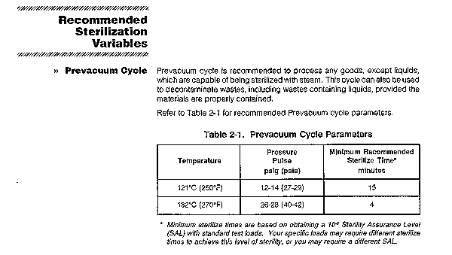

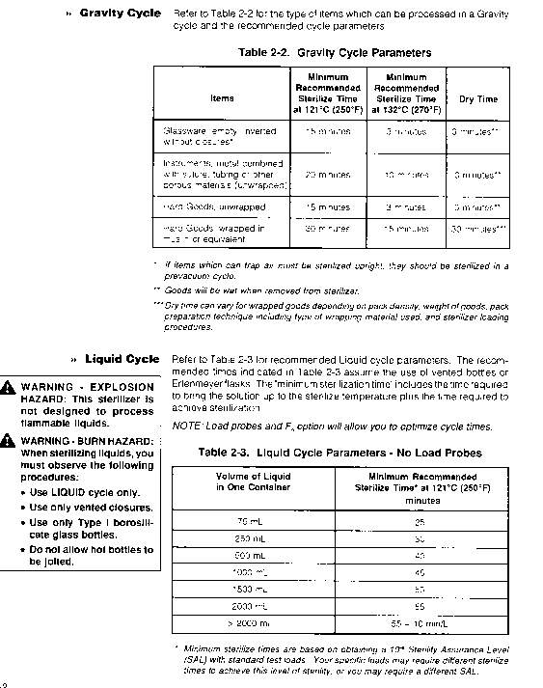

--------------------------------------------------------------------------------------------------------------------------------

Created by: Kathy Ragheb Date: April 23, 1999

Verified by: Date:
Print Name
Sign Name

