SOP-E015

CyClone on the XDP MoFlo Sorter

Objective: To prepare the Cyclone on the XDP MoFlo Sorter for a
96 well plate sort.

When you intend to use the CyClone to sort on to a slide or a plate, you must first acquire
data from the samle, set regions and gates, set sort decisions, configure the
slide or plate in Summit software, and configure the CyClone before sorting.

Procedure:

1. First you will need to check the alignment of the 96 well plate to be sure the sort is centered in
the center of the wells.

2. Press the Home Button. (This should be well A1 on the 96 well plate). The CyClone will move
to the last set position. If you want to change the Home position, use the Arrow Buttons to move
the CyClone to the desired location. Press the Set Button to store the new position.

3. To test the new position, press the Squirt button and observe if the fluid is deposited in the
desired location. If this is the right location, press the Set Button. (If you do not press the set
button, the position will be lost.)

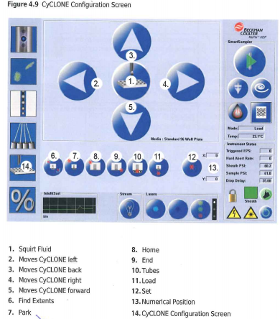

4. Click the End Button. Then repeat Step #3.

You must set the decisions for stream Right 2 (R2) ONLY and the Voltage around 2800

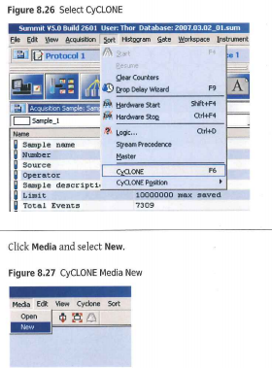

1. From the main Sort menu in the Summit software, select
CyClone and click Media and select New.

2. A dialog box appears. Select the appropriate
Medium from the list.

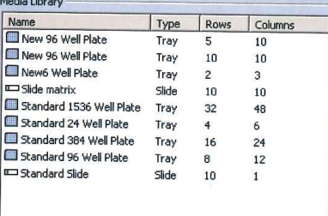

3. A layout of the chosen medium appears. Click on all of the circles that will receive one of
your sort decisions. To Select individual circles, press the CTRL key while you click the circle.
To select a group of circles, click one circle, press the SHIFT key while you click another
circle. To clear a selected circle, click it again.

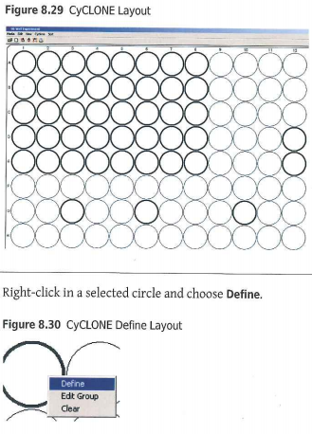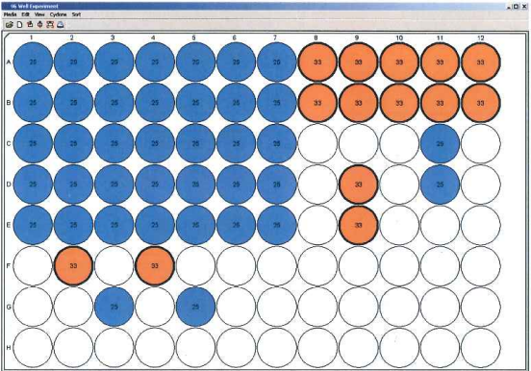

4. Once your CyClone layout has been chosen, Right-click in a selected circle and choose Define.
Set a limit for the maximum number of cells that will be sorted in one location.
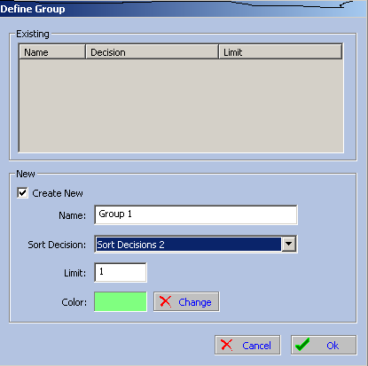
5. If you intend to sort more than one set of sort decisions, repeat steps 1-4.
Then select a different color for the set. Then click okay.

6. Each time you make a change, that becomes a new decision.
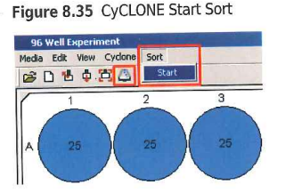
7. To begin sorting, click the Sort Icon

Or click Start.

Pause Sorting:

1. During a sort run, you may want to pause data acquisition but continue to run the sample
so you can continue to view events on the aXcess Control Panal, and then resume data
acquisition later.

a) To pause a sort in this manner, go to the main Sort menu in Summit software
and select Pause.

b) To resume sorting and acquiring data in Summit software, go to the main Sort
menu and select Resume.

2. If you are using a plate or slide, the sorter will resume sorting at the same position that the
CyClone was in when you paused the sort.

Reminder: You must set the decisions for stream Right 2 (R2) ONLY and the

-----------------------------------------------------------------------------------------------------------------------------

Created by: Cheryl Holdman

Verified by: Date: 8/19/2013
Print Name
Sign Name

