Agonist Treated Cells

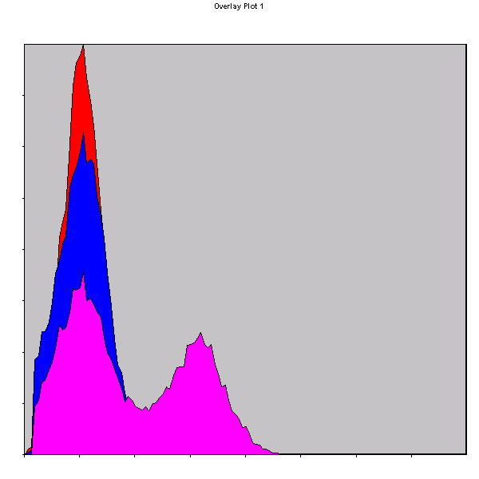

Cell Type % Gated X-Mean X-Mode
Secondary antibody only (red) 0.13 2.0 2.8
IgG + secondary (blue) 2.07 1.8 1.3
Antibody (pink) 40.70 4.2 3.0

Vehicle Control Cells
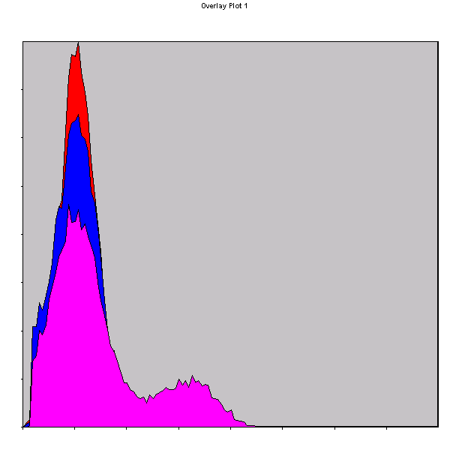

Cell Type % Gated X-Mean X-Mode
Secondary antibody only (red) 0.19 2.3 1.0
IgG + secondary (blue) 2.02 1.6 1.0
Antibody (pink) 22.91 4.2 2.4

K-S Analysis for 1:2 Secondary Antibody Treatment

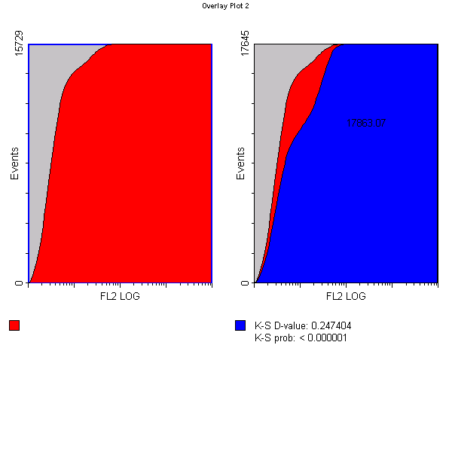
Chi² = 17863.07

K-S Mode probability = <0.000001

K-S Mode D value = 0.247404

