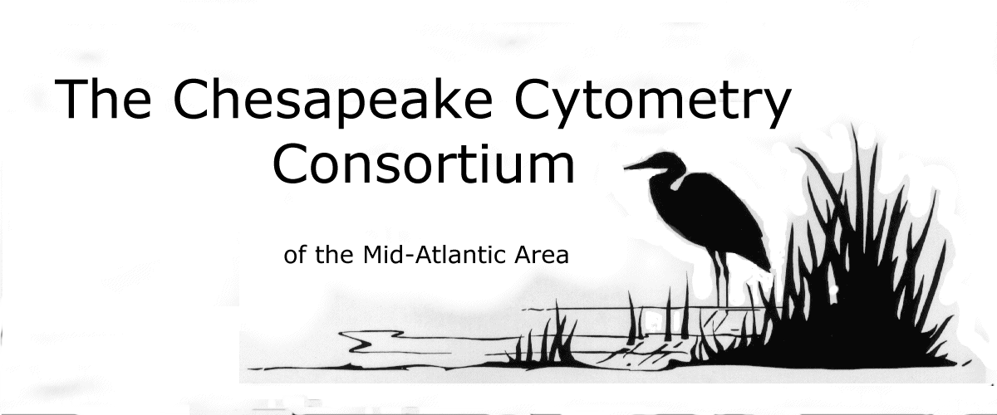
You are cordially invited to attend the Chesapeake Cytometry Consortium Flow Cytometry User Group luncheon meeting.

When: Monday, June 24th, 2002
Where: Forest Glen Annex of Walter Reed

Host Contact: Lt. Gary Brice

Agenda:

10:00-10:15 Brief business meeting (open to all)

10:15-11:00 "Emerging Fluorochrome Technology in Flow and
Image Cytometry"

Dr. William Telford
Laboratory of Immunology
NCI, NIH

11:00-11:45 “Difficult Cases in Clinical Flow Cytometry”

Maryalice Stetler-Stevenson, M.D., Ph.D.
Chief, Flow Cytometry Unit
Laboratory of Pathology, NCI, NIH

11:45-12:00 Sponsor’s Technology Update

Lunch will be provided by Beckman Coulter Inc.

Please RSVP by June 19th, 2002. Please reply to Fischer1@mail.nih.gov or Solmaz.Ebrahimi@coulter.com and confirm your attendance.

