Co-Sponsoring

The Northeast/Mid-Atlantic Cytometry Symposium

April 5-6, 2002
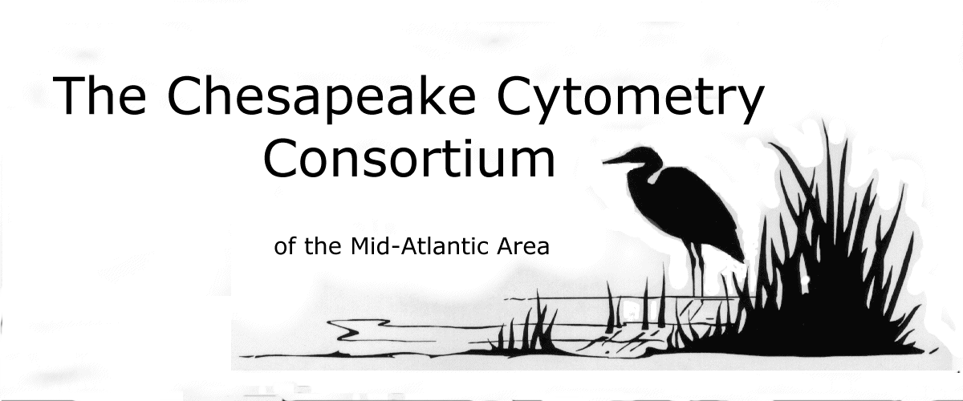


MetroFlow Users Group
(NY/NJ Flow Cytometry Users Group)
The Chesapeake Cytometry Consortium
Participant Registration Form

Name: ______________________________ Title: _____________________________

Institution: ______________________________ Department: _________________

Address: ______________________________________________________________
City: _______________________ State: _________ ZIP: _____________

Phone: (_____) _____-_________ FAX: (_____) _____-_________

E-Mail: ________________________

I am registering for:
Member Student (w/ID) Non-member

Fri., 4/5 ____ ($65) ____ ($65) ____ ($75)
Sat., 4/6 ____ ($65) ____ ($65) ____ ($75)
Both Days ____ ($120) ____ ($120) ____ ($140)

My check (payable to CCC) is enclosed for: $_________

Bill my credit card: (Circle one) VISA MasterCard AMEX
Card #: ___________________________ Expiration (month/yr.): _________

Amount: $ ___________ Signature: ______________________ Date: ________

Please return this form and payment to:
Dennis Broud
Secretary/Treasurer, CCC

4030 Adams Drive, Wheaton, MD 20902
or by FAX (credit cards only) 301-594-303

Pre-registration Deadline is March 22, 2002
All registrations after this date will incur an additional $15 fee
Onsite registration will be on a space available basis only

